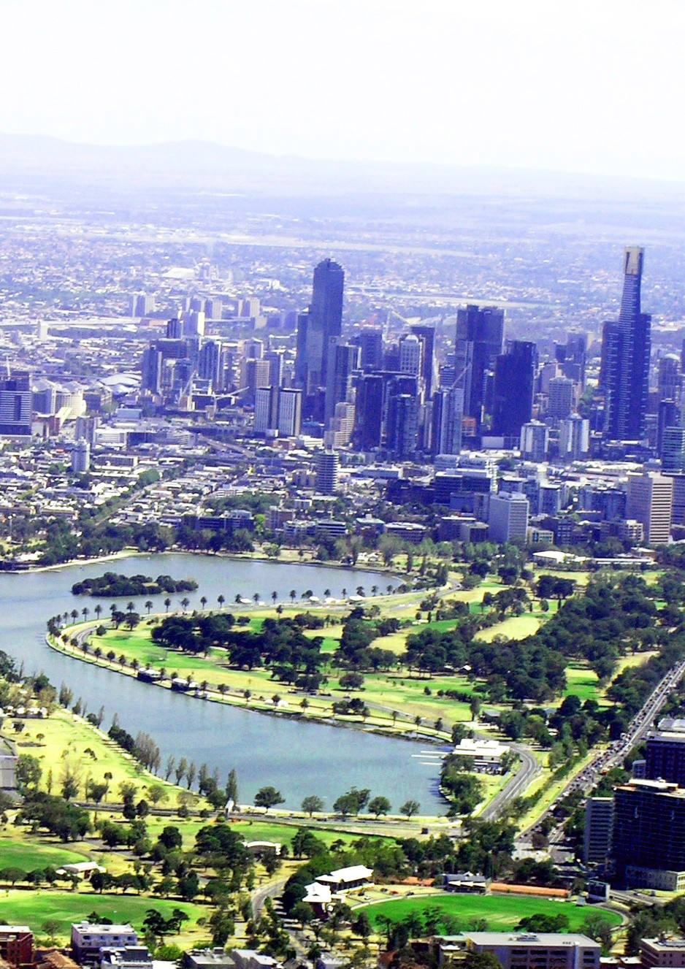
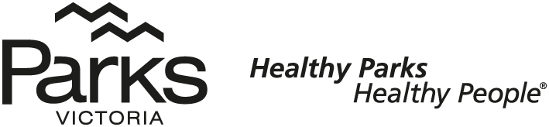
A l b e r t P a r k
M A S T E R P L A N

Albert Park Master Plan project governance

The project team structure established to guide and oversee development of the master plan includes:
- Hansen Partnership
landscape architecture and master planning
- @ Leisure
recreational planning
- GTA consultants
traffic and transport consultants
- Ecology & Heritage Partners
ecological and cultural heritage consultant
- Harvest Digital Planning
web developer
- Laidlaw & Laidlaw
landscape heritage and arboricultural advice
- Optias
investment and revenue opportunities.

The project governance structure established to guide and oversee development of the master plan includes:
- Parks Victoria collaborating with the Traditional Owners Boon Wurrung Foundation and Bunurong Land Council Aboriginal Corporation, and with Wurundjeri Land Council
- Project Working Group comprised of Parks Victoria planning and regional staff
- Project Steering Committee comprised of Parks Victoria directors to provide direction, strategic advice and input into the master plan development.

Authorised and published by Parks Victoria L10, 535 Bourke Street, Melbourne, VIC 3000 Copyright © Parks Victoria 2019
Acknowledgment of contributors

The project group wishes to acknowledge the input and assistance of the following:
- Traditional Owner group representatives
- Members of the Project Working Group and Project Steering Committee
- Parks Victoria staff from various directorates and Albert Park staff who provided technical advice
- Community, industry and stakeholder group representatives who gave their time and knowledge during various consultation phases
- Anne-Marie Pisani, Senior Precinct Planner (Project Manager)
- Nick Loschiavo, Senior Precinct Planner (Document)
- Cameron Bergmeier, Precinct Planner (Maps and Document)
- Andrew Shannon, Manager Stakeholder and Community Engagement (Document).

Traditional Owners acknowledgment

Parks Victoria acknowledges the Traditional Owners of Victoria, and pays respects to their Elders past, present and future, and their ongoing connection and responsibilities in caring for Country. Parks Victoria will continue to work with the Traditional Owners in the implementation of this plan.

Contents

- Executive summary
1 | Initiative 7: | Improve the light rail underpass | 49
 | Initiative 8: | Improve equitable universal access | 52
Initiative 9: |  | Removal of pedestrian barriers | 52
0 Initiative 10: Enhanced lighting, signage & amenities 53

- Introduction 5

- Significance of Albert Park 1
- Vision, Themes and Future Directions 11
- Statutory Environment 12
- Community & Stakeholder Engagement 13
- The Albert Park Master Plan 18
Study area and context 18
Landscape Character 20
- Theme one: Nature and environment 21
8.1 Future direction - Protecting and enhancing landscape values
Initiative 1: Landscape Character Types 21
The lake and lakes edge 22
Open Woodlands and sports precinct 23
Eastern lawn and golf precinct 25
Fitzroy Street Precinct 26
Avenue Plantings 27
Albert Road Blvd 28
Perimeter Planting 28
Initiative 11: Promote the Perimeter Path 56
Initiative 12: Tree Line Avenues 56
Initiative 13: An Integrated cycling network 56
Initiative 14: Programmed cycling circuit 56
Initiative 15: Rationalise vehicle access & circulation 58
Initiative 16: Reduce through vehicle traffic 58
Initiative 17: Consolidate car parking 59
Initiative 18: Drop-off and bus parking areas 59
9.2 Future direction - a healthy environment providing experiences of culture and nature where people can connect with one another
Initiative 1: Quality amenities and facilities 62
Initiative 2: Flexible event spaces 64
Initiative 3: Recognise and celebrate cultural heritage 66
10. Theme three: Healthy and active 69
10.1 Future direction – an adaptable and diverse urban park that is enjoyed and valued for relaxation and sports
Initiative 1: Programming sports grounds use 70
 | Indigenous regeneration | 28 | Initiative 2: | Improve performance of sports grounds | 70
 |  |  | Initiative 3: | Retain a golf offer | 72
Initiative 2: | Albert Park planting strategy | 30 | Initiative 4: | Youth and community social hub | 72
Initiative 3: | Learning in nature | 31 | Initiative 5: | Multi use courts | 72
Initiative 4: | Sustainable materials and resources | 32 | Initiative 6: | Outdoor fitness | 72
Initiative 5: | Improve social sustainability | 33 | Initiative 7: | Contemporary play spaces | 73
Initiative 6: | Celebrating the lakes importance | 34 | Initiative 8: | Revitalise picnic areas | 76
Initiative 7: | The lake promenade as a destination | 35 | Initiative 9: | Lakeside platforms | 76
Initiative 8: | Support lake recreation | 36 | Initiative 10: | Criterium circuit and road cycling | 76
Initiative 9: | Wetland Board Walks | 37 | Initiative 11: | Dog off-lead areas | 77

Initiative 10: Gunn Island 39
Initiative 11: Wetland play and recreation 39

9. Theme two: Community connections 41
9.1 Future direction - a welcoming park for everyone
Initiative 1: Upgrade Queens Rd pedestrian crossing 44
Initiative 2: Albert Road boulevard 44
Initiative 3: Prioritise public transport connections 44
Initiative 4: Fitzroy Street access enhancement 44
Initiative 5: Clearly define park entrances 46
Initiative 6: Define primary accesses 48
Primary Access: Lakeside Drive 48
Primary Access: Lakeside Gateway 48
Primary Access: Fitzroy Street 48
Primary Access: Aughtie Drive 48
Primary Access: Canterbury Road 48

- Implementation strategy 80
  - Implementation Plans 81
- Appendices
  - Appendix A: Governance 85
  - Appendix B: Policy Context 87
  - Appendix C: Albert Park Guiding Golf Principles 91
  - Appendix D: Existing Conditions 93

Executive summary

Albert Park will offer a diverse range of high quality visitor experiences within an urban parkland setting. It
will be valued as an opportunity to connect with nature in the city, contributing to the health and wellbeing of the community of Melbourne and its visitors.

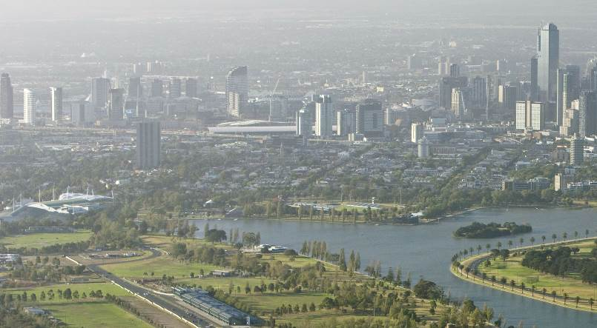

Planning Albert Park’s future

Albert Park is situated three kilometres from the centre of Melbourne and provides 225 hectares of parkland including a 45 hectare lake. Over six million visits to the park are made each year. The park provides open space for local communities, hosts district sports games, is the venue for a multitude
of charitable events, fun runs/walks and is known internationally as a venue for the Australian Formula One Grand Prix.

Melbourne is Australia’s fastest growing city, with the current population of 5 million, is expected to increase to 7 million by 2042. Rates of obesity and health issues across the population and life stages; increases in chronic diseases such as coronary heart disease, cancers, diabetes and mental health issues, such as depression, for which increased physical activity can have positive effects, and the levels of social isolation in Australia are rising and climate change is placing increasing pressure on our urban parks and open spaces.
As Melbourne’s population grows, so does the demand on our parks and gardens. The Albert Park Master Plan will guide improvements to the park over the next 25 years, ensuring it meets the diverse and changing needs of visitors, while enhancing
the health and wellbeing of visitors to the park and quality of the park landscape.

Through consultation we have heard that the park is much loved and that the underlying layout is working well, but there are some key areas for improvement. The master plan provides a series of interventions to improve the quality of experiences available for visitors, in large part by improving the
park environment through increased planting and by improving access to the park.

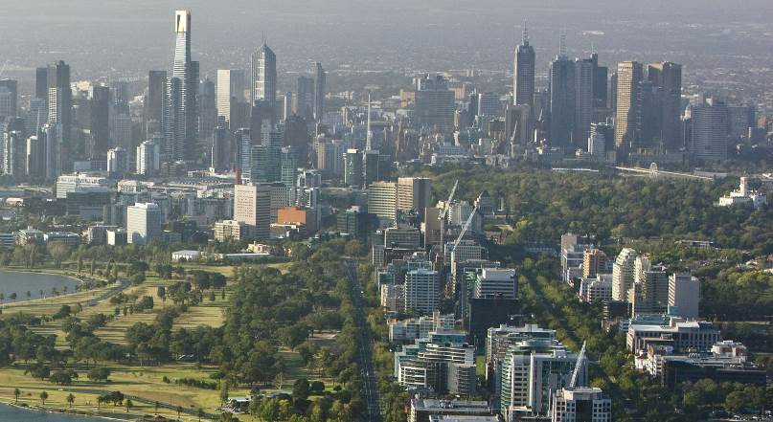

Master Plan aims

Parks Victoria recognises that, over the life of a master plan, circumstances affecting the park may change. Changed circumstances that may necessitate a refresh of the master plan, based on demonstrated need and clear rationale, would be prioritised. These changes may be a response to new recreational opportunities; unexpected and/or significant increases in visitor demand; new threats or risks
to natural and cultural values; changes in park/ reserve boundaries and/or land-use; or changes in government policy or legislation.
The master plan sets out a flexible and adaptable framework for the future, under three themes and five future directions. Project initiatives are outlined under each of the strategic directions.

Theme one: Nature and environment

- A healthy park that will showcase the sustainable use of resources in a time of climate change
- Celebrate the importance of the lake as the heart of the park

Theme two: Community connections

- A welcoming park for everyone
- A healthy environment where people can connect with one another while being immersed in nature and culture

Theme three: Healthy and active

- An adaptable and diverse urban park that is enjoyed and valued for relaxation, sports and recreation.

Executive summary

The Vision: Albert Park — open space for Melbourne’s growing future

What does the Master Plan propose?

The master plan proposes adaptation and
activation of the site to meet the changing needs of Melbourne’s growing population. The main proposals of the master plan include:
- A new 6–8 metre wide, 5 km long Lake Promenade, with lighting for evening use.
- The creation of a wetland edge a new meandering board walk to bring people close to nature on the lake.
- A diverse range of picnic, play and fitness areas, connected to the Lake Promenade.
- Ongoing provision for community-based and grassroots sports, by increasing resilience of sporting fields and greater use of programming through sharing of fields and pavilions.
- Support for the Albert Park Planting Strategy, for further tree planting, to mitigate the effects of climate change, provide shade and shelter, improve amenity and provide greater opportunities for visitor experiences.
- A reduction in non-essential through traffic to improve visitor safety and park amenities, and
to better provide for prioritised public transport, walking, cycling and event opportunities.
- Crossings to improve visitor safety across Queens Road and a green walking and cycling link from the park to the new Anzac Station.
- Improved access by better defining entrances and tree-line avenues leading to the lake.
- Protection of the Ngargee (Corroboree) Tree.
- A range of programs and activities to get a broader range of people involved in the park.
- A treed community urban space adjoining Fitzroy Street.
- Establishing Albert Park as one of Australia’s most accessible parks for people of all abilities.

The master plan provides clarity for Parks Victoria, as the park managers, for the various clubs and leaseholders and park visitors. It establishes a shared community vision for the park and a long- term framework to inform decision making and
investment. This will aim to ensure that Albert Park is flexible and can evolve over time to meet the
changing needs of the community and contemporary park. This shared vision will provide the desired confidence for government and leaseholders to invest in the future of Albert Park.

Consultation informing the master plan

The master plan has been informed by three rounds of community engagement, stakeholder discussions and detailed analysis that has included meetings
with stakeholders, community information and drop- in sessions, and an interactive website with online mapping tools and surveys.

The background analysis report is underpinned by investigations, analysis and the first phase of engagement in 2014, where people told us what
they consider is most important about the park and what needs to be addressed. For many people the lake is the heart of the park and the lake walk is an important part of their daily or weekly life. We heard that sports build a sense of community as well as contributing to health and fitness. Many people referred to the park as “breathing space” in the midst of a rapidly growing city. People told us that the park can be inhospitable on windy, rainy or hot days and that the landscape lacked interest for those not engaged in sport. Visitors felt that the park was not easy to get into or move through and that we need to be better prepared to respond to climate change and to cater for an increase in participation in sport and other health and recreational activities.

The initial framework plan

The Framework Plan tested ten key ideas and was exhibited in 2016. All of the ideas received support, to varying degrees, with particularly strong support to “enhance the park’s landscape character, quality and habitat potential through additional planting.” Feedback, together with expert advice from the Victorian Design Review Panel of the Office of the Victorian Government Architect, subsequently informed the development of a draft master plan. Exhibited during November 2017 and January 2018, the draft master plan received 2000+ responses. The new Lake Promenade concept was well supported, while we heard overwhelmingly from golfing advocates that they treasured the existing 18-hole golf course and did not want to see it reduced in size. Sports clubs continued to advocate that the future park will need to meet increasing demand for sports grounds.
How will the master plan be implemented?

Due to the complexity of functions and operations at Albert Park, actions will be implemented incrementally over time as leases expire and new opportunities arise, as visitation and demands change and as funding is made available to support the associated capital works program.

The delivery of new infrastructure and facilities will follow best practice in design, provide flexibility and support a variety of different complementary uses and provide resilience and sustainability into the future.

A series of design and development parameters have been established to provide guidance on the design of these facilities. These parameters are listed in the ‘Implementation’ chapter.

Implementation will be supported by a process
of design review led by the Office of the Victorian Government Architect to review major development proposals and provide independent advice to government, clients and design consultants on design ambitions. Its purpose is to ensure quality design and visitor experience outcomes are met and realisation of the ambition of the master plan is met. Successful implementation of the master plan will depend on partnerships with external organisations, community and stakeholder groups and the private sector to deliver the full spectrum of opportunities.

The Albert Park Master Plan aligns with the four pillars of Parks Victoria Shaping Our Future. The vision is underpinned by the Healthy Parks Healthy People approach that this master plan will further explore and activate.

Introduction

Victorians love Albert Park, and make more than 6 million visits to the park each year. For o ver 140 years, the 225 hectare park, located 3 kilometres from the centre of Melbourne has provided for a range of amateur sports, community events and an escape to nature.

The need for a plan

The 1993 master plan for Albert Park has been largely implemented and has provided a strong structure for the park. Parks Victoria has developed this new master plan to set a vision for the park and guide it through the next 25 years and enable the park to maximise its contribution to the health and wellbeing of the Victorian community. As an inner city park, every square metre performs a function. There is an increasing demand for space by new and emerging sports and leisure activities, including a myriad of public and charitable events, a need for further environmental and amenity improvements, and for greater accessibility for our diverse community.

Twenty five years ago Melbourne was very different to what it is today. With the rate of technological and social change increasing significantly, Melbourne in 25 years from now, (the lifespan of this plan) will be very different to what it is today.
- Twenty-five years ago the greater Melbourne population was 3.2 million, and is now 5 million. On current trends could be 6-7 million in 25 years time. The biggest demographic change is the number of people aged over 65, which is expected to double to 1.26 million by 2041.
- Climate change impacts in Melbourne are expects to see a rise in the number of very hot days (where temperatures exceed 35 degrees) and flash flooding, known to cause the most deaths or injuries of all natural disaster weather events, will increase. With this, Albert Park
will be called on to assist in climate change mitigation and flood control.
How to read this master plan

The Albert Park master plan is underpinned by the Parks Victoria Shaping Our Future four pillars and
a broad project vision and future directions. The master plan approach addresses three major themes that support the objectives of the project vision. These themes are then investigated through a series of key initiatives. These initiatives direct a sequence of actions that inform the implementation plan for potential deliverables.

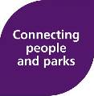
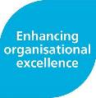
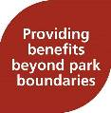
Shaping Our Future

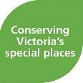



Parks Victoria’s vision

Shaping Our Future outlines Parks Victoria’s vision, purpose and strategic directions for the next decade, and in the context of this master plan, for the next
25 years. It identifies a vision for Parks Victoria to be a world class park service ensuring healthy parks for healthy people.

Healthy Parks Healthy People is a global movement that recognises the fundamental connections between human health and environmental health. For Parks Victoria, Healthy Parks Healthy People is the very foundation of how we manage parks and gives us the opportunity to improve the health of both our parks and communities.

In delivering our vision, Parks Victoria aims to inspire the community to conserve and enjoy Albert Park’s unique natural and cultural heritage. Together, we care for Country and promote the value of Albert Park and Albert Park lake for the benefit of all Victorians and visitors.

The following four pillars of Parks Victoria’s strategic plan explain the vision and purpose and how it will be achieved through the Albert Park Master Plan.

Conserving Victoria’s special places aims to increase the resilience of natural and cultural assets in Albert Park and maintain ecosystem services in the face of climate change and other stressors. Albert Park Lake plays a significant role in meeting this objective and provides the opportunity for greater engagement with visitors to Albert Park
Enhancing organisational excellence is focused on improving the Parks Victoria’s capacity and capabilities and recognises the important role of our partners in achieving the desired outcomes. This master plan acknowledges the commitment and ongoing relationship with other government
partners, lessees, sporting groups and independent event organisers to enhance Albert Park.

Providing benefits beyond park boundaries recognises the organisation’s role in contributing to the safety, living standards and wellbeing
of Victorians. Albert Park is a key urban space contributing to and enhancing the liveability of Melbourne. It builds strong connection with the surrounding city fabric, connecting with Anzac Station, linking with other nearby open spaces such as Faulkner Park, Fitzroy Street and the bay.

Connecting people and parks aims to support and improve the health and wellbeing of Victorians by managing Albert Park in a way that is highly valued by the community. Implementation of this master plan supports increasing visitor access, activation and enjoyment, and deliver social and community- based programs to promote social sustainability, universal inclusion, health and wellbeing.

Planning for diverse people and activity

In talking with many hundreds of people through the course of planning it is clear that Albert Park is a much-loved part of Melbourne and is providing
a range of healthy activities and experiences. From what we have heard, the basic structure and layout of the park are working, but there is a need for improvements in some key areas. These include:
- Access into and around the park
- Provision of increased shade and shelter
- Access to playing fields and adaptable open space
- Improving the experiences for casual visitors, especially the lake environs
- Opportunities to experience the park’s flora and fauna
- Environmental sustainability.

Albert Park with the neighbouring Melbourne Sports and Aquatic Centre (MSAC) has long been known
as “the home of amateur sport”, providing entry
at a community level for a range of popular sports. The lake is often described by sailors as a ‘valuable nursery for learners’. While some have gone on to represent Australia at a national level, most people play for recreation, fitness, wellbeing and the community connection.

The 2011-12 report on Participation in Sport and Physical Recreation in Australia notes that walking for exercise has the highest rate of participation nationally. The lake path is the most-used facility in the park and accommodates a very broad range of fitness levels and diversity of users.

Continuing to provide for diverse community members to be active is critical in tackling the growing issues of obesity, diabetes, heart disease and mental health. Albert Park will continue to provide community-based and entry level sport to encourage greater rates of participation by more people.

Albert Park’s topography, its central location and the activities on offer, provide a great opportunity for it to be an exemplar for all abilities access. Parks Victoria’s aim is to support inclusive experiences
where diverse visitors feel included when visiting the park with their family and friends. Bringing together accessible park infrastructure and experiences,
and providing opportunities for everyday social interaction with others will be central to achieving this aim. This will be supported by improved access to public transport connections in the park and improved continuous paths of accessible travel throughout the park.

The master plan places emphasis on improving the casual recreation and amenity values of the park
to meet the needs of a more diverse community, with a range of abilities and interests. Albert Park will continue to evolve to provide a broader range of visitor experiences and environmental outcomes supported by accessible infrastructure and amenity including toilets and ‘Changing Places’ facilities.

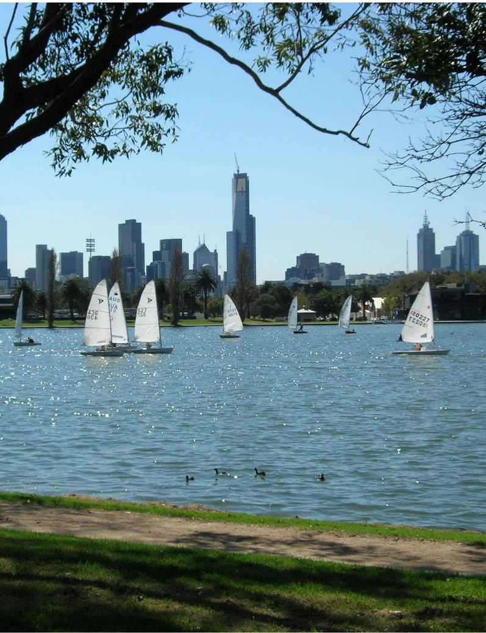
Image:A lbert Park, Melbourne
Photo credit:Parks Victoria, 2018
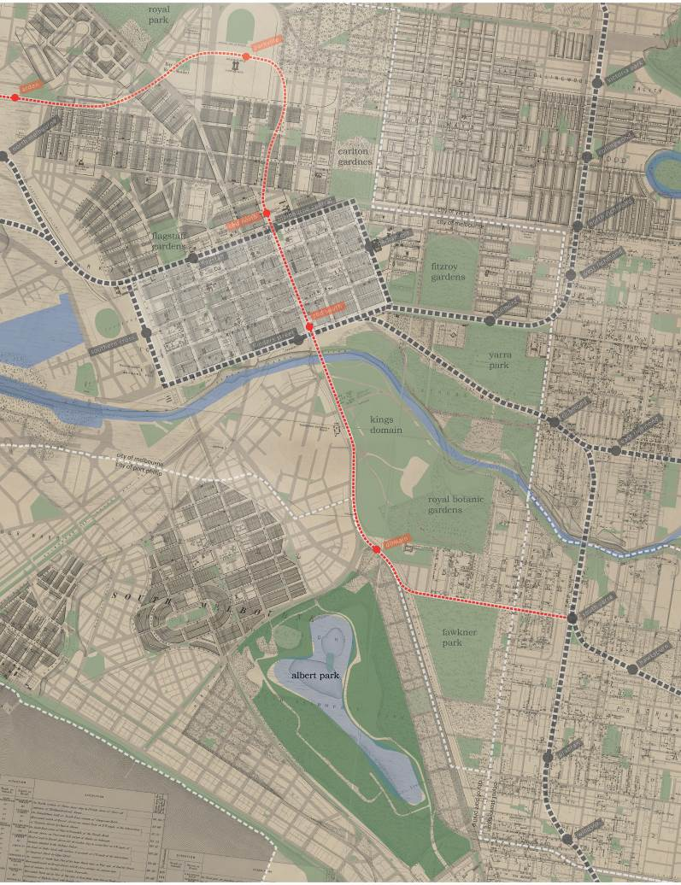
Image: Historic Plan of Melbourne Photo credit: State Library Victoria, 2018.

Significance of Albert Park

Albert Park provides open space for local communities, hosts district sport competitions, and is known internationally as a venue for the Australian Formula One Grand Prix.

The people’s playground

The following perspectives Albert Park are important and have been considered in the master planning process.

For some local residents, the park is significant as local open space where they can relax and perhaps walk the dog. The heart of the park is the lake and it provides a daily dose of nature and peace. For local communities, the park is a place to get together with family and friends, or be part of a community sports club. The park helps define their suburb
and their relationship with the city. A number of built structures within the park have local heritage significance, helping to tell the story of early St Kilda and South Melbourne.

In the context of Melbourne as a capital city of 5 million people, the park provides breathing
space and green relief from the hard-edged urban environment. The path around the lake is one of its most loved features, attracting residents and workers for a regular walk or run. With its plentiful
settings for community sport, Albert Park has earned a reputation as ‘the people’s playground’. Many popular community events, such as the RSPCA Million Paws Walk and the Melbourne Marathon, are celebrated at the park. Along with Domain Parkland, Royal Park, and Yarra Bend Park, it is one of the significant open spaces contributing to Melbourne’s fame as being the “World’s Most Liveable City” between 2012 to 2018.

At a state level, Albert Park hosts many sporting challenges and state championships. The Junction Oval has become the new home to Cricket Victoria. The Melbourne Sports and Aquatic Centre, a neighbour to the park, is the state’s major swimming venue and Lakeside Stadium is the state’s premier athletics venue.

From a national perspective, the 2006 Commonwealth Games used many of the park’s venues and many sporting championships are undertaken at the park. Albert Park is an important tourist destination and a popular attraction for interstate and international visitors. The distinctive shape of the lake, with the backdrop of the city skyline, has been taken to the world through the televising of the Formula One Grand Prix.

Vision, themes and future directions
Albert Park – open space for Melbourne’s growing future

The vision for Albert Park

Albert Park will offer a diverse range of high quality visitor experiences within an urban parkland setting. It will be valued as an opportunity to connect with nature in the city, contributing to the health and wellbeing of the community of Melbourne and its visitors.

Themes and future directions

The master plan sets out a flexible and adaptable framework for the future under three themes and five future directions. Project initiatives are outlined under each of the future directions.

Theme one: Nature and environment

- A healthy park that will showcase a sustainable use of resources in a time of climate change
- Celebrate the importance of the lake as the heart of the park

Theme two: Community connections

- A welcoming park for everyone
- A healthy environment where people can connect with one another while being immersed in nature and culture

Theme three: Healthy and active

- An adaptable and diverse urban park that is enjoyed and valued for relaxation, sports and recreation.

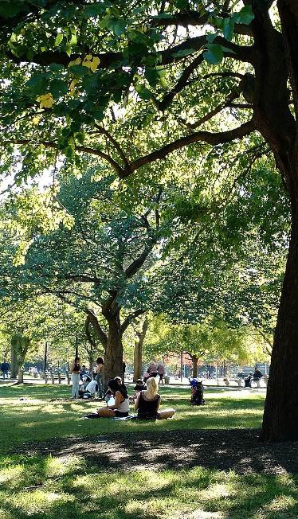
Image: Open Woodland Photo credit: Phoebe, 2018.

Statutory environment

Statutory planning

This section highlights a number of strategic and operational planning documents produced, or in production, by both state and local government authorities that interact or overlap the Albert Park Master Plan. Mentioned in this section is the Resilient Melbourne (Melbourne Urban Forest Strategy). The recommendations from this plan
directly influence the ecological recommendations within the plan including linkages and plant palette.

Strategic planning

State Government’s Plan Melbourne and the Fishermans Bend Public Space Strategy and Framework Plan have been carefully considered in the preparation of the Albert Park Master Plan, in relation to future neighbourhood planning and
maximising public benefit with the provision of open space. Consideration has also included the strategic direction of the City of Port Phillip and its open space and biodiversity strategies.

Other key documents considered through the development of the master plan include:
- City of Melbourne’s Urban Forest Strategy: Making a Great City Greener 2012 – 2032
- City of Port Phillip Open Space Strategy (2009)
- Inner Melbourne Action Plan 2016-2026
- Victorian Memorandum for Health and Nature 2017
- Victorian Public Health and Wellbeing Plan 2015-2019
- Protecting Victoria’s Environment – Biodiversity
2037
- Resilient Melbourne (2016).

As the master plan is implemented over time, it will be important to understand the context and influence of these and other documents including relevant local government municipal strategic statements and public health and wellbeing plans.

URBAN FOREST STRATEGY
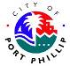



















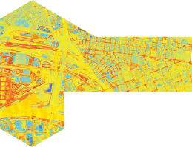


Making a great city greener 2012-2032

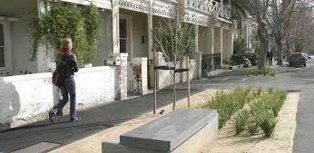



CITY OF PORT PHILLIP OPEN SPACE STRATEGY

- Community and stakeholder engagement

What we’ve heard

Parks Victoria thanks all local residents, park visitors, sports players, clubs and government agencies who contributed their ideas and views to the planning process.

Sports clubs and commercial tenants based in the park generally have some form of lease or licence agreement with Parks Victoria, and were invited directly to participate in the planning.
A dedicated project website was established at www.albertparkmasterplan.com.au. A postcard introducing the project was letter boxed in the neighbouring communities. Signs in the park raised the profile of the planning to regular visitors.

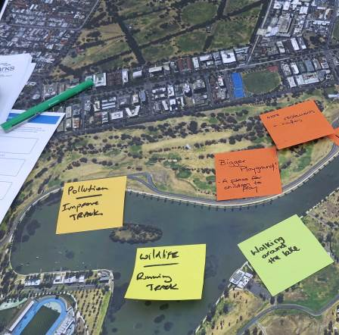
The initiatives listed in this master plan have been developed from and based upon comments and feedback received during the various stages of engagement and consultation between 2014 and 2018.

Phase One

What do you value in the park?

In the 2014 consultation, Parks Victoria sought feedback on what was important about the park, and what people thought needed to be addressed. Engagement opportunities included :
  - Three drop-in sessions by the lake path
  - Three forums – summer and winter sports clubs, lake sports clubs, and commercial tenants
  - An online map where people could provide information (received over 3,900 views)
  - Meetings with major stakeholders.
In response, we heard from more than 500 people and organisations. Feedback from phase one highlighted that many people consider the lake the heart of the park, and the lake walk is an important part of their daily or weekly routine. A key aspect of the park is that community-level sports build a sense of community contributing to health and wellbeing. A key consideration identified was a desire to cater for a greater number of sport participants, generally. Clubs using the lake talked about issues with aquatic vegetation and water level affecting their sports,
and about wave reflection from the lake wall. Some people stated their view of the importance of the park as “breathing space” in the midst of a rapidly growing city.

We heard that the park can be inhospitable on windy, rainy or very hot days and that much of the landscape lacked interest for those not engaged in a sport. We heard it isn’t always easy to get into or move through the park, and the park needs to be better prepared for climate change and an increase in participation in sport.

For detail on the consultation and findings, refer to the Albert Park Master Plan Consultation Report, 2017, located on the project website.
PROJECT INCEPTION

BACKGROUND REVIEW AND
FUNCTIONAL ANALYSIS PLANS

PHASE 1: STAKEHOLDER AND
1 COMMUNITY ENGAGEMENT
ISSUES IDENTIFICATION

PREPARE ASSESSMENT OF
SIGNIFICANCE

DRAFT VISION AND CONCEPT FRAMEWORK PREPARATION

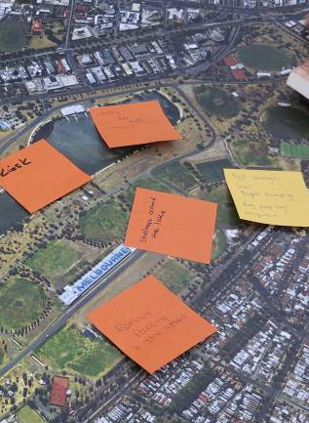

Image: Albert Park, Melbourne Photo credit: Parks Victoria, 2018.

PHASE 2: STAKEHOLDER AND COMMUNITY ENGAGEMENT REVIEW / COMMENT ON CONCEPT FRAMEWORK OCT 2016 - MAY 2017
2

DRAFT MASTER PLAN
PREPARATION

PHASE 3: STAKEHOLDER AND COMMUNITY ENGAGEMENT
3 REVIEW / COMMENT ON
DRAFT MASTER PLAN
NOV 2017 - JAN 2018

REVIEW FEEDBACK, AMEND AND COMPLETE FINAL MASTER PLAN
2019

Phase Two

Engagement on concept framework

The 2016 consultation tested community and stakeholder views on a series of ten “ideas” designed to address the issues and ideas raised in phase one.

Engagement opportunities included drop-in sessions by the lake path, facilitated workshops, meetings with stakeholders and an online survey.

More than 500 survey responses were received with support for all of the ten ideas. There was particularly strong support to “enhance the park’s landscape character, quality and habitat potential through additional planting.”

The ideas presented in phase two have been further developed to form the draft master plan. A report of the consultation findings is available on the project website.

Fitzroy Street workshop

During phase two of consultation, the section of the park that fronts Fitzroy Street was the subject of much discussion. Local resident groups were interested in how this section of the park, which is easily accessed but currently not highly visited, can
become a valued destination for local residents and visitors. Particularly given, the rapid increase in the residential population around the St Kilda Junction area and the redeveloped Victorian Community Cricket Centre at Junction Oval. A workshop was convened in May 2017 to discuss issues and develop the ideas into an outline concept. The output of the workshop was included in the draft master plan, for broader community comment in phase three.
Phase Three

Draft Albert Park Master Plan Engagement

In late 2017 the draft master plan was released for comment. A number of engagement opportunities were held, including drop in sessions by the lake path, meetings with stakeholders, facilitated workshops and an interactive online survey.

Feedback and comments were received from more than 2000 individual responses from a range of stakeholders, sporting clubs, community groups and individual community members.

What we heard

We heard strong support for the key concepts outlined in the draft master plan including:
- Widening and lengthening the lake side promenade
- Increase tree and shade through programmed planting and
- Retention of the 18-hole golf course and golf driving range in their current locations.

Phase 3 consultation closed in January 2018.

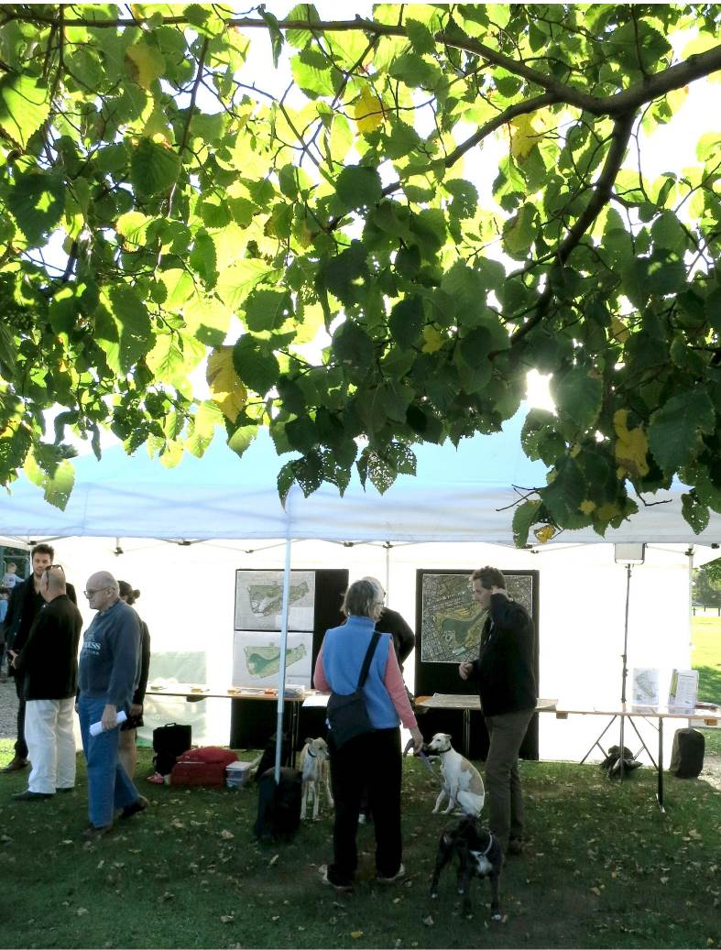
Image: Albert Park, Melbourne consultation
Photo cred it: Parks Victoria, 2018.

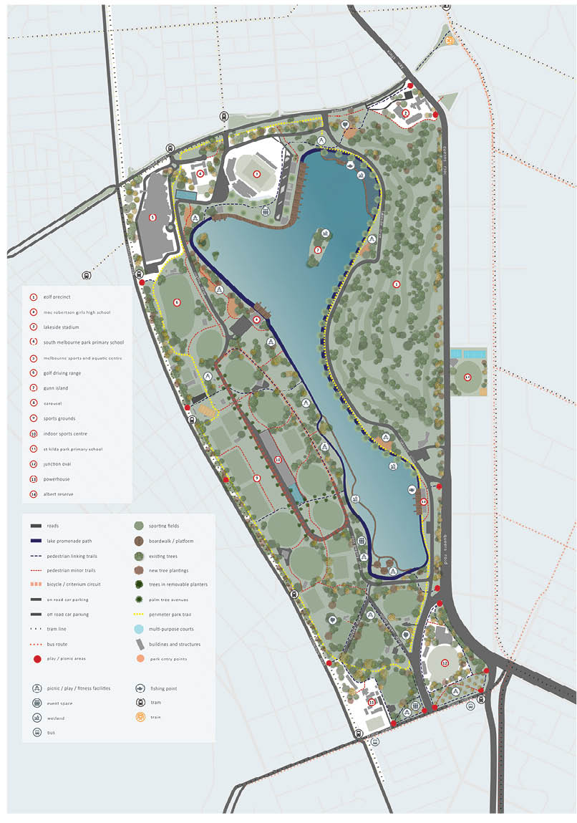
Page: 17

The Albert Park Master Plan

Melbourne’s iconic park

The Albert Park Master Plan establishes our vision to reinvigorate a highly utilised and loved public open space that caters to a great diversity of park visitors. Increasing population and greater public transport access will create pressures on the park, that the master plan responds to. Three themes have been developed to support the master plan vision: nature and environment; community connections; and healthy and active.

A major component of the plan is to increase the tree planting and to continue the work undertaken with the current planting strategy, providing landscape amenity and connecting habitat, shade and shelter. A broader and continuous lakeside promenade will create focus on the lake and increased wetlands. The promenade will be a journey interspersed with nodes of play and intense activity such as exercise stations and parkour areas.

The wetland area aims to connect people with nature and to invite exploration. Interwoven boardwalks will allow closer access to the wetland and lake, promoting the values of learning and investigation.

To cater to and increase the current level of sport and organised activation, the master plan promotes the upgrade and shared use of sports grounds and fields and associated facilities. This will include refurbishing and upgrading sport and playing areas to improve diversity of sport use.

A key focus for increased activation of the park is through promoting and ensuring clear, welcoming, safe, easily accessible and legible entrances and access into and around the park including from neighbouring roads and transport hubs. This includes access and thoroughfare for pedestrians, cyclists, both commuter and recreational, and other active participants such as joggers, dog walkers, young families, anglers and national and international visitors. Car parking will be consolidated to create efficiencies and, legible and accessible parking areas.

The master plan responds directly to a series of existing and current site factors including the
lake as a storm water receivable point, the spatial requirements and overlay of the Grand Prix event, the 18 hole golf course, the golf driving range, existing tenancies on the park and adjacent neighbours, as referred to on adjacent map.

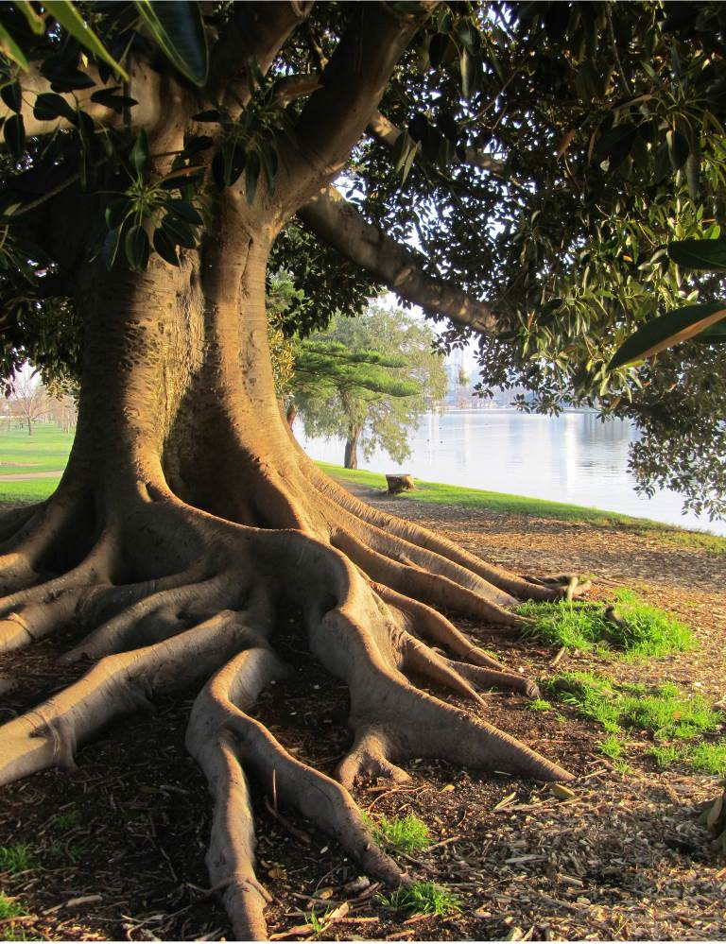

Page: 19
Image: Albert Park, Melbourne Photo credit: Parks Victoria, 2018.

Landscape character

Iconic landscape

The Albert Park landscape has a relatively flat, open and exposed character compared to other major metropolitan parklands such as the Royal Botanic Gardens and Royal Park. This is due to the natural topography, compounded by considerable
expanse of playing fields and the sizable lake. While this character of the park means that it is at times more exposed to climatic conditions, it also creates notable views across Melbourne’s skyline.

At 225 hectares, the Albert Park is one of the largest public green spaces in inner Melbourne, therefore
a consideration for ‘no net loss’ of open space may be required for its sustainable future to support a rapidly growing city. The principles guiding ‘no net loss’ of open space will be developed and defined through the implementation stage of the master plan. The park provides nearly 60% of the City
of Port Phillip’s public open space (Open Space Strategy, 2009. City of Port Phillip) and plays a critical environmental role as the “green and blue” lungs within its dense urban setting.

Albert Park needs to continue building on its sense of place and identity, and create more defined
spaces to achieve a sense of protection and personal retreat.
Establishing a cohesive landscape character

Albert Park is a significant urban park. The various landscape types provide visitors with a number
of different opportunities and landscape settings, within which to interact, socialise and recreate.

The master plan aims to build park resilience through strengthening the park as a healthy urban ecosystem. This can be achieved by transitioning to landscape plant species of greater resilience that are better able to adapt and cope with climate change. This will provide a broader diversity of settings and a long term sustainable and cohesive landscape park experience.

Additional trees will strengthen and define the park character and will provide more shade which will help cool the environment and mitigate urban heat island effects. Tree and plant species are selected through a process of investigation and understanding of which species respond to the changing climate conditions as well seeking to address the larger issue of the Melbourne urban forest fragmentation of urban canopy, currently an ongoing concern in Albert Park and other large parks.

The overall canopy density within the Albert Park will be enhanced through increased planting with a preference for selection from a native plant palette. Work done by City of Melbourne through
their Melbourne Urban Forest Strategy will directly feed into this approach. A common conservation approach is to create or improve connectivity by restoring habitat using corridors, “stepping stones” and buffer zones.

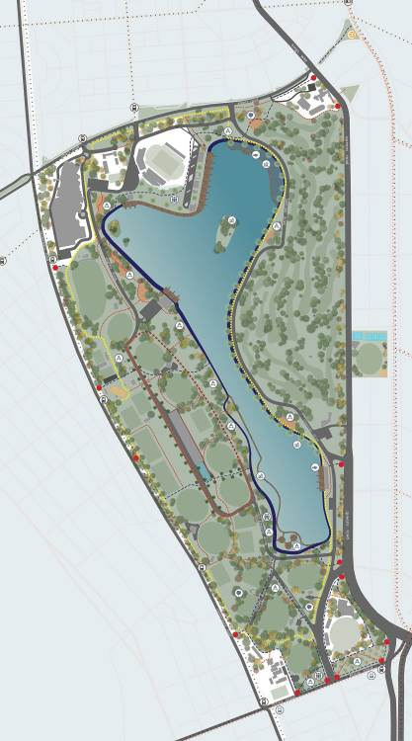
Theme one - Nature and environment

8.1 Future direction – protecting and enhancing landscape values

Initiative 1 – Albert Park landscape character types

The master plan describes the future conditions in terms of the landscape character and function. The intent is to work with the park’s existing features, qualities and values to create a range of diverse settings, suited to different visitor’s needs.

Albert Road boulevard plantings
6

eastern woodland and golf course
3

eastern woodland and golf course
3

avenue plantings
5

open woodlands and sports fields
2

the lake and lake edge
1

perimeter planting
7

indigenous restoration
8

Fitzroy Street precinct
4

1 The lake and lake edge

The lake is a central feature of Albert Park and the Lake Promenade following the lake edge will be the primary destination for visitors.

The objective for the lake perimeter is to soften the south-western edge of the lake with new wetlands consisting of marshy and reedy areas of variable depth and inundation. This aims to provide a rich aquatic habitat and an inviting fringe for visitors
to explore, via a weaving and interconnected timber boardwalk, complete with picnic decks. The marshy vegetation surrounding the edge location of the original swamp will be expressed with a contemporary landscape treatment. The wetland areas will be created and planted with indigenous species that will provide habitat for fauna such as fish, birds, insects and reptiles.

The lake is fed by stormwater runoff gathered from neighbouring suburbs and plays an important role in storing and treating storm water, and capturing litter prior to overflowing into Port Phillip Bay.

The additional wetland planting will further assist in the cleaning and re-use of storm water from
surrounding neighbourhoods, providing a source for park irrigation and trap litter that bypasses the gross pollutant trap that washes in with the storm water,
and is able to be collected from the lake to reduce the amount entering the bay.

The wetland plants will play an important role in filtering and cleaning the lake water by removing contaminants and nutrients. They will help reduce wave reflection, reducing erosion around the lake bank and contribute to a reduction in water turbidity and reduce the impact of waves on rowers and sailors.

Boardwalks will link aquatic nature play spaces with picnic decks nested amongst the reeds. This will enhance the experience of the aquatic environment to provide opportunities to learn more about the role of water in the urban environment and connect with nature.

The design and implementation of the wetlands will be developed in consultation with lake users to mitigate negative effects on rowing and sailing.

Plant communities will vary along the length of the lake edge and will respond to the wetland character in the specific location, be that native or
exotic plantings referencing the original indigenous landscape or the recent European history, creating a range of settings for visitors to enjoy.

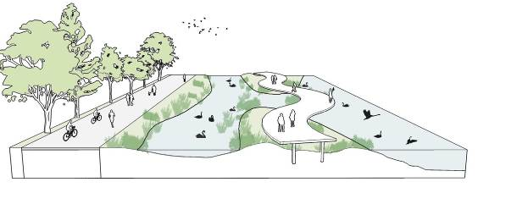
Image: Concept Planning- Wetlands Image credit:

- Open woodlands and sports precinct The open woodlands will consist of sports grounds interspersed with an open mixed canopy of native
and exotic trees, planted in informal clumps with a
low grassy under storey. Framing ovals and sports grounds, the open woodlands will occupy the ‘spaces in between’ providing a shaded environment for spectating, picnicking, relaxing and informal active recreation.

The open landscape character is an important aspect of Albert Park and has the advantage of providing notable views across to Melbourne’s skyline and provides good general visibility, passive surveillance and a sense of personal safety.

A disadvantage of the open landscape is that the park can feel very exposed to the natural elements on windy or hot days and the sparseness of tree canopy means some park areas lack shade. There is an opportunity to provide smaller areas with
increased tree planting and shelter as retreat spaces.

The establishment of an open woodlands is a long- term whole-of-park objective to be implemented considering existing constraints and current and future uses including current leases and major events. Where the objective is to provide tree lined avenues or shade within areas that are affected
by existing functions, alternative planting options and consideration for provision of trees includes relocatable planters.

Tree selection will vary from large native to exotic shade trees providing a broad canopy, to those with a narrow canopy structure, where it is important to reflect and build on heritage plantings. Low under storey plantings will complement the majestic lake promenade tree lined avenue.

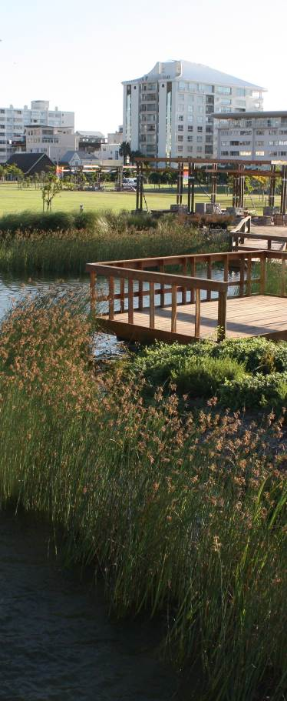

Image: Wetland edge - Green Point Associates Photo credit: Abu Shawka

Further, the planting will enhance the park character and quality. Plantings, particularly those near paths or facilities, will consist of native grasses and small shrubs to maintain clear sight lines in accordance with Crime Prevention Through Environmental Design (CPTED) principles. Increased tree canopy
will provide a pleasant contrast to the open fields that characterise much of the park and provide the co-benefits of shade, climate change mitigation, increased biodiversity and a setting to promote general health and wellbeing.

New planting will increase biodiversity values and enhance habitat. These improvements will create habitat for attracting canopy specialist birds such as Pardalotes, Thornbills and Gerygones, as well as mid-canopy specialists, such as Whistlers, Grey Shrike-thrush and a variety of robins. Increases in
these host species may lead to the return of cuckoos to Albert Park, four species of which have been historically recorded, but none in the past 20 years.

An area just north of the golf course and away from adjacent paths is allocated to be home to a
range of under storey planting heights, from low to three metres high, to further aid in increasing the biodiversity of this area (CPTED principles will be applied).
The open woodlands will create settings that offer new visitor experiences and extend the directions developed by neighbouring City of Melbourne in its Urban Forest Strategy: Making a Great City Greener 2012–2032, which aims to increase the tree canopy cover throughout Melbourne.
Along the western boundary of the Albert Park, immediately south-east of MSAC with its native plantings and grassed landscape setting, and adjacent to the Community Playground, a nature play area will be established in the open woodland. Adjoining the south end of the lake and surrounding Ross Gregory Oval, the open woodland will connect the leafy urban space along Fitzroy Street with the lake.

Open woodlands planting will be a mix of native and exotic trees with a low under storey. Trees will be chosen for their tall height, open form and shade provision. The tree palette will be broadened to provide greater variety and interest in the park, taking into account adaptability for climate change.

Avenues through the open woodlands will be consistent in species type to provide a uniform approach to tree planting within the park and clarity in way-finding.

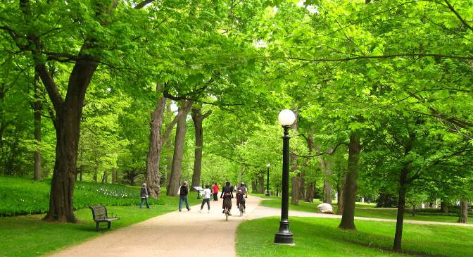
Image: Open woodland
Photo credit: Creative Common





























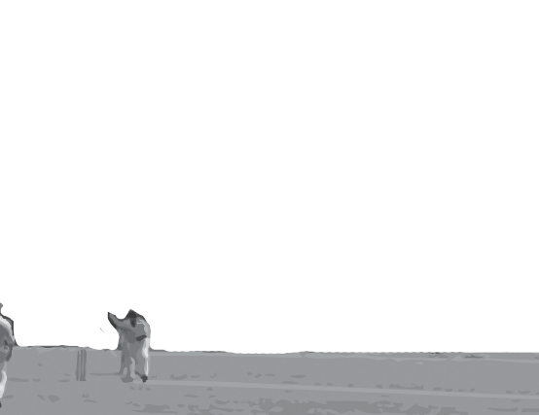










- Eastern woodland

The eastern woodland setting encompasses a large portion of the eastern side of the park as the golf course, currently to remain. It is a distinctive arrangement of bands of shade trees within open
space. It takes advantage of the mature trees in this area, that provide a backdrop for the park and a buffer from Queens Road. It will provide a tranquil setting, that can be experienced by visitors playing golf.

The plantings in this woodland landscape form part of the larger urban forest that will provide an
ecological buffer within Albert Park, connecting the woodland canopy to the larger city urban forest canopy to create habitat corridors and help to mitigate adverse effects of climate change.
Public access exists along the eastern woodland to north of the golf course bounded by Albert Road and Lakeside Drive and MacRobertson Girls High School.

- Fitzroy Street precinct

The landscape treatment in this area provides for a functional space for small to medium-scale
programmed community events such as markets, community or local school gatherings.

This will be a leafy urban space characterised by a grid of trees with joining canopies that provide shade and dappled light supporting an open space for community events.

As part of the City of Port Phillip Fitzroy Street street- scape upgrade, Fitzroy Street will be lined on each side with a row of plane trees. A second row along the Albert Park/Fitzroy Street boundary will create a strong avenue character, and behind this second row will be multiple rows of exotic trees with touching canopies.
Tall exotic tree species with clear trunks will provide shade during hot weather, and allow the warm sun to filter through the canopy during the colder, winter months. Low garden beds will provide additional visual interest and separation, and increase the biodiversity of this urban park setting. The pavement surrounding these trees will be a hard wearing
and resilient permeable pavement treatment to accommodate a high volume of activity and foot traffic.



















Image: Sporting Render- Albert Park Photo credit: Cam Bergmeier

- Avenue plantings

Broad tree-lined avenues will provide defined access and connect the primary entrances to the park and the Lake Promenade located at the centre of the park. Generous in width to cater for a mix of walkers, joggers, cyclists including maintenance access, the avenues will provide a range of seating and facilities that take advantage of the shaded environment. The avenue planting strategy is a long-term objective
that will be implemented in a staged fashion over time to ensure that current use and events are not compromised. Alternative planting options will be considered in areas that are constrained.

Ultimately, once established, the planted avenues will form modest thoroughfares, providing a strong visual and physical connection to the lake.
Tree selection for the avenues will be a key component of the planting approach. Avenues will use a mixture of proven and new species to increase diversity and provide habitat to encourage bird species to return to Albert Park.

- Albert Road boulevard

A broad tree-lined boulevard with a wide separate shared pedestrian cycling path prioritises sustainable travel and strengthens the east/west connections between Anzac Station and Port Phillip Bay. The
aim is to enhance the identity of Albert Park by strengthening the planting along its perimeter with a mixture of species.

A row of trees will line the park boundary, supplementing the majestic boulevard street trees. The selection of native and exotic trees will be chosen for their tall height, wide canopies and resilience to the specific climate.

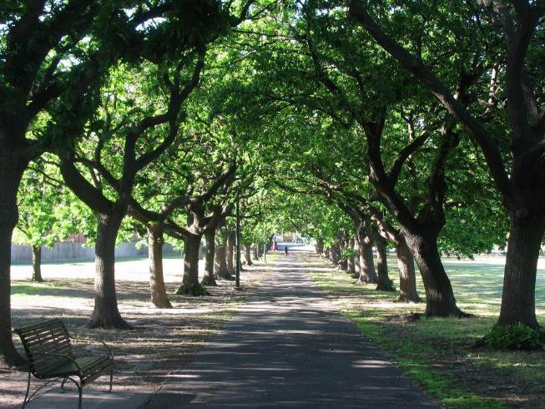

Image: Tree-lined avenue Photo credit: Abu Shawka, 2018

- Perimeter planting

The master plan aims to enhance the identity of Albert Park by strengthening the planting around its perimeter with a mixture of species. Perimeter planting will ensure a uniform and distinguishable edge to Albert Park from all sides. It will provide
a sense of arrival through which visitors move to reach the more expansive open woodlands that will characterise the majority of the park. Perimeter planting will include species that are considered street and road plantings in adjacent neighbourhoods.

Perimeter plantings will make the boundaries of Albert Park highly recognisable, guiding visitors to the park entrances and will reflect the character of the adjacent areas. Existing stately tree plantings along Albert Road will reinforce the shade providing boulevard tree character.

Perimeter planting along the northern length of Queens Road reinforces the existing elm avenue and transitions to native plantings just over half- way along, to reinforce the regeneration of native plantings of the existing Red Gum Triangle and Ngargee Tree environs.

Fitzroy Street interface planting will reference the Fitzroy Street streetscape upgrade with broad, exotic shade trees.

The full extent of the Canterbury Road perimeter will continue with a mix of native plantings and trees for shade and increased biodiversity.
The restoration of the indigenous plant community at the Red Gum Triangle will support natural regeneration of species and ensure the full range of indigenous plant types are established at the
site, including low ground covers, mid-height under storey and trees.

The future management and landscape response will respect and respond to the aspirations of the
Traditional Owners of this area and further works will be undertaken in collaboration with the Traditional Owners.

Planting Objectives
Key objectives for tree planting may include:
- Establishing a continuous spreading canopy with trees to have stately form and depict strong avenue aesthetics
- Trees planted in blocks, along evenly spaced lines to create an avenue effect
- Maintain a continuous rhythm of tree planting with trees planted directly opposite each other along parallel lines
- Clear trunks to ensure clear sight lines
- Hardiness and drought tolerance are important considerations in the selection of plant species.

Action:

Include in the planting approach and methodology for Albert Park, a plant palette developed through canopy mapping of both the park and surrounding areas which contain the specific and individual landscape character types and plant species associated with individual feature and zone plantings.

8 Indigenous restoration

The master plan supports an approach for a flourishing indigenous under storey at the Red Gum Triangle and promotes indigenous planting through to the area surrounding the Ngargee (Corroboree tree).

The aim is to enhance the original identity of the landscape of Albert Park by strengthening the indigenous plantings in this small, little-known pocket of the park. Extending indigenous plantings further into the centre of the park along the southern perimeter of the lake gives this area the recognition it deserves.

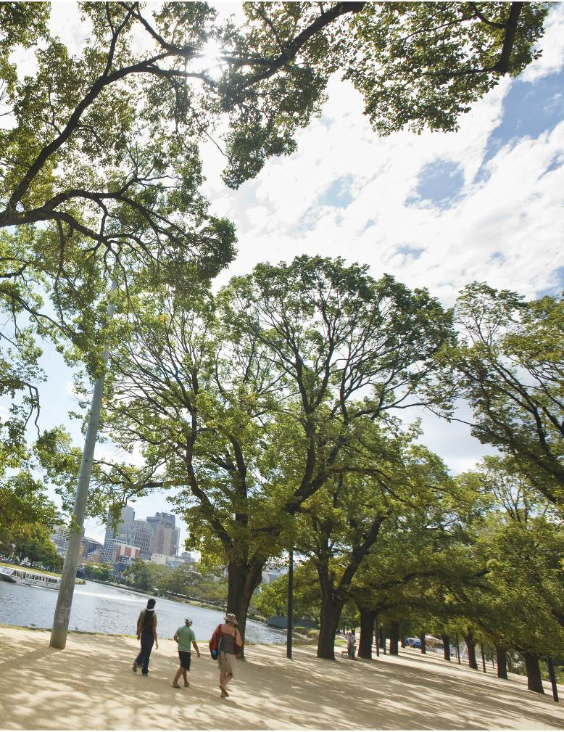

Image: Birrarung Marr Photo credit City of Melbourne, 2018

Initiative 2 – Albert Park planting strategy

Cities are known for their contribution to the ‘heat island’ effect – where the large amounts of
absorptive surfaces combined with materials of high thermal mass result in cities storing heat, reducing comfort over the summer months as referred to in the Victorian Health and Wellbeing Act, 2008.

The City of Melbourne’s Urban Forest Strategy 2012– 2032 clearly identifies the benefits and importance
of trees and their vital link to the health and well being of communities. These include:
- Environmental – shade and mitigation of the urban heat island effect
- Community – encourages outdoor activity which leads to greater positive impact on the community
- Economic – positive impact on tourism and decreasing health costs.

Building on the excellent work started by the City of Melbourne and the City of Port Phillip with
respect to an Urban Forest Strategy, the master plan recommends the planting approach for Albert Park aligns with the current urban forest principles to guide the establishment and expansion of vegetation throughout the park over the long-term and support the case for ongoing carbon sequestration. This includes undertaking a study on the existing canopy coverage and thermal heat mapping conditions to provide detailed information for areas requiring
a greater amount of tree planting, to understand which areas of Albert Park are most vulnerable and should be modified to lower temperatures.
The reduction in paved surfaces and additional planting has a direct impact on countering this effect, improving the summer comfort for visitors to the park, and those residing in surrounding buildings.

Specifically selected and located trees, to be planted, will provide a lasting legacy to be enjoyed by future generations. The planting strategy will be reviewed
in consultation with existing events, lessees and organisers with a long-term vision for a greener Albert Park.

The current tree canopy at Albert Park comprises approximately 25% native and 75% exotic trees scattered in open lawn and grassy precincts and trees planted in avenues and rows that delineate current and former roads.

The ongoing selection of trees and ground covers will seek to address the native/exotic tree balance and draw on the previous 100 years of plantings
in and around the park, inspiration from the indigenous flora of Port Phillip’s coastal hinterland and a contemporary approach to address the climate change over the next 100 years. It will extend existing patterns in the park as the basis for establishing the different landscape characters.

Emphasis will be placed on the selection of tree
and plant species that are able to thrive in the more frequent temperature extremes, which will occur with climate change. Further reed beds within the lake filter storm water, provide additional habitat, and soften the urban edge to reframe a more natural, innovative urban ecology.

The planting approach should aspire to the following objectives:
- Utilising Albert Park as a heat sink, mitigating the impacts of the urban heat island effect through a long-term vision for a mature and established collection of trees
- A park landscape which provides a wide range of settings to support a diversity of visitor experiences
- Species which will be resilient to climate change
- A variety of exotic, native and indigenous species, suited to the specific site conditions
- Maintain formal planting patterns and historically important trees in select locations, to express connections and heritage, and to define and identify key locations such as the Palms Lawn and Pinetum
- Enhance indigenous conservation areas within the park to increase biodiversity and habitat values.

Action:
Review the planting strategy for Albert Park to consider the landscape character types, plant species and to increase plant numbers to provide improved shade, shelter and amenity relevant to visitors across the park including sport fields. The planting strategy provides direction and principles to guide the location for different plant community types and succession planting to respond to climate change impacts.

Initiative 3 – Learning in nature

Albert Park will provide an inviting and engaging environment to support various learning programs. It will provide an extension to local schools, providing a space for outdoor classrooms.

The master plan aim is that Albert Park will provide a critical connection between nature and health, providing physical, mental, social and economic health and wellbeing benefits. These benefits are well documented by the Victorian Government and referenced in appendix A: Policy context under the Victorian Public Health and Wellbeing Plan 2015- 2019.

Parks Victoria has developed a learning in nature plan outlining programs and initiatives that will reinvigorate the education and interpretation offer available in Victoria’s parks, including Albert Park. The plan includes a range of programs to enable learning in nature, such as the Wild Cities program, Urban Nature ‘Learn-scapes’, Junior Ranger program,
Citizen Science and Digital Discovery tours. The plan also supports Traditional Owners to share cultural knowledge and experiences with visitors and the local communities.

A low-key nature education area adjacent to and facilitated by the South Melbourne Park Primary School provides a space where children can learn about the interaction between nature and the environment in an urban park setting. The low-key nature play space will be accessible and available to Albert Park visitors.

Action:
Implement ‘learning in nature’ programs to complement the Albert Park setting, in
collaboration with partner organisations. Work to deliver programs and initiatives that engage and connect various sectors of the community in healthy park programs.

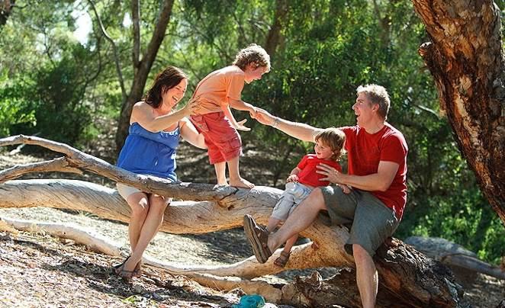
Image: Brimbank Park, Melbourne Photo credit: Parks Victoria, 2018.

Initiative 4 – Maximise use of sustainable materials and resources

Increasing the use of sustainable materials and minimising the park’s overall consumption of resources is a priority for management.

Parks Victoria will aim for all new buildings and works to meet a high environmental standard and star rating for energy and water use including insulation, passive cooling, water tanks and solar panels. Parks Victoria will aim for a net zero emissions from all new lighting in the reserve.

Supporting the implementation of this initiative will be a set of design and development parameters
to adhere to and that align with the principle of material and resource sustainability. The new Parks Victoria office at Albert Park will be exemplar in sustainable design to meet and support ongoing sustainable objectives.

New leases and development agreements provide a key mechanism for government and Parks Victoria to enforce improvements. Design and development parameters, are to be developed to provide a key
reference tool against which all future developments and works must be assessed.

Action:
Develop guiding principles for future management and potential development of any asset or feature within Albert Park to meet with responsive sustainability principles and best practice guidelines.

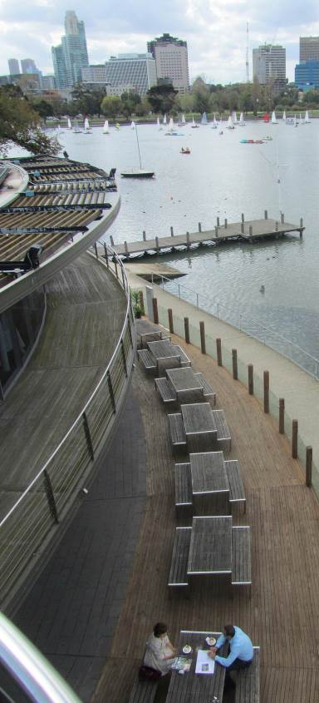
Image: Albert Park, Melbourne Photo credit: Parks Victoria, 2018.

Initiative 5 – Improve social sustainability

Albert Park will be a central metropolitan park venue used to explore opportunities with volunteer and partner organisations working to deliver programs that engage and connect various sectors of the community in healthy park programs.

Albert Park brings millions of people together every year. The master plan aims to encourage the sense of connectedness and community within the diversity
of people who visit the park. Sports clubs play a vital role in building sense of team and sense of community for those engaging in structured sports.

Volunteering allows the community to share a common sense of place and social connectivity. It affords beneficial social interaction, communication and learning in a shared space and rich park environment.
Action:
Deliver programs in collaboration with partner organisations that develop and improve the aims and aspirations of a socially sustainable
environment across all sectors of the community.

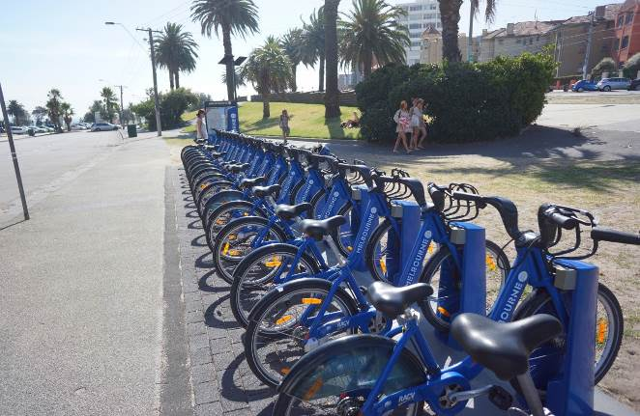
Image: Melbourne City Bike Share, St Kilda Photo credit: City of Port Phillip, 2018.

Initiative 6 – Celebrate the importance of the lake as the centre of the park

The lake sits at the centre of Albert Park and is a major body of fresh water that plays a key role in the network of parks in and around Melbourne. The
lake defines and distinguishes Albert Park from other large open spaces around Melbourne. The water provides a focus for recreation, supporting sailing, rowing and fishing. It affords views to and across
the water and engagement with the benefits of increased access and proximity to fresh water.

The lake has an important ecological function and service, for the storage and treatment of storm water captured from surrounding neighbourhoods.

The master plan aims to reinvigorate the lake surrounds, with a new lake edge, boardwalk and the expansion and enhancement of the existing wetlands. This will provide a range of different ways for visitors to engage more closely with the aquatic environment.
Action:
Deliver a new and holistically integrated interface with the lake and lake edge that focuses on the environmental wetland aspects with consideration for pedestrian and water craft access.

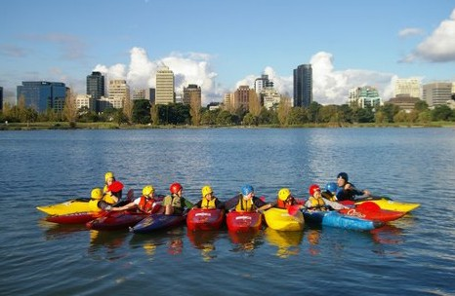
Image: Albert Park, Melbourne
Photo credit: City of Port Phillip, 2018.

Initiative 7 – The lake promenade as the primary destination

The Lake Promenade will be a generous path around the lake’s edge. It will incorporate both the existing ‘lake path’ and the ‘lake circuit’, as they currently referred. The aim of combining these two paths is
to improve the accessibility and quality of the park’s primary destination.

The aim of widening the lake promenade is to better accommodate groups of walkers, families, runners, casual and family cyclists and will be similar in width to the “Tan” track around the Botanic Gardens
(6.5m wide). Trees located between the two existing paths will be retained and incorporated in the Lake Promenade.

Wherever possible the Lake Promenade hugs the lake edge, ensuring a continuous relationship between users and the lake. In two locations where the lakeside venues, sailing clubs and boat sheds are located, the Lake Promenade will divide into two. This will provide a continuous path for jogging,
running and casual riding away from the conflict with rowing and sailing rigging areas.

Lakeside venues and sporting clubs have an important interface with the lake edge that is critical to their success and operations – be that lakeside dining or boat launching. The experience by casual strollers and families walking continuously along
the lakeside section of the wide Lake Promenade will be enhanced by consolidating car parking away
from the lake edge. The dedicated boat rigging areas will also be separated from the continuous lakeside promenade.

The Lake Promenade will be extended as a continuous gravel pavement, to measure five kilometres in length and be ideally suited to training schedules and distance events such as fun runs
and the weekly ‘Park Run’. Additional lighting will be provided to allow for safe, extended use in the shorter day winter months.
The Lake Promenade will provide direct access and connections to a range of activities, including:
  - picnic areas, play spaces and fitness stations that relate to the local context of the park
  - fitness nodes including the fitness park
  - board walks through the lake reeds with associated platforms
  - cafés, restaurants and event areas
  - boat harbouring and rigging areas.

Action:
Improve and extend the existing lakeside path to a five kilometre-long lakeside promenade to act as a signature destination for the park.

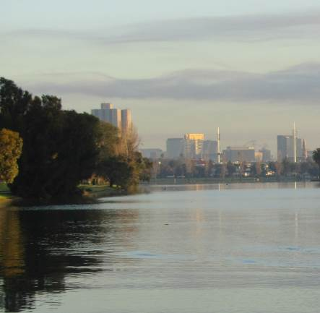

Image: Albert Park, Melbourne Photo credit: Parks Victoria, 2018.

Initiative 8 – Support lake recreation

The aim of the master plan is to increase lake recreation as Albert Park Lake remains an important asset for water based activities.

In addition to existing recreational and competitive lake activities, specific approaches will be considered to aim to maintain the lake at a depth with suitable clearance for sail boats, and enable a rowing course through the centre of the lake. An increase of a
range of recreational opportunities will be explored such as kayaking and canoeing.

With the full length of the lake currently being utilised for sailing and rowing, the southern end of the lake will include passive recreation activities.
A wetland area will offer the experience of a small channel to invite further exploration.

Fishing is an important recreation activity on the lake and will be enhanced through addition of fishing platforms.
Action:
Support an increase in lake and water craft activities that align with Albert Park broader activation objectives including recreational fishing.

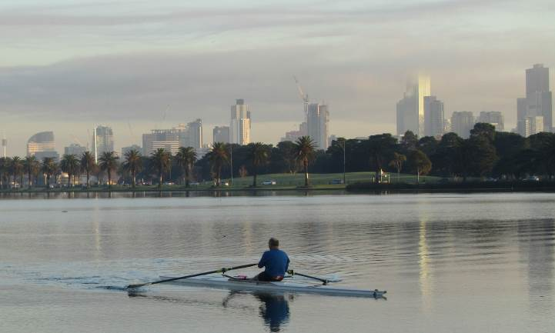

Initiative 9 – Wetland boardwalks

A meandering timber board walk will traverse the wetlands to provide an opportunity for visitors of all abilities to access and interact more closely with
the wetland. The aim of the board walk is to include opportunities for visitors to pause and enjoy the surrounding environment, particularly on boardwalk platforms that appear to float and provide unique picnic opportunities.

Wetlands play an important role in maintaining the health of the lake and will provide a great opportunity for visitors to explore and learn about the value of wetlands in water filtration, nutrient
stripping and erosion control. The lake will provide a diverse ecosystem and habitat for a range of aquatic and bird species.

Reminiscent of the original pre-settlement landscape, new wetlands at the north and south end of the lake look to re-establish the indigenous plant species including trees, sedges and water plants, providing habitat for birds and aquatic life. The wetland will be constructed on the landward side of the lake wall and extend into the lake. There is an opportunity to explore the wetlands from the lake’s perspective as a kayaker.

A timber boardwalk encircles the wetlands at the Albert Road/Lakeside Drive end of the lake, providing an opportunity to experience the interface between the wetlands and the lake. These new wetlands
are an integral component of the storm water treatment system, and will build upon the existing smaller wetland system where, through a series of wetland-based treatment ponds, local storm water is collected and filtered by the wetlands. This reduces flows of untreated storm water into Port Phillip Bay, contributing to the ongoing health of the bay.

Further investigation with sailing and rowing clubs will be required in developing the design and location of the wetlands and boardwalks to mitigate potential impacts for yachting and rowing.

Action:
Deliver an integrated wetland and boardwalk system to facilitate access and experience of the lake environment and wetland ecosystem.

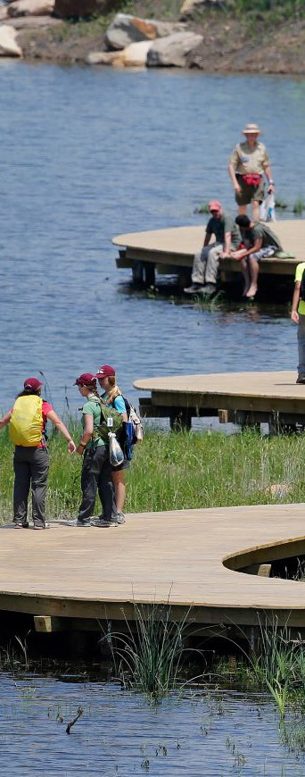
Page: 37
Image: Summit Bechtel National Scout Reserve wetland boardwalk Photo credit: Nelson Byrd Woltz Landscape Architects, 2018.

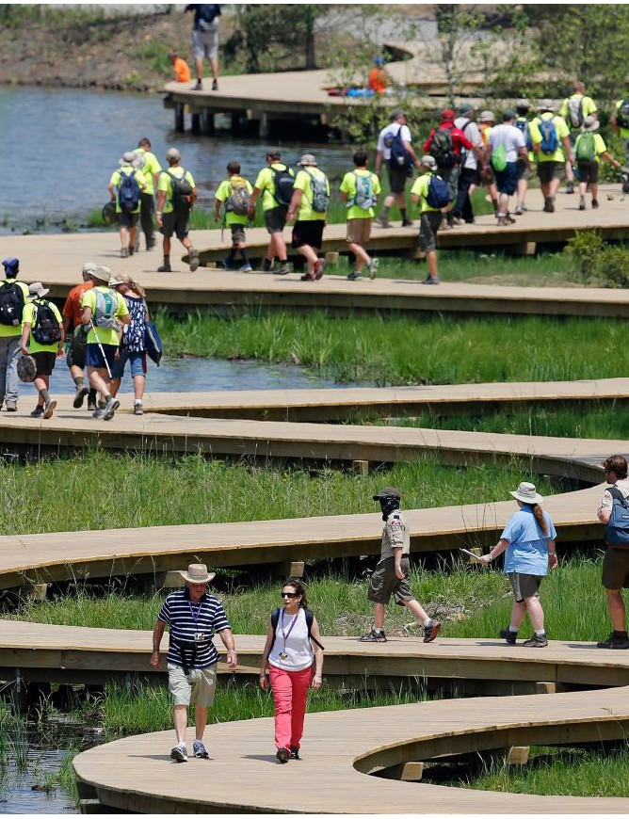
Page: 38

Initiative 10 – Gunn Island
Initiative 11 – Wetlands play and recreation

Gunn Island, a central feature in the lake, will be retained. The island vegetation will be sensitively managed so that it can provide a safe refuge for roosting and breeding water birds and other fauna. The absence of feral cats and foxes on the island, coupled with very low levels of human disturbance make it an important site for bird life in a busy park setting. Retaining the island as a refuge is important for maintaining populations of the lake’s iconic Black Swans and other birds and animals.

To further enhance the lake’s conservation values, the conservation zone around the two smaller islands will be retained and managed to ensure the safety and protection of native animals and their habitat.

In addition to the wetlands, the surrounding parkland provides habitat for a number of bird species and native mammals and is an important source of food for many species. This habitat is
enhanced through additional plantings along the lake shore.

The focus on using native trees and shrubs, indigenous to this area, assists in supporting habitat for native species ensuring they can continue to thrive in the urban environment.

Action:
Develop and retain Gunn Island as a safe refuge for flora and fauna and maintain a management approach for the preservation and protection of Gunn Island and other islands that form part of Albert Park Lake.
Located along the Lake Promenade and close to the gateway from Queens Road, the wetland play space adds to the range of play experiences dotted around Albert Park.

The wetlands play space will provide a simple and engaging experience in a natural lake setting. The attraction may be centred around the interplay and control of water via water sprays, through building channels and dams and opening sluice gates.

Action:
Deliver a wetland play space that engages and connects with the various sectors of community, particularly children, in line with the healthy parks program.

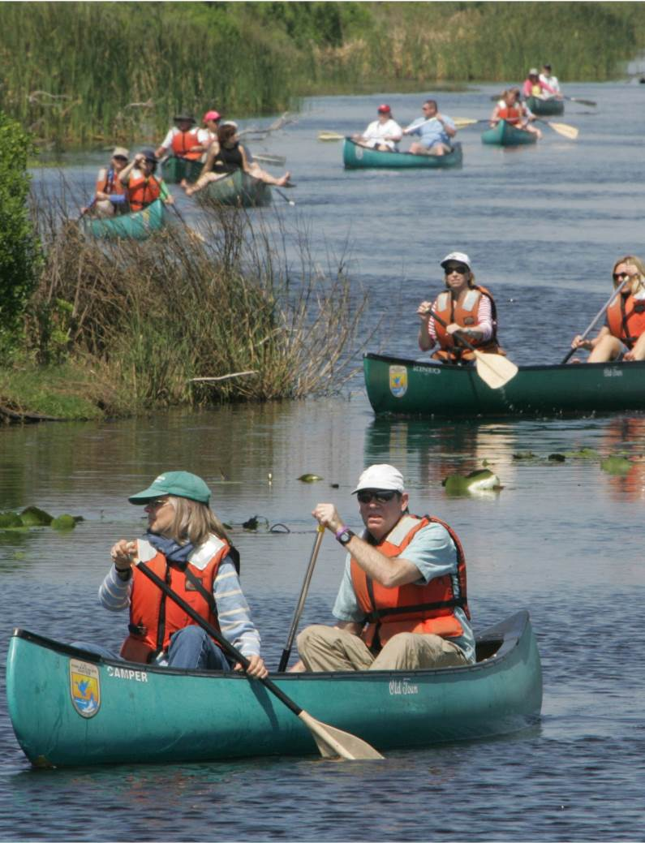
Image: Water+based activities
Photo credit : Page: 40

Theme two – community connections

A community parkland

Albert Park provides a vitally important setting
for people from all around Melbourne to connect through formal sports, recreation and enjoyment of the open space it provides for a range of leisure activities.

In order to continue to meet community needs, Albert Park will need to be flexible, to adapt to the ways in which visitors choose to recreate, as different sports become more popular, new activities emerge and the demands on park infrastructure change.

Visitors to Albert Park currently arrive by walking or cycling from neighbouring suburbs, by public transport or by travelling in private vehicles. Albert Park is uniquely positioned to access a wealth of public transport and active transport and travel options.
Big changes

Big changes are needed to better cater for the dramatic increase in visitation that is projected for Albert Park. Locally, the City of Port Phillip population is projected to grow by 48.49% by 2041.

Albert Park must evolve over time to ensure that it continues to be an attractive place for people to come together, relax and enjoy sport recreation. There may be current functions that do not contribute to Albert Park’s core park values, that could be shed. These are propositions the master plan responds to and that will shape the future of Albert Park.

City of Port Phillip projected population growth


Year 2041

Population: 168,549

Year 2018
Population: 113,512

= 1,000 people

= 500 people

48.49%
population growth

  - Future direction - a welcoming park for everyone

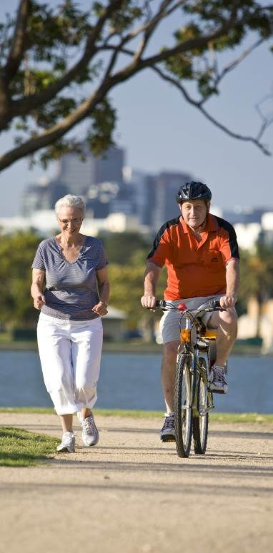
Albert Park is serviced by a broad cycling network, four tram lines, bus stops and the new Anzac underground railway station. Bicycle routes from the City of Port Phillip direct cyclists through Albert Park on their way north to the centre of Melbourne and surrounding areas. The relatively flat topography provides for all abilities access.

The greatest barriers to visitation are poor access, significant barriers to pedestrian movement and poor signage, particularly along the park’s eastern boundary. Providing better access and permeability along the eastern edge of the park through to the lake, is a key challenge.

In future, as transport technologies change, a continuing shift is anticipated away from private vehicle use towards walking, cycling and public transport, ride sharing, self-driving vehicles and other as yet unknown forms of transportation. Albert Park will need to adapt to these trends and accommodate new transport technologies as they establish.

Furthermore, as a valued part of Melbourne’s open space network, Albert Park will be an exemplar for access via sustainable transport, providing a diverse range of options for visitors to travel to and within the park, highlighting its sustainability function as identified in the City of Port Phillip ‘Move, Connect, Live’ Draft Integrated Transport Strategy 2018–28.

Roads and car parking infrastructure currently comprise approximately 5% of the park by area. Consideration must be given to the flexibility and performance of these assets for functions other than transport.

Image: Albert Park, Melbourne Photo credit: Parks Victoria, 2018.

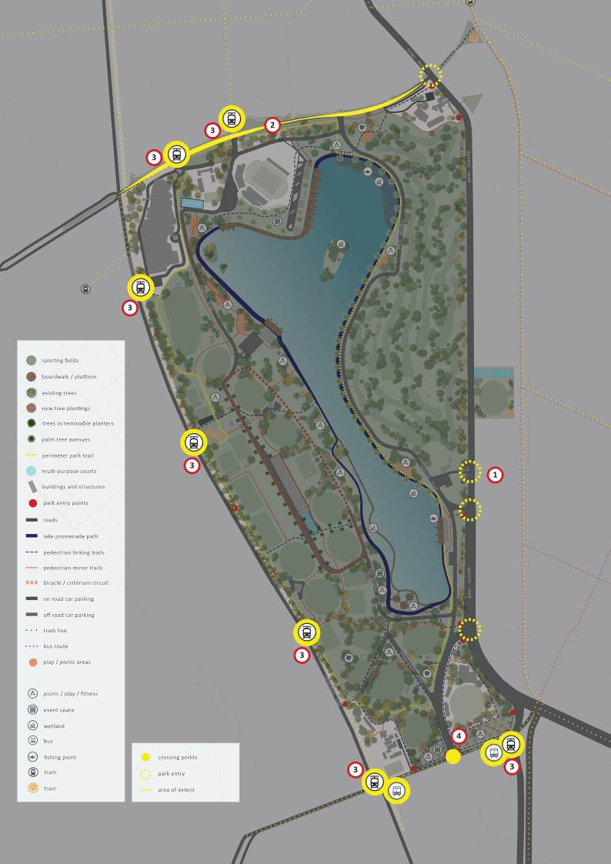

0 50 100 250

Page: 43

Park interface

    - Initiative 1 – upgrade Queens Road at grade pedestrian crossing points

The master plan identifies an upgrade of the at- grade pedestrian crossing over Queens Road, at the intersection of Lorne Street. This will help connect the residents of St Kilda Road and Prahran with the park. All other existing at-grade pedestrian crossings across Queens Road will be retained.

Action:
Consider safe access to Albert Park from Queens Road at the Lorne Street crossing and other potential at-grade pedestrian crossings along Queens Road to provide improved levels of accessibility.

    - Initiative 2 – Albert Road boulevard

The aim in the master plan is to connect Albert
Park into the fabric of its surrounding urban setting.
This can be achieved by landscape treatments and tree planting that fits with the character and
palette of Albert Park. This can include a tree lined avenue accommodating wide, separated cyclists and pedestrian paths, all connecting back into the park. With the changes at Anzac Station, there will be an increase in public transport commuters in the immediate vicinity.

Action:
Extend the park character to Albert Road to intuitively identify Albert Park as a key park destination.

    - Initiative 3 – prioritise public transport connections
along Fitzroy Street. The aim for these entrances is to prioritise them as pedestrian entrances. This
will include providing safe plantings, amenities and lighting to cater to higher use.

On-site parking will be reconfigured over time to encourage sustainable transport methods whilst catering for required park dependent needs, in alignment with the City of Port Phillip’s Sustainable Transport Strategy (2014).

Planning and design of infrastructure will enhance the convenience and efficiency of access by public transport. A long term strategy will be developing planning controls, leases and agreements that will preference sustainable transport options for park leaseholders and events.

Action:
Prioritise Albert Park’s pedestrian access and public transport nodes and hubs.

    - Initiative 4 – Fitzroy Street access enhancement

An aim of the master plan is to encourage a stronger connection between the residents, workers and visitors from the Fitzroy Street precinct, St Kilda Junction and Albert Park through the strengthening of the park entrances at Fitzroy Street and Queens Road.

Action:
In collaboration with government partners work together toward the enhancement of existing pedestrian crossings along Fitzroy Street, including the underpass access from St Kilda Road Junction, at the intersection of Queens Road.

All public transport stops that directly border the
park will provide an integrated, seamless connection into the park. The master plan aims to make the most of the number of existing and proposed public transport options including an improved connection to the new Anzac station. Of the six tram stops that directly border the park, two are located along Albert Road, three along Canterbury Road and one

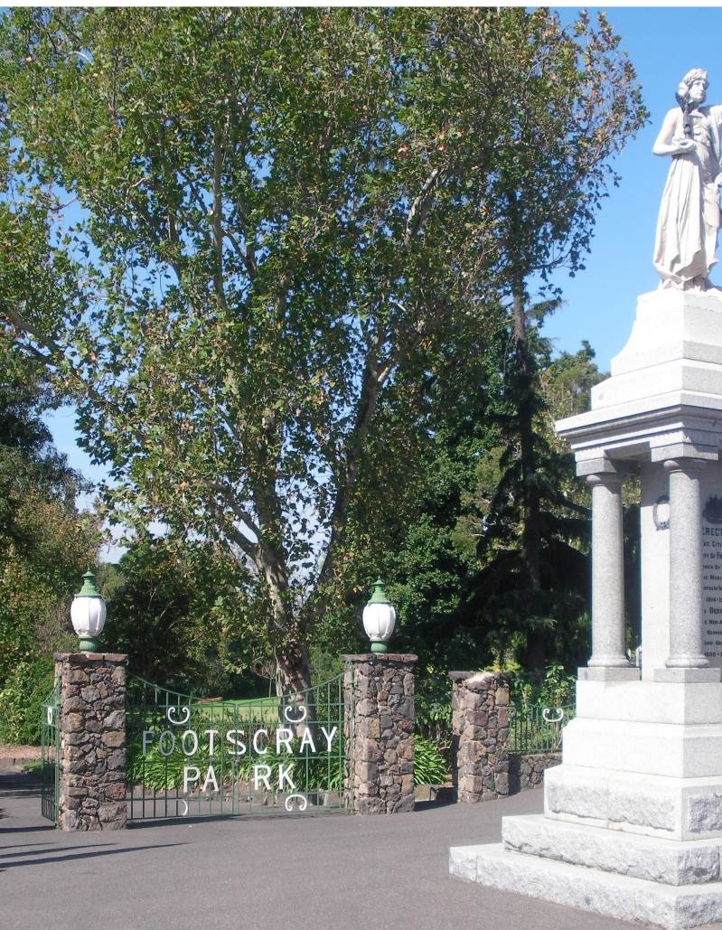

Park entrances

Initiative 5 – clearly define park entrances

The master plan defines primary and secondary entry points that require specific landscape treatment to make them more identifiable as welcoming and open entrances to Albert Park and to increase visibility, accessibility and safety.

      - Primary entry points
Primary entry points act as ‘signature’ entrances
– they provide highly identifiable main access points into Albert Park, for pedestrians, cyclists and vehicles. Tree-lined pedestrian avenues lie adjacent to road entrances, which will provide wide, clear and safe threshold and entrance points.

      - Secondary entry points
Secondary entry points are identifiable as more informal access points into Albert Park, suited to regular users requiring efficient, direct and convenient access to their destinations within
the park. These entrances are consistent in style with each other, but exhibit a local planting character. The secondary entrances will be enhanced with path widening and landscape treatment to provide safe and inviting access.

Each entry will respond to its specific conditions while remaining recognisable as one of many possible entry points. Garden beds with a mixture of tree and low shrub plantings will help define each of the main entrances, while different species, colours and textures will differentiate entrances from each other. Through variations in planting, each entrance will be distinct and memorable along its boundary, while ensuring clear sight lines are maintained based on Crime Prevention through Environmental Design (CPTED) principles, by addressing the principles of passive surveillance and legibility.

Entrances will include high quality signage and information to assist with way finding around the park.

Action:
Define and formalise park entrances with dedicated planting, clear and safe access and easily definable destinations.

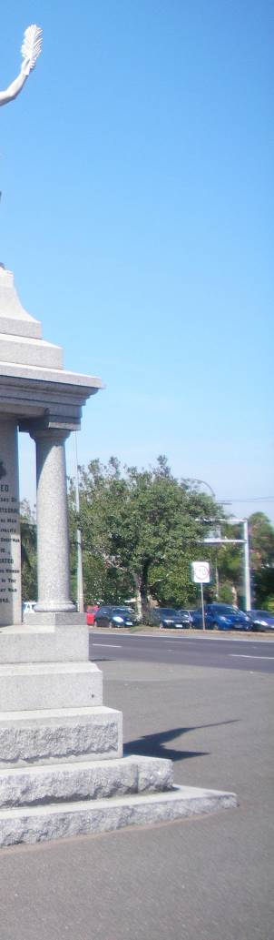
Image: Footscray Park entry, Melbourne Photo credit: Parks Victoria, 2018.

Page: 46

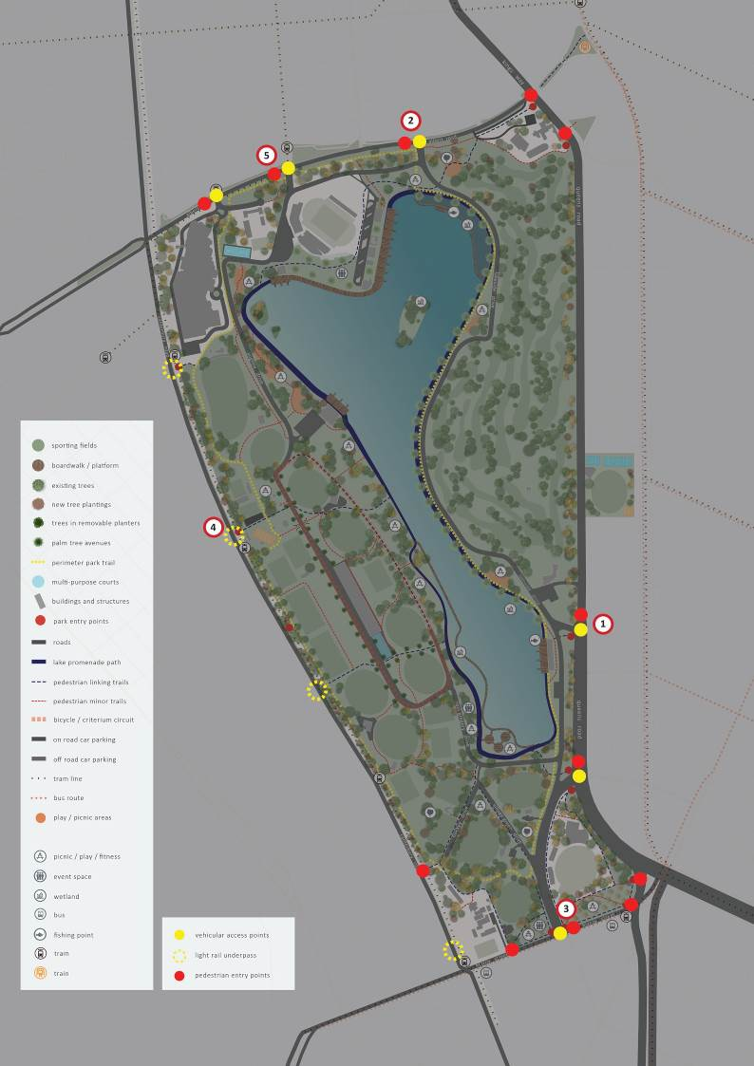

0 50 100 250

Page: 47

Getting to the park

Initiative 6 – define primary accesses

1 Primary Access – Lakeside Gateway The primary access point from the east will be the Lakeside Gateway, located at the intersection of
Queens Road and High Street, which provides direct
access to the Lake Promenade near the Powerhouse building. The Queens Road slip lane pedestrian crossing will be retained.

4 Primary Access – Canterbury Road
The primary entrance on the western edge of the park will retain the existing underpass entrance at Middle Park, and also has dedicated vehicle access. This primary access will be supported with a series of secondary entrances located adjacent MSAC (underpass), Langridge Street (underpass) and Canterbury Way Reserve (underpass). An additional at-grade light-rail crossing exists at Fraser Street.

- Primary Access – Lakeside Drive

A new primary entrance will be established along the Albert Park boundary, between Queens Road and Lakeside Drive. This will provide a generous, high volume entry point for visitors arriving from the new Anzac Station wishing to access the eastern edge of the park.

A second primary entrance will be established on the western side of Lakeside Drive capturing visitors arriving from north of the park.

- Primary Access – Fitzroy Street

The Fitzroy Street entry provides the main entrance for visitors approaching from St Kilda, the foreshore and the proposed new tram super-stop. This entrance connects visitors from the leafy urban plaza landscape to the southern edge of the Lake Promenade along a wide tree lined avenue.

This entry is supported by secondary entrances at St Kilda Junction and adjacent to St Kilda Park Primary School.

Entrances adjacent MSAC and at Middle Park will integrate with the light rail tram stops, while all entrances align with adjacent pedestrian crossings on Canterbury Road. The Bay Trail integrates the commuter cycling network with the Fraser Street entrance.

5 Primary Access – Aughtie Drive

The former gates at the Clarendon Street entrance to Aughtie Drive are to be retained and celebrated as a historic marker. This entrance will provide access to Lakeside Stadium and the north-west corner of the park.

The Clarendon Road entrance will be supported by a secondary entry point at Cecil Street, providing
local access to South Melbourne Park Primary School and Melbourne Sports and Aquatic Centre (MSAC). Both of these entrances are serviced by existing tram stops.

Action:
Consolidate and revitalise existing park entrances as primary entrances and differentiate from informal secondary entrances.

Page: 48

Access the park

Initiative 7 – improve the light rail underpasses

A key strategy for improving access at St Kilda Junction and along the western boundary of the park is to work collaboratively with partners to provide welcoming, accessible, safe and well-lit underpasses. This includes the underpass at St Kilda Junction and along the Canterbury Road light rail at Melbourne Sports and Aquatic Centre, Middle Park, Langridge Street and Canterbury Way Reserve.

Upgraded underpasses will support connections to public transport nodes, day-to-day use by walkers and cyclists and more effective visitor arrival and exiting during major events such as the Formula One Grand Prix. This process will involve collaboration between Parks Victoria, VicTrack and the City of Port Phillip.

Consideration will be given to integrated artwork, designated street art locations, installations and urban design treatments (including lighting) to maximise passive surveillance and visibility, while mitigating the potential impacts of anti-social behaviour.

Action:
Work with stakeholders and Government agencies to improve light rail access points from Canterbury Road and St Kilda Junction.

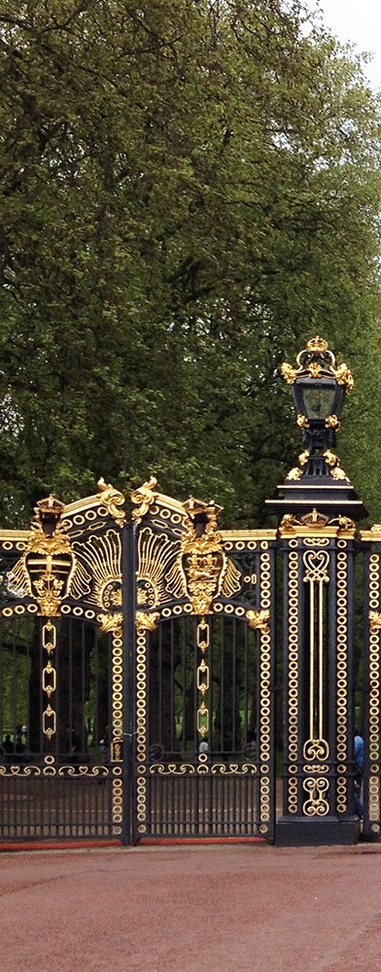
Page: 49
Image: Park entry experience, Canadian Gates, Green Park, London Photo credit: Parks Victoria, 2018.

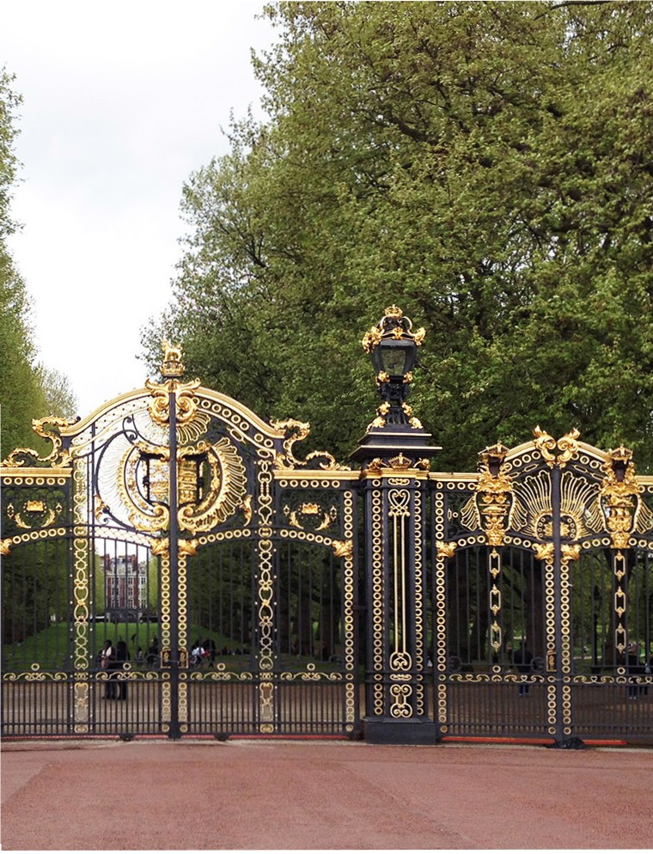
Page:50

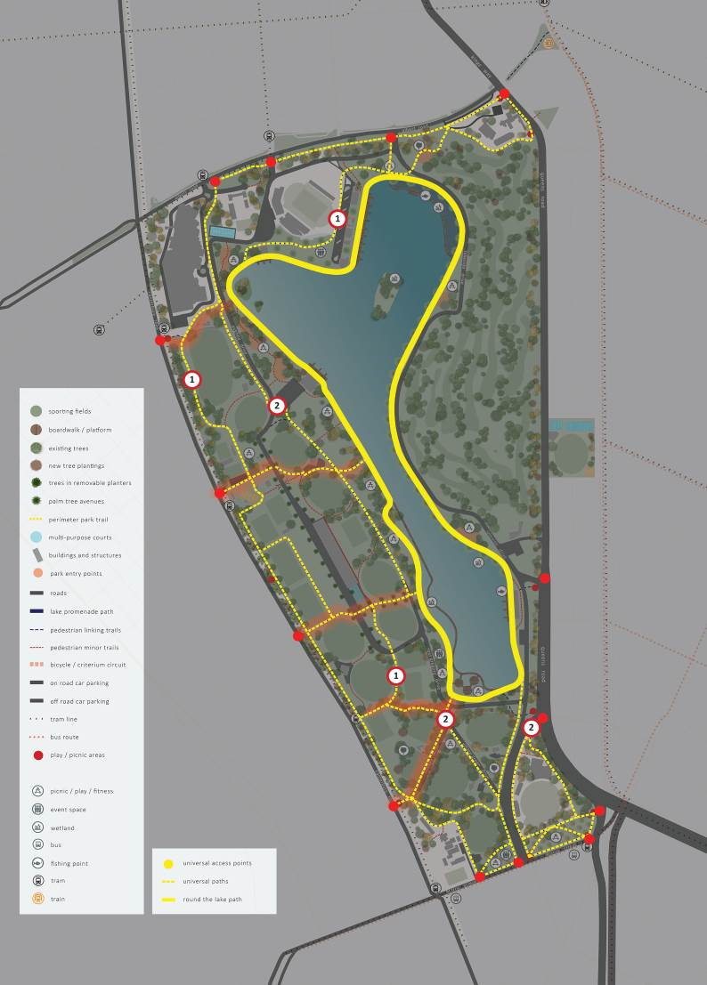

0 50 100 250

Visitor circulation

The primary visitor circulation path network will broadly consist of a perimeter loop path that connects to each of the entrances around the boundary of the park; the new Lake Promenade
and a series of tree-lined avenues that join the two. This provides a logical and legible framework for access that connects the path network to adjacent public transport and local bicycle networks. Quality trafficable surfaces will ensure that the primary path network is accessible to everyone. The provision
of lighting will provide safe access to main avenues from the park boundary to and around the Lake Promenade at all times of day.

- Initiative 8 – improving equitable, uni- versal access

Albert Park master plan aims to create an exemplar of accessibility and inclusivity by bringing the park’s paths and assets into compliance with requirements of the Disability Discrimination Act, 1992, the Victorian Disability Act, 2006 and industry codes and standards.

The path network and all facilities will be designed to the highest accessibility standards for people of all abilities, those with specific needs, for young people, the elderly and a diversity of cultural backgrounds and practices in line with principles in the World Health Organisation Age Friendly City Guidelines and Child Friendly Cities Guidelines.

The park’s relatively flat topography means that universal access to virtually all areas, facilities and buildings are possible. This includes integration with adjacent public transport stops, which will generate economic benefit through its appeal as an accessible destination for tourism and events.

‘Changing Places’ toilets and other specialist facilities will be incorporated to increase the park’s broader appeal to visitors.

Action:
Ensure the implementation of paths, access, assets and facilities comply and meet with universal access principles including all current standards.
- Initiative 9 – removal of barriers to pedestrian movement

Free and unobstructed ground level public access will be maintained to all areas of the park, including limited access to lease areas.

An objective of the master plan is to avoid the inclusion of fences, bollards, clutter and other barriers, as they limit access and at other times, obstruct the flexible use of open space. Alternative techniques for controlling access such as mounds, swales and vegetation should be considered in preference to structures.

Roads and car parks often create a psychological barrier to movement, discouraging access to certain areas. At-grade crossings and the prioritisation of pedestrians and cyclists at key crossing points and intersections is supported.

Action:
Remove and avoid landscape clutter, obstructions and psychological barriers to increase the quality of the visitor experience and ease and legibility of navigation through the park.

Page: 52

Visitor circulation

- Initiative 10 – enhanced lighting, signage and amenities

Best-practice lighting and signage strategies will be developed for optimum safety and performance for the primary path network at all times of the day. This will include providing for increased access and use
of the sporting fields, the Lake Promenade and other key locations.

The existing lights will be upgraded to meet with Albert Park’s growing objective of broader environmental and social sustainability.

Lighting upgrade to the underpasses is to be considered in collaboration with other government partners and the principles of Safety in Design and Crime Prevention Through Environmental Design.

A signage strategy will help to identify the park. It will provide a process for delivery of prudent distribution of:
- clear entrance signs
- clear directional signs
- interpretive and information signs
- regulatory signs.

A furniture manual will support the provision of high quality amenities including seating, picnic facilities, drinking fountains and other landscape furniture elements and add to the quality and significance of Albert Park as a primary visitor destination.
Signage will provide critical and useful navigation information that remains effective during major events or when park closures are in place. Another signage layer is to consider the identification of
key destinations and points of interest through the varying linkages to places beyond the park boundary.

Utilising current and future digital technologies will be an additional asset in providing interpretation and information to park visitors and users, and
will provide visitors with an insight into the park’s heritage and its natural and cultural values.

Action:
Deliver a whole of park landscape style guide including lighting and signage strategies to increase broader visitor activation and to foster a safe environment with easy navigation.

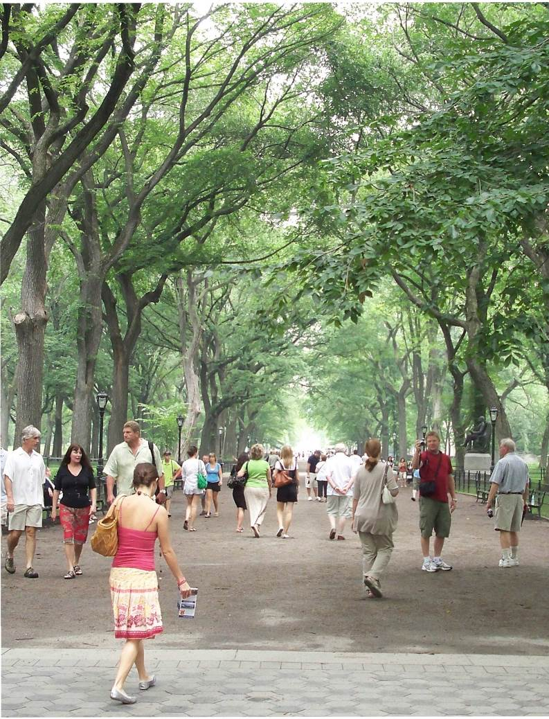

Image: Shaded Avenue- The Mall and literary Walk, Central Park
Photo credit. Ahodges7, 20l8. Page:54

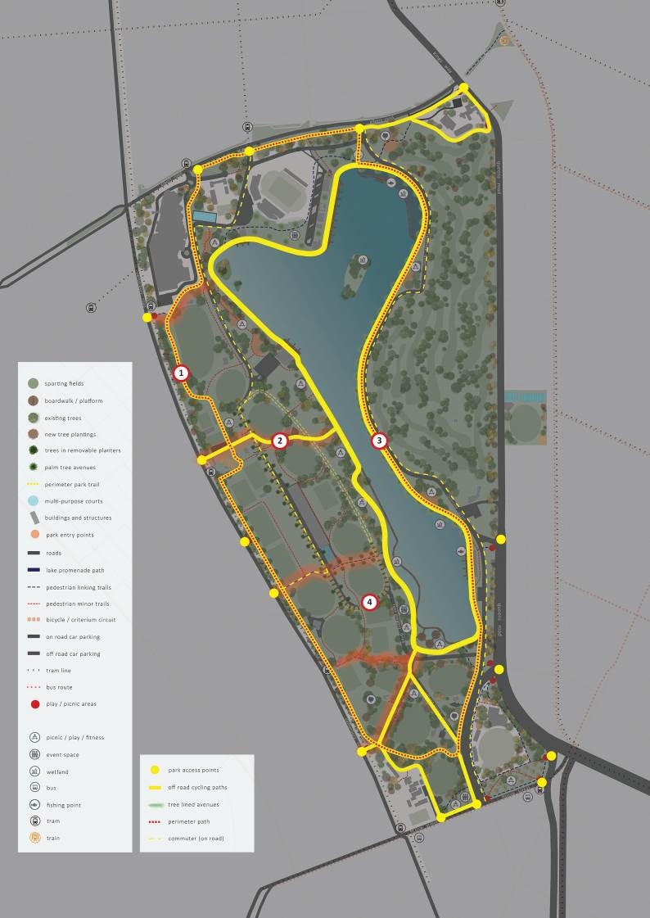
Page: 55

0 50 100 250

Visitor circulation

- Initiative 11 – promote perimeter path A perimeter path will utilise the existing path network with new, short, joining sections of path
as required to form a continuous 7km loop trail
for pedestrian and casual cyclists. The aim of this alternative path is to provide a quieter, sheltered and additional walking experience to the walk around the Lake Promenade. This loop trail will connect each
of the current entrances and connect with the Lake Promenade.

Any future changes to access through the Eastern Woodlands (golf course) could provide an opportunity to realign this section of path. Additional opportunity exists to further extend the length of
the trail by connecting the perimeter path/Lake Promenade with the nearby Royal Botanic Gardens ‘Tan’ track.

Action:
Create a park perimeter walking loop to encourage a walking experience to take in other aspects of the park.

- Initiative 12 – tree lined avenues

The master plan aim is to create tree-lined avenues to promote tree shaded walks and locations to sit and rest or watch sporting events. The tree lined avenues will help with orientation and identification of location within the park.

Generously proportioned tree-lined avenues will connect entrances to the Lake Promenade.
Pedestrian crossing facilities located at road crossings and aligning with these avenues will be improved (existing crossings) or provided (new).

In the short-term, events and access provisions limit tree planting in many areas and alternatives for tree planting will be investigated including relocatable planter boxes.

Over time, as park functions change, opportunity will be sought to establish avenues of mature shade trees and planting beds to help formalise the avenues and further provide shelter and shade.

Action:
Deliver an increase of avenue tree planting as a component of the overall Albert Park Planting Strategy with particular reference to avenues and other key structured and formal tree plantings.
- Initiative 13 – an integrated cycling network

Bicycle paths and access will be improved with new on-road bicycle lanes and greater access to an off- road path network.

An objective of the master plan is to provide greater connectivity to the local bicycle networks north
and south of Albert Park, and improve bicycle access within the park for casual, recreational and commuter riders including ‘arm powered’ hand- cycling. This aims to strengthen the connections from Moray Street, and with the Bay Trail increasing the universal access opportunities for all abilities.
This approach supports the Victorian Government initiative called ‘Shrine to Sea’, to create a boulevard connecting the Domain Gardens to Port Philip Bay
to promote and improve cycling and pedestrian links along Albert Road and connection into Albert Park along its journey.

Within the park, the generously proportioned primary path network will provide sufficient width to cater to a broad range of users, including casual and family riders. Commuter cyclists will be discouraged from using the western cycling path (a dog off-lead zone) and encouraged to use Aughtie Walk through Aughtie Drive. Casual and family leisure riders will continue to be able to cycle the western bike path.

On-road bicycle lanes will be integrated in both directions along Lakeside Drive to greater support commuter riders, and a city-bound bicycle lane along the northern length of Aughtie Drive will be provided subject to further consultation with VicRoads.

Action:
Implement improved bicycle paths and access including new on-road bicycle lanes and greater access to off-road path network.

- Initiative 14 – programmed cycling circuits

Through utilising existing road infrastructure the master plan provides for the inclusion of street and criterium circuits. Both will be programmed as part of the sporting offers within the park.

Action:
Provide a criterion cycling circuit as a component of the cycling network offer.

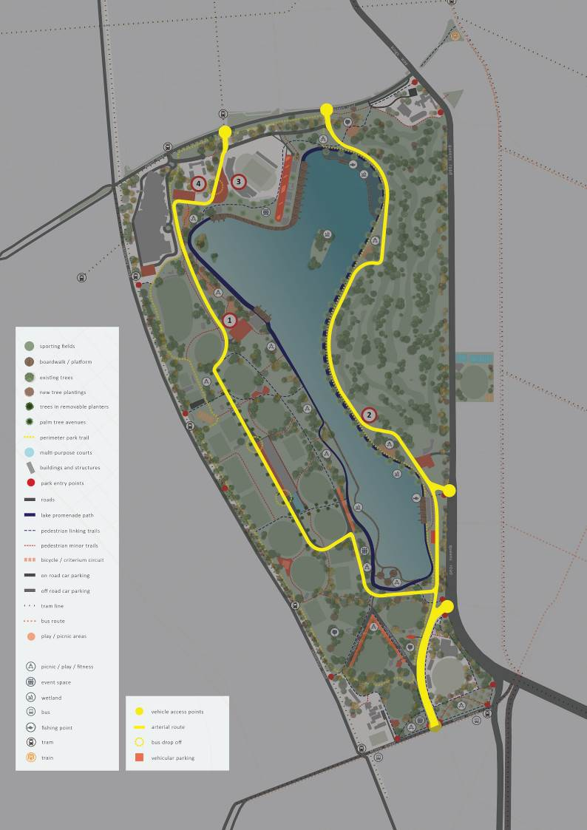

0 50 100 250
Page: 57

Vehicles

- Initiative 15 – rationalise vehicle access and circulation

The aim of the master plan is to encourage and support the Victorian Government direction for road users to regularly use public transport as the alternative to car travel.

The existing road network including the Grand Prix track will be retained, in recognition of its cultural, historic and tourism importance. Roads are viewed as an adaptable and flexible resource to provide opportunities for other community or social events. They can also support a more diverse range of functions over time and as demands change.

The separation between road, bicycle and pedestrian paths will reduce conflict. During events and on weekends when Lakeside Drive is closed to through traffic, the Golf Precinct Car Park will be accessed directly off Queens Road. Any event or weekend
road closures for Aughtie Drive will mean that car parking for the Sports Precinct will be via the light rail underpass.

- Initiative 16 – reduce vehicle through traffic

Reducing vehicle through traffic by initiating speed limit reductions within Albert Park, installing temporary road closures and reconfiguring a key intersection will help to make Albert Park more pedestrian friendly, safe and accessible.

Commuters use roads through Albert Park as alternatives to Queens Road. Unnecessarily high volumes of non-park related traffic through the park disrupt pedestrian access and park amenity.

While recognising the need for vehicular access and parking, particularly in the short-term, the master plan aims to reduce vehicle through traffic over time, in order to create a safer and more accessible pedestrian experience. Roads within Albert Park will reflect their context within a park environment, as distinct from the surrounding urban environment.
This will be achieved through a variety of traffic calming initiatives and methods, introduced incrementally over time, including infrastructure treatments, speed reductions, partial road closures and intersection reconfigurations.

The master plan recommends the investigation of:
- A reduction of the speed limit for Lakeside Drive to 40km/hr.
- Additional temporary road closures during weekends, on public holidays and non-peak periods to provide a car-free environment for cycling, community use and events. These strategies would be implemented incrementally over time, initially as a trial.
- The intersection of Lakeside Drive at Queens Road opposite Union Street will be reconfigured to direct city-bound Lakeside Drive commuter traffic onto Queens Road, to minimise vehicle through traffic in the park. The function
of turning left at this intersection and to continuing along Lakeside Drive in a northern direction to Queens Road slip road will remain. The addition of traffic calming devices will identify this section of road as a less preferred option providing cyclists priority of access through this intersection.

These measures will further support the approach to reducing the carbon footprint of Albert Park.

Action:
Reduce the volume of vehicle traffic and rationalise vehicle access and circulation.

Vehicles

- Initiative 17 – consolidate car parking

Car parking at Albert Park is to be considered as
a flexible resource which will change over time in response to demand, mode shifts to cycling, public transport and sustainable transport options, and with the emergence of new transport technologies such as ride sharing and driver-less vehicles.

In this context, the long-term strategy is to take opportunities through development proposals to rationalise car parking resources and maximise the provision of open space.

Car parking will be carefully managed through a needs-based approach with a clear preference for visitors with specific parking needs. These include people with disabilities, visitors with boat trailers
and local individuals who often carry large quantities of equipment such as coaches, golfers, trainers, umpires and local business operators.

The vast majority of other visitors access Albert Park for relatively short periods, primarily for drop-off and pick-up requirements. They are able to park within Albert Park for limited periods. Consequently, the majority of parking within the park should be short-term during the day, converting to longer- term parking at night time to improve access to park restaurants and cafés.

Car parking along Albert Road in the ‘Shrine to Sea’ master plan proposal (under development) will be developed with the Melbourne Metropolitan Rail Authority ‘Domain Precinct Development Plan’.

Lakeside car park
The master plan identifies restructuring Lakeside car park to provide a safer, greener and easier entry to Albert Park. Dividing the parking into two separate areas will provide better views to the lake on arrival. The parking for vehicles with boat trailers between the boating hub and Lakeside Stadium will be retained.

Action:
Consolidate visitor car parking and provide clear provision for other specific needs parking.

Page: 59
- Initiative 18 – drop-off and bus parking areas

Efficient car and bus drop off facilities will be required in order to minimise traffic congestion and maximise pedestrian safety. A dedicated car and bus drop-off and pick-up area in front of Lakeside Stadium will provide ease of access to the Albert Road precinct, utilise existing pedestrian crossings
whilst reducing traffic and the need for visitor buses to drive further into the park. This area will also cater for bus drop-off and pick-up for visiting groups such as other schools, and for the Melbourne Tourist Bus. Access to existing school car parks and dedicated entrances including to park neighbours such as Melbourne Sports and Aquatic Centre are retained.

Within the park, the master plan recommends that all new development proposals, including sporting club pavilions, consider the need for drop-off facilities to complement and offset the need of on- site parking.

Action:
Consolidate general and large vehicle parking and provide clear provision for specific needs parking, drop-off and bus parking areas.

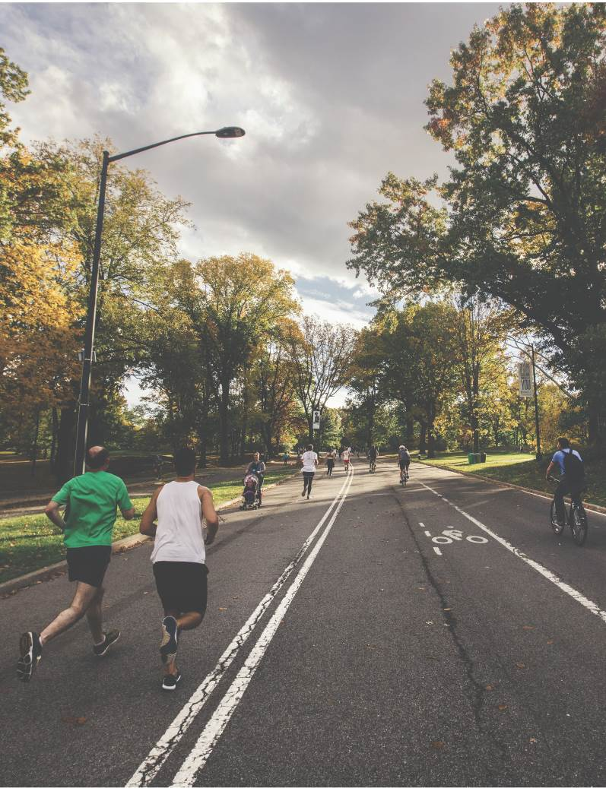
Image: Shared Pedestrian I Cycling I Road Networks
Photo credit: Ahodges7, 2018.

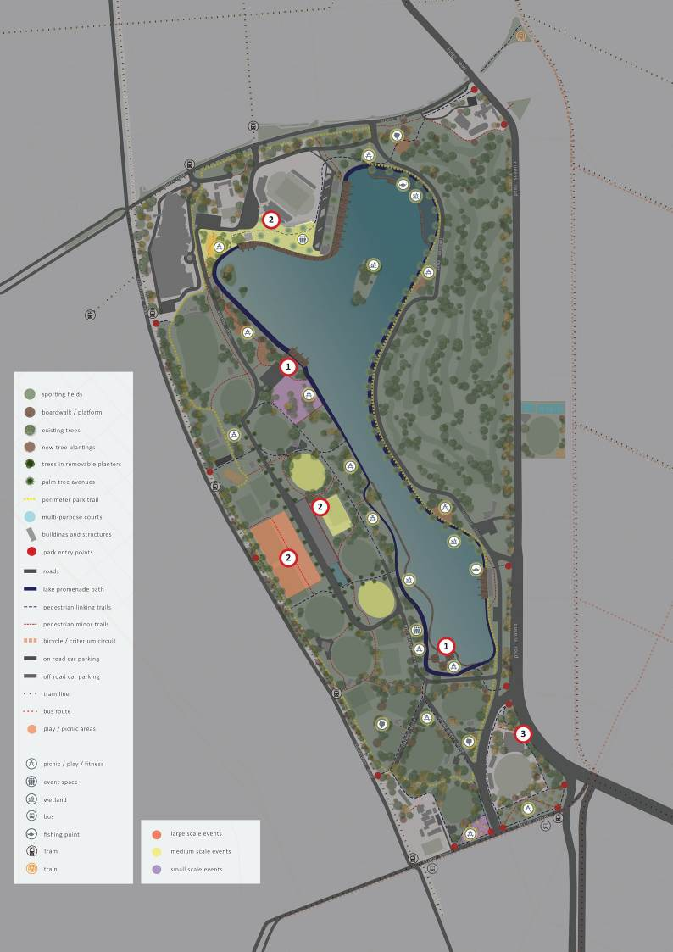

0 50 100 250
Page: 61

