My visit to Serendip Sanctuary

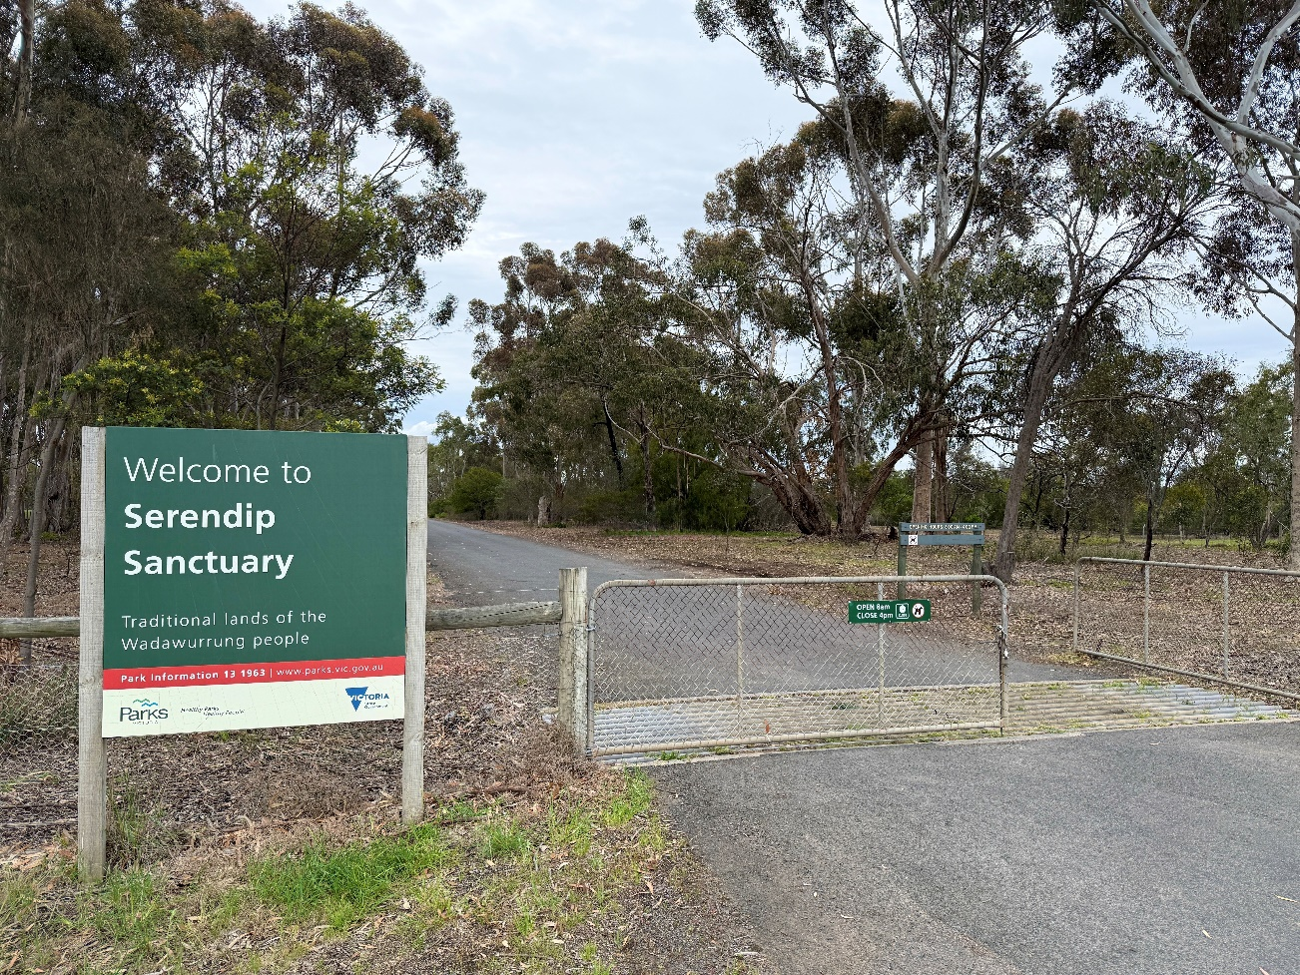

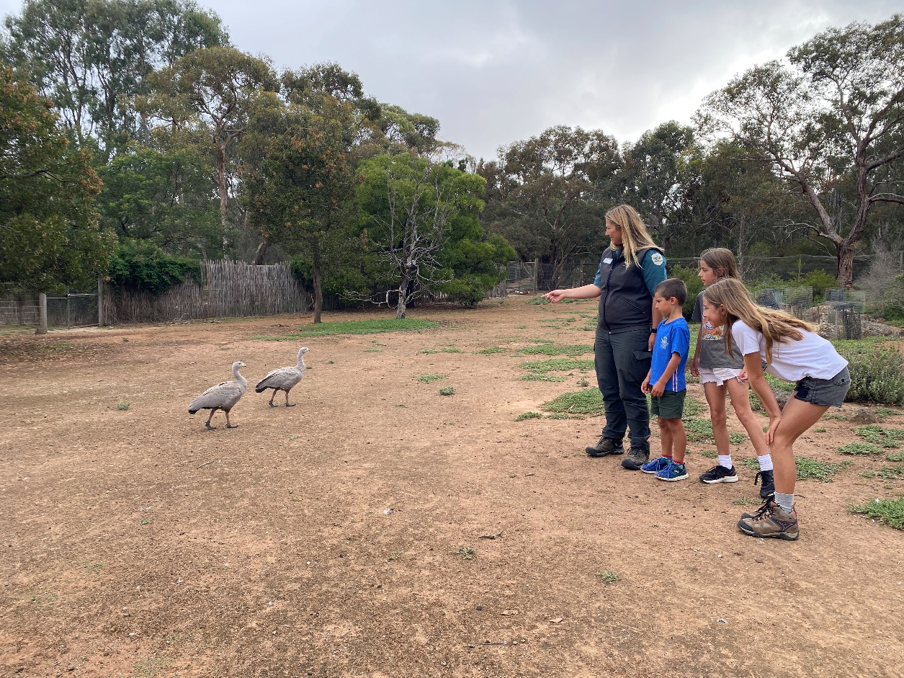
I am going to Serendip Sanctuary. A sanctuary is a safe park for Australian animals to live. Other people will be there to visit the animals too.

When I walk through the park quietly, I might see some of these animals.
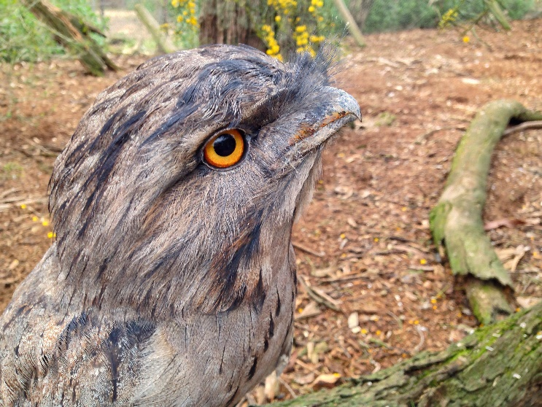
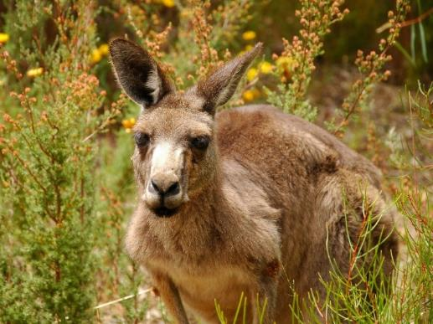

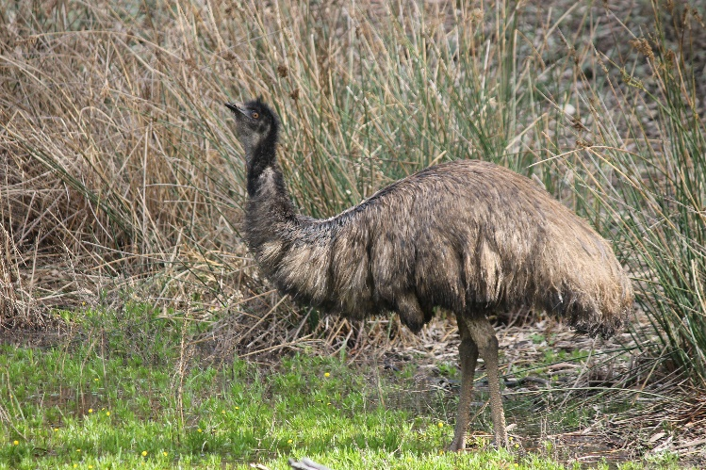
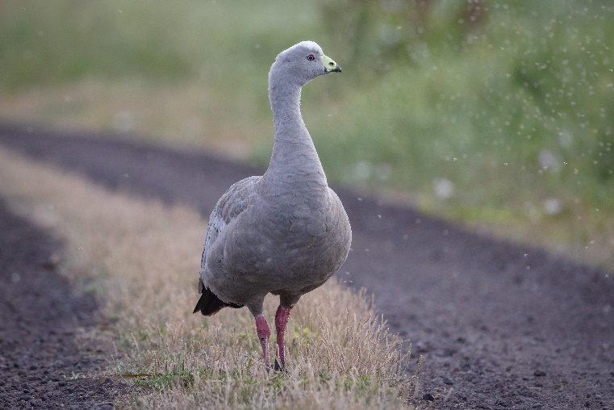

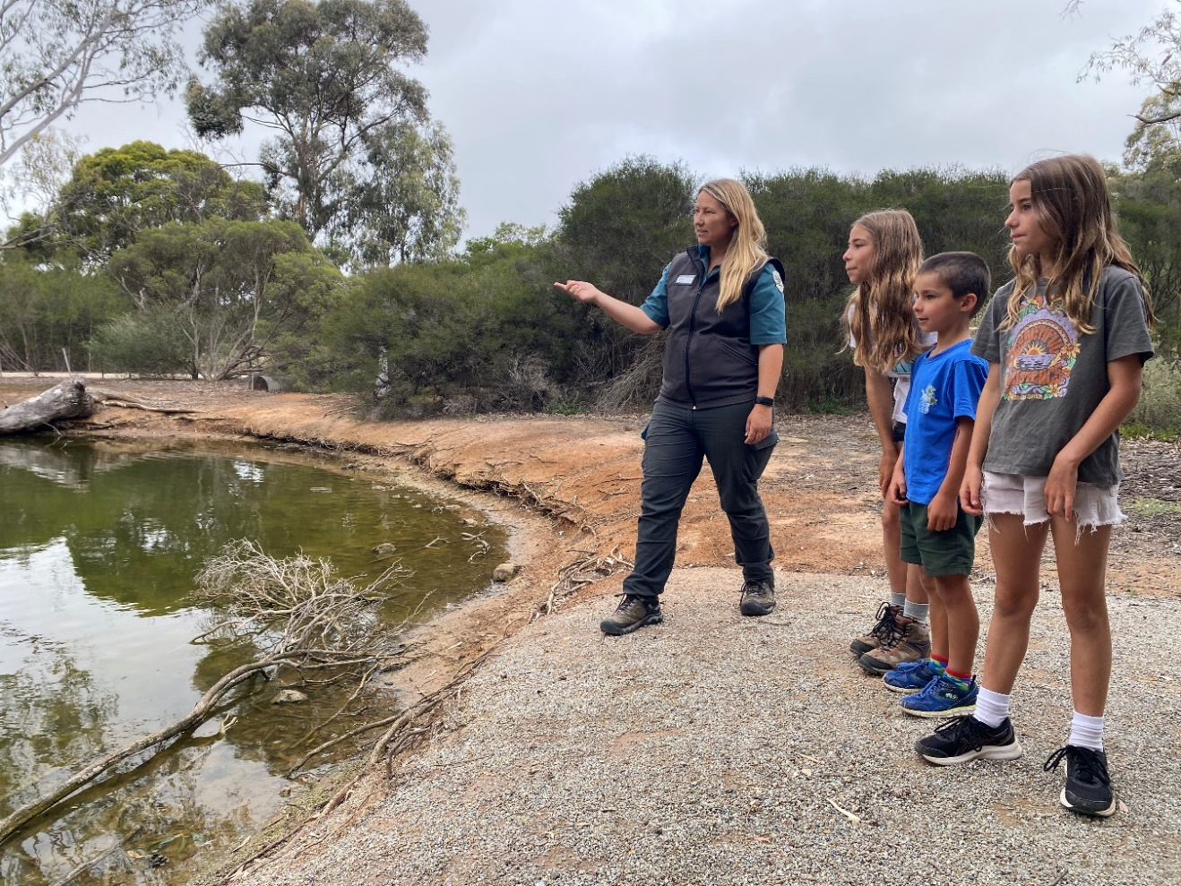
A Ranger will be leading an activity for my class at the pond. Rangers wear a uniform, and I can ask them questions about the park.

When I get to the park, I have to stay with my teacher and the Ranger. There are many cars here, so I need to look for moving cars and be safe.
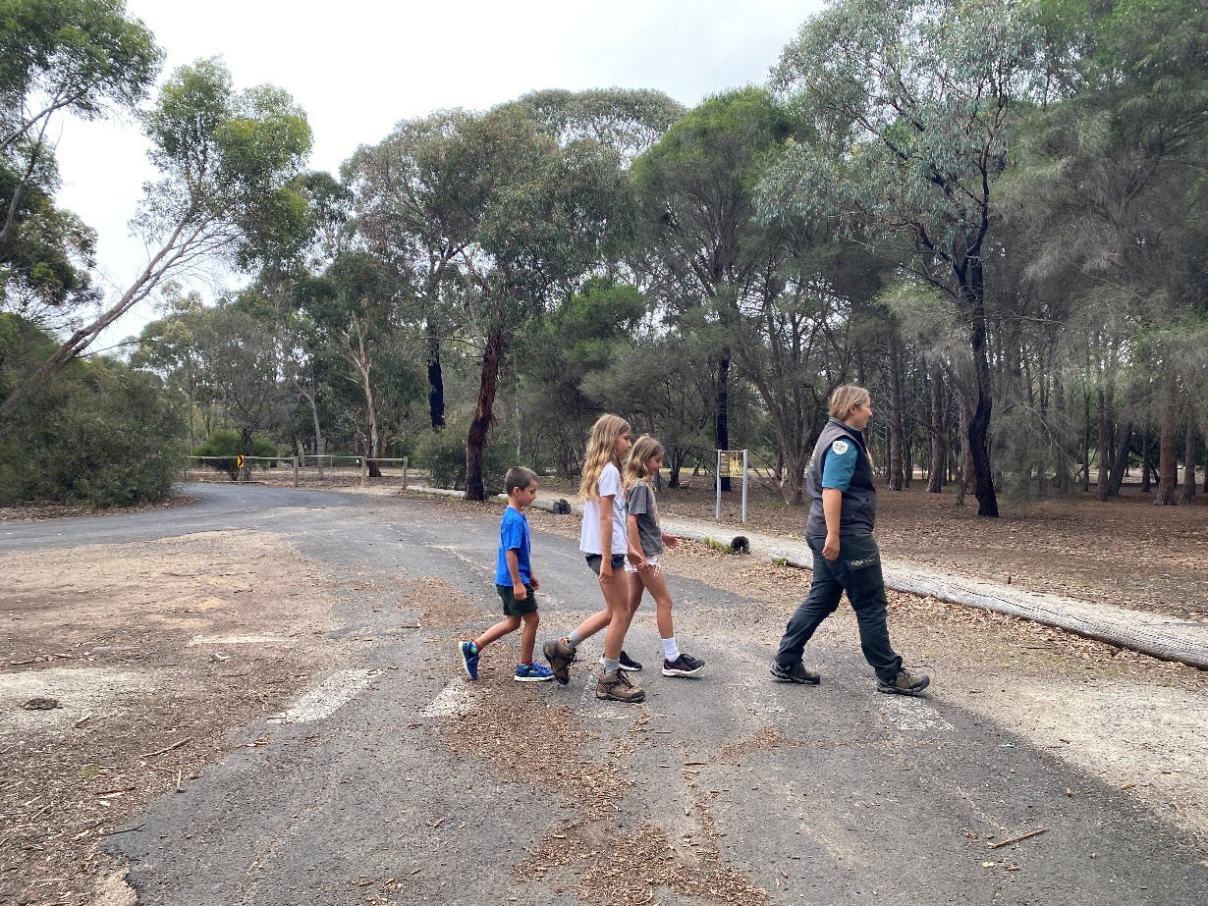

The Ranger will meet my class at the picnic area and talk about the park rules. I will stay on the paths, keep my distance from animals and take my rubbish back to school.
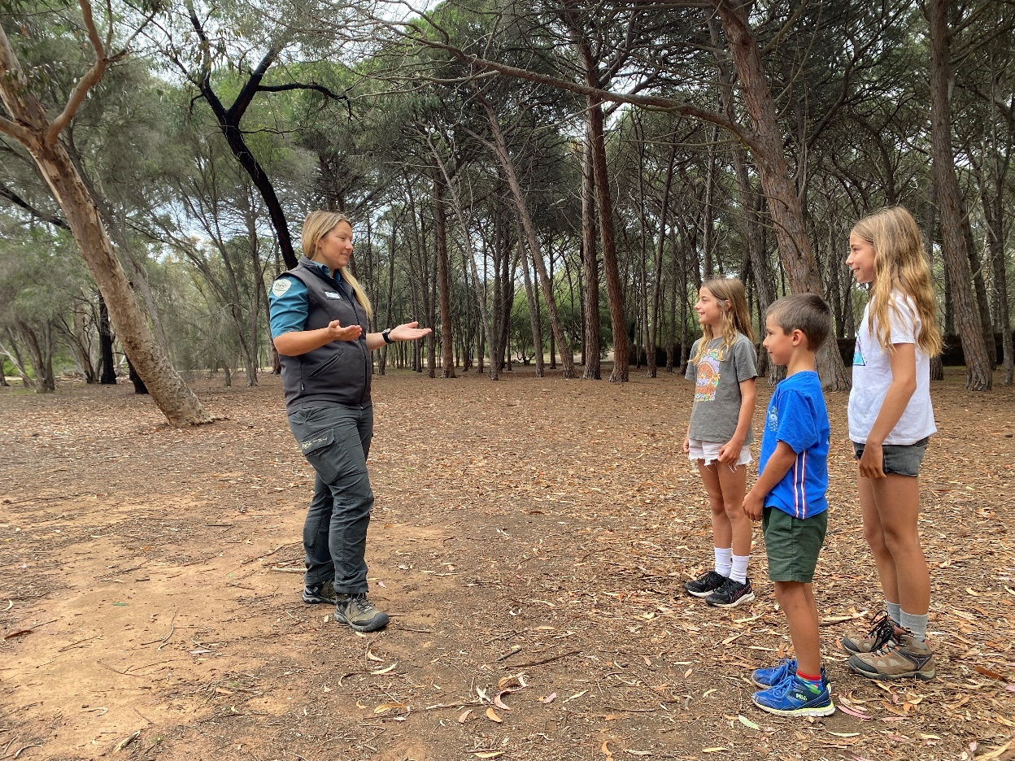

I will follow the Ranger on a path through the park to the pond. I will stay with my teacher and the Ranger. This keeps me safe.
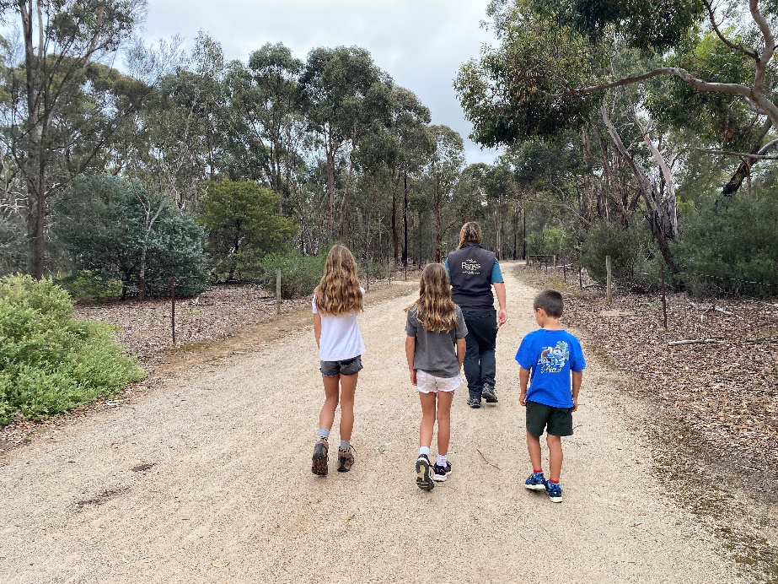
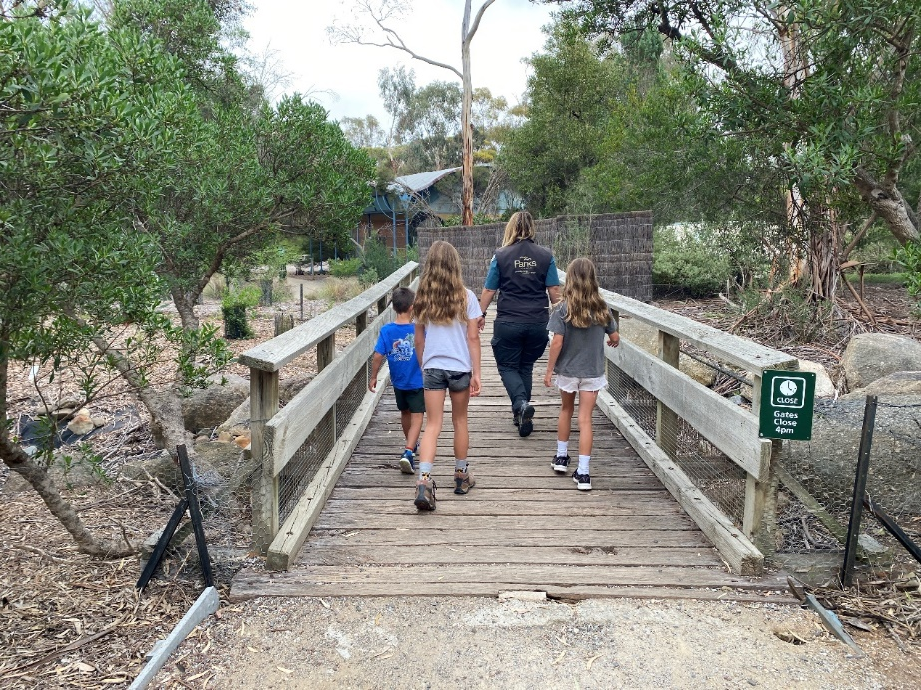

At the pond, there will be a gate. The gate keeps the animals safe. The Ranger can help me open and close the gate. I then follow the Ranger to the shelter next to the pond.
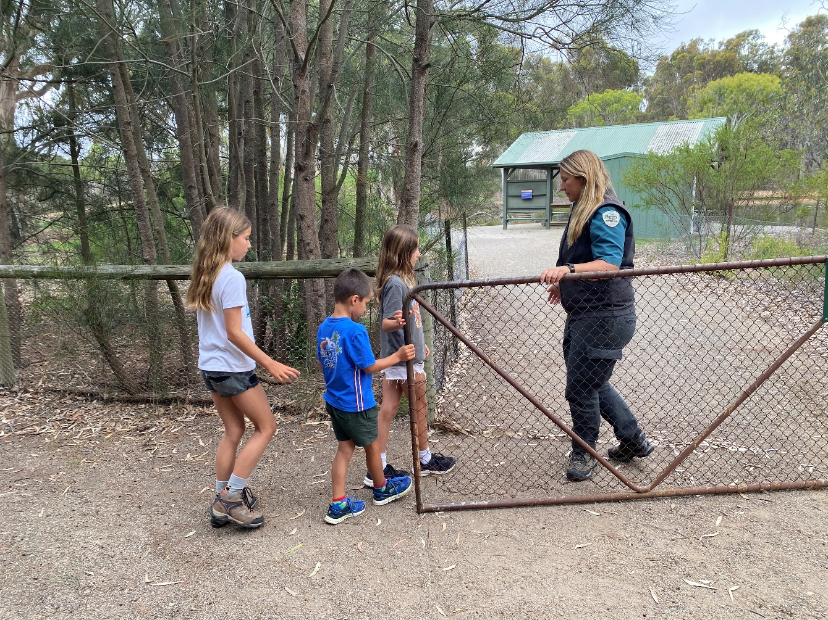

I will take a seat and listen to the Ranger explain how to catch minibeasts and stay safe near the water. My teacher will assign me to a group, and I will take part in a minibeast activity with 3 other students.
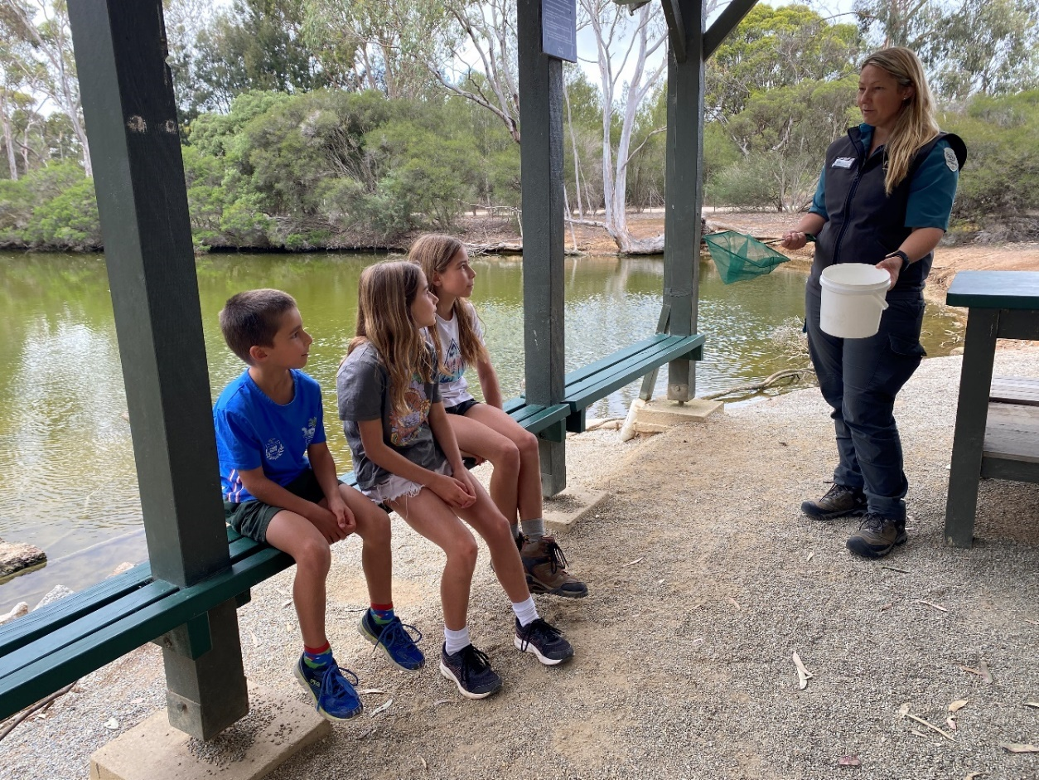

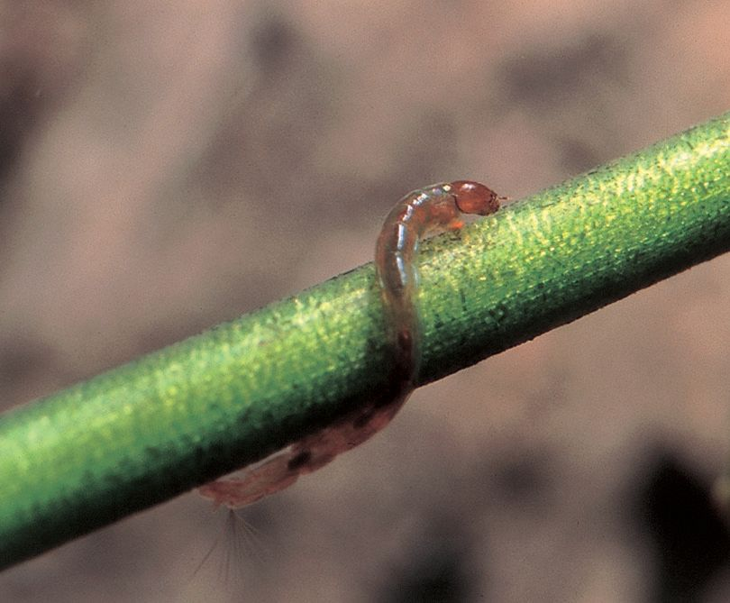
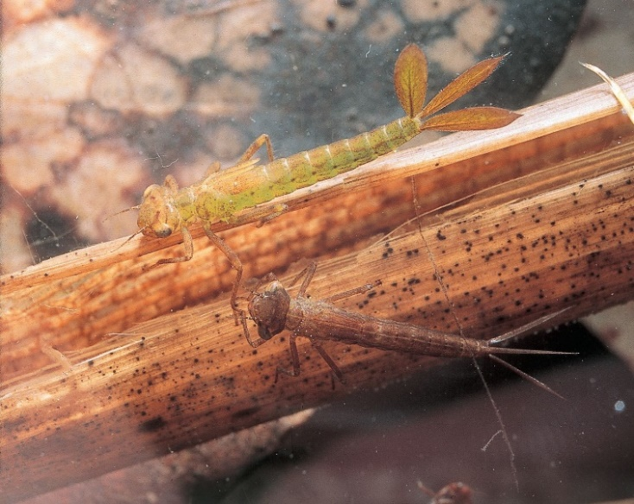
Minibeasts are small creatures that live in the pond. I might see some minibeasts like a Damselfly Nymph, Blood Worm, Water Mite or Scud.

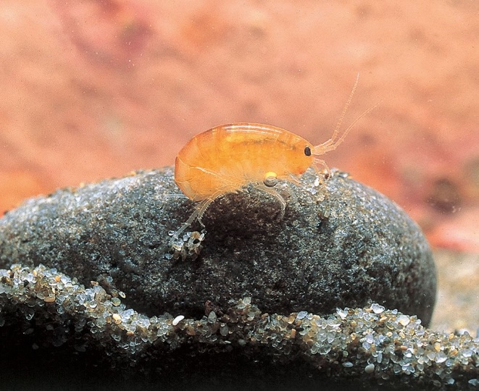
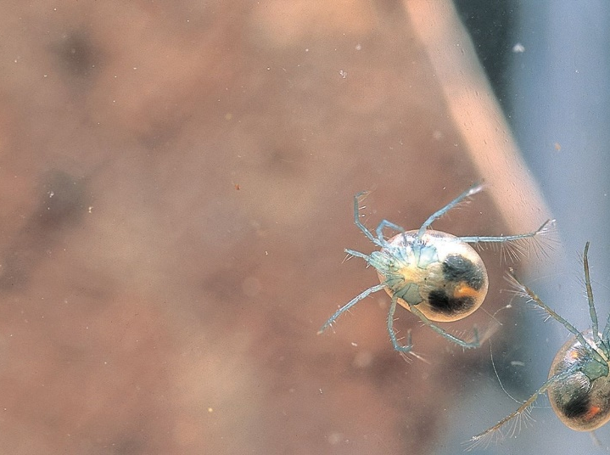

I will follow the Ranger to the pond and fill my bucket with water. When I dip my net in the water, I need to bob down to keep safe. I move around my net in the water to catch minibeasts and then tap them into a bucket.
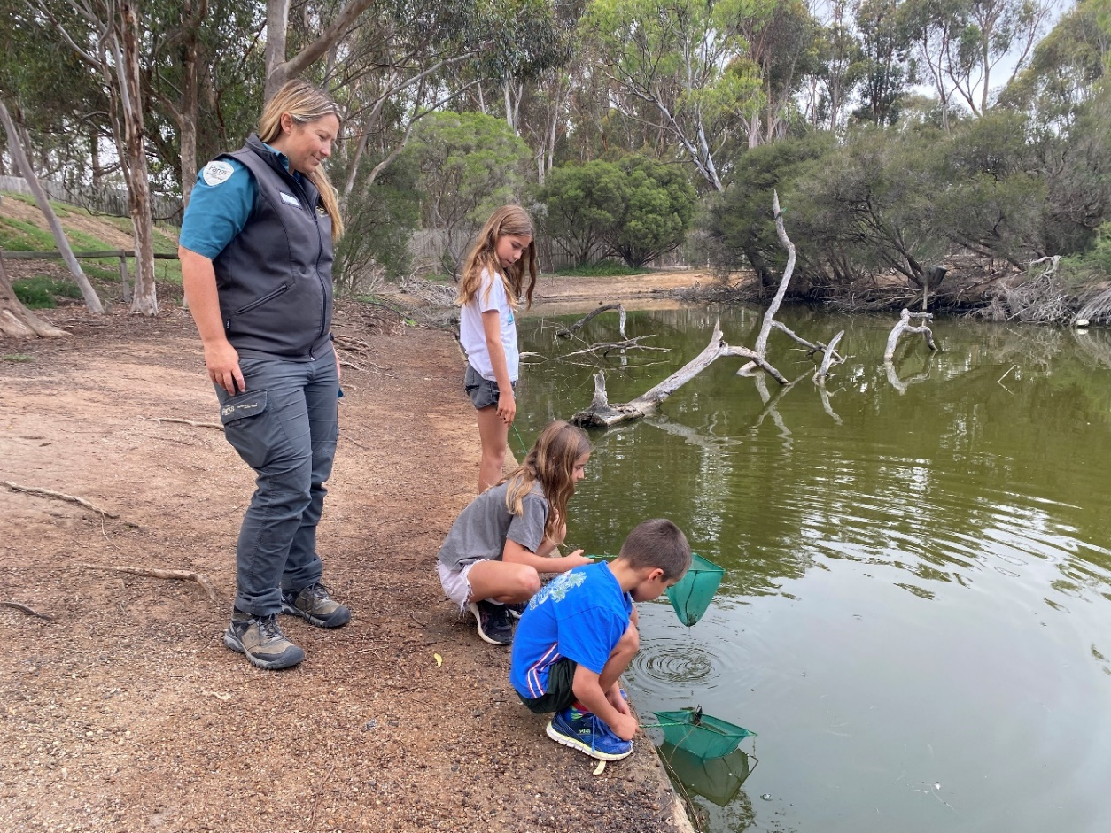

I follow the Ranger back to the shelter. The Ranger will pour the bucket of water into a large tray. I can catch minibeasts using my spoon and put them into an ice cube tray. I use a spoon to keep the minibeasts safe.

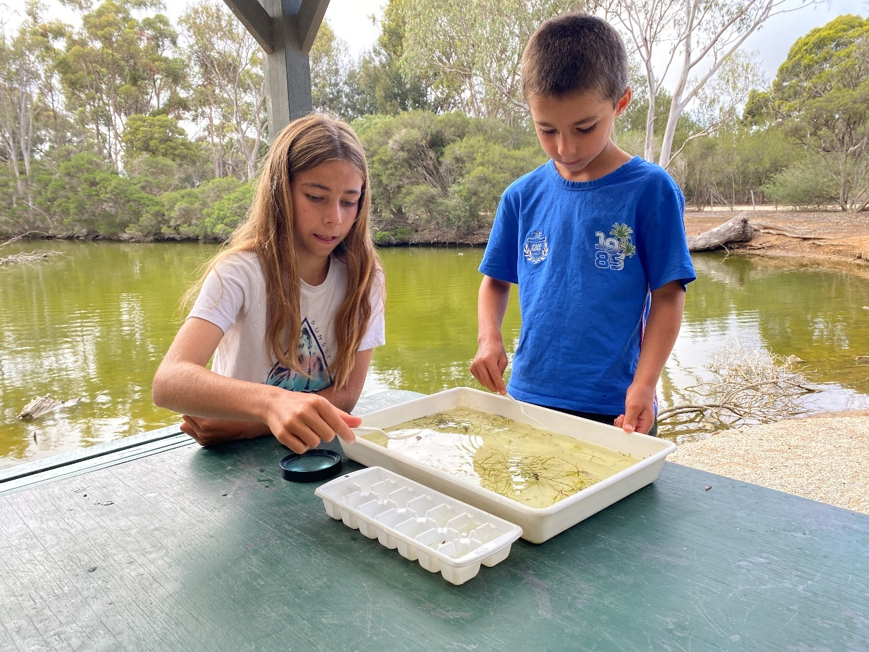

I can put a different minibeast in each cube of the ice cube tray. I can use a magnifying glass to have a closer look at the minibeasts.

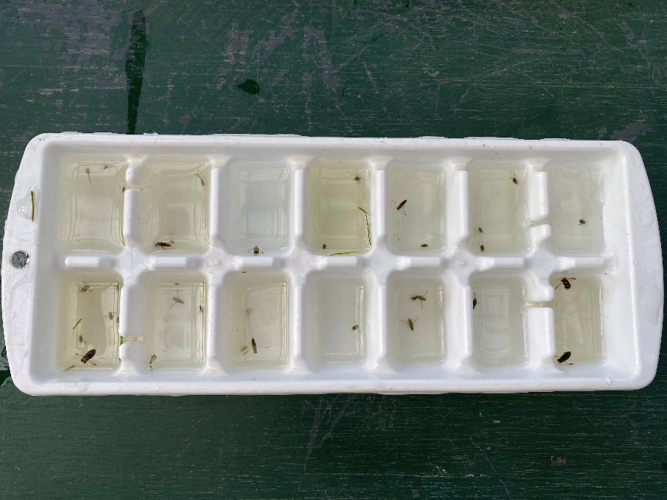

I can find out what minibeasts I caught by looking at the Water Bugs board. I can ask the Ranger to help me identify minibeasts.
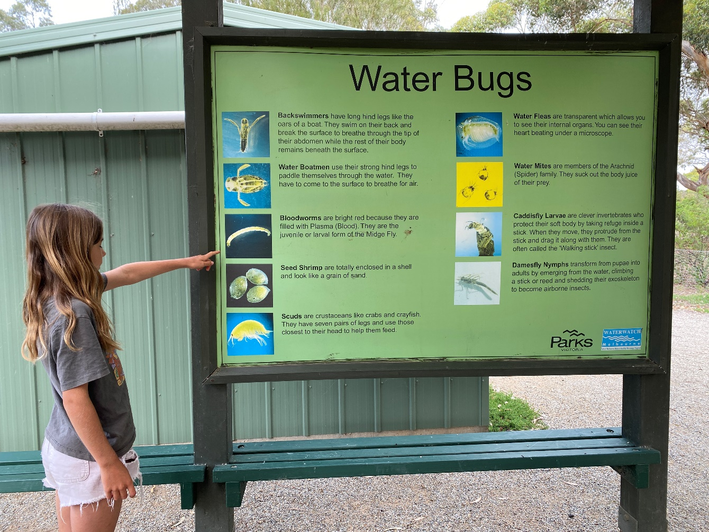

The Ranger will ask me to help clean up the equipment. I can tip the bugs in the ice cube tray into the large tray and can put spoons and magnifying glasses back into the plastic tubs. The Ranger will tip the large tray back into the pond.
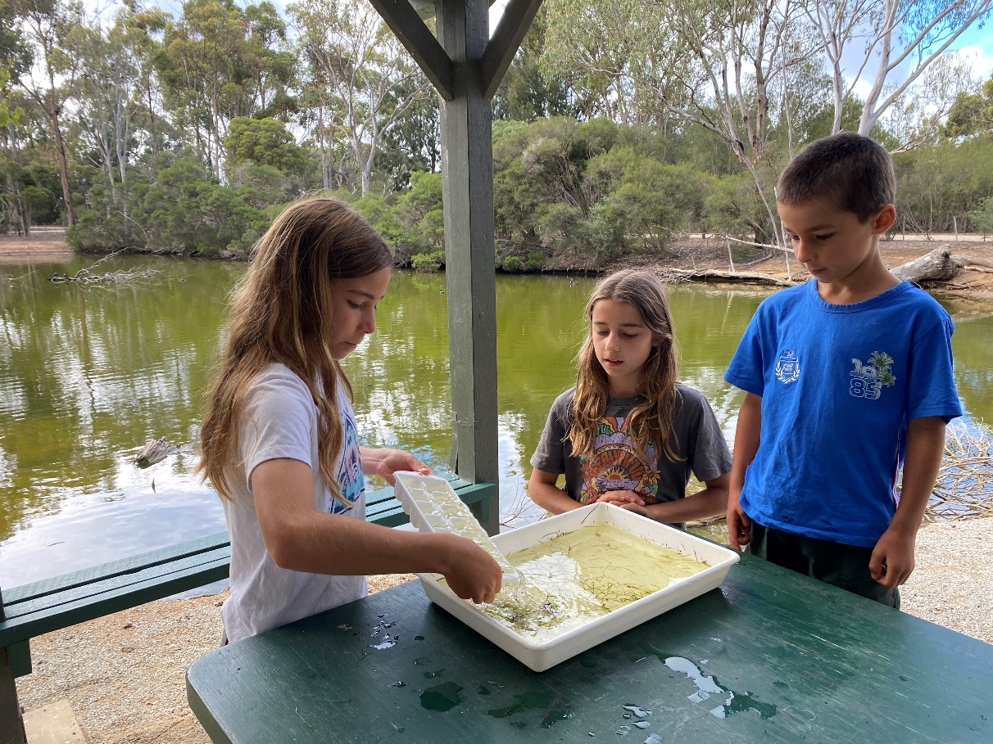

When I am finished packing up, I clean my hands using hand sanitiser. I can use my own hand sanitiser. The Ranger will ask my class questions about what minibeasts we caught and what this means for the health of the wetland.
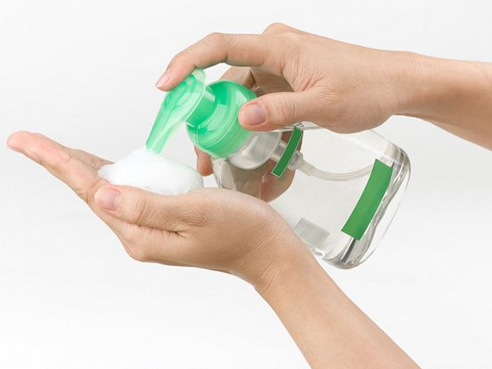
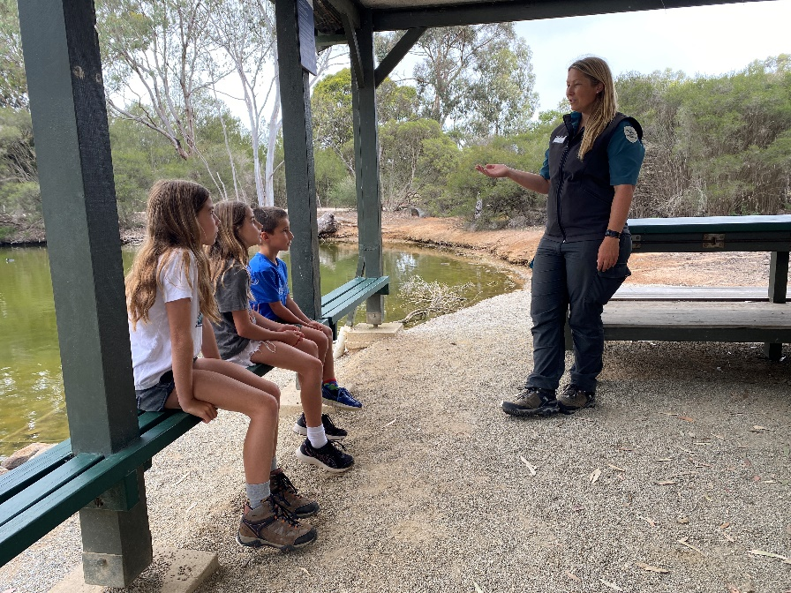

I will follow the Ranger on a path through the park to the picnic area. I will stay with my teacher and the Ranger. This keeps me safe.
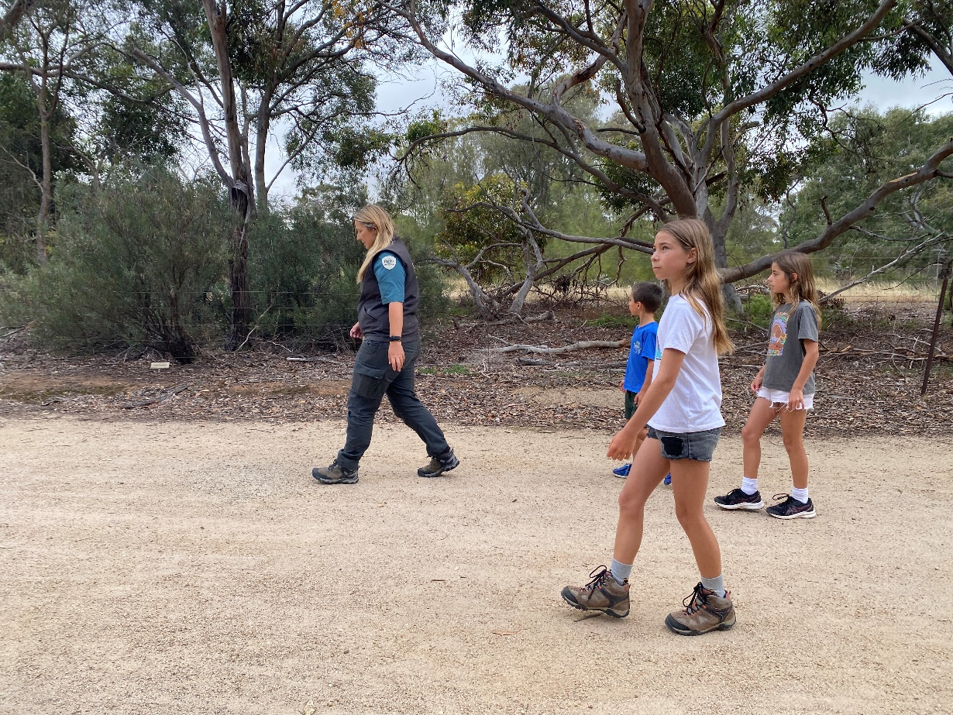

Next to the carpark, there is a place I can sit to eat my food. This is called the picnic area. I can sit at the table. My food is not for the animals. I will stay with my teacher.
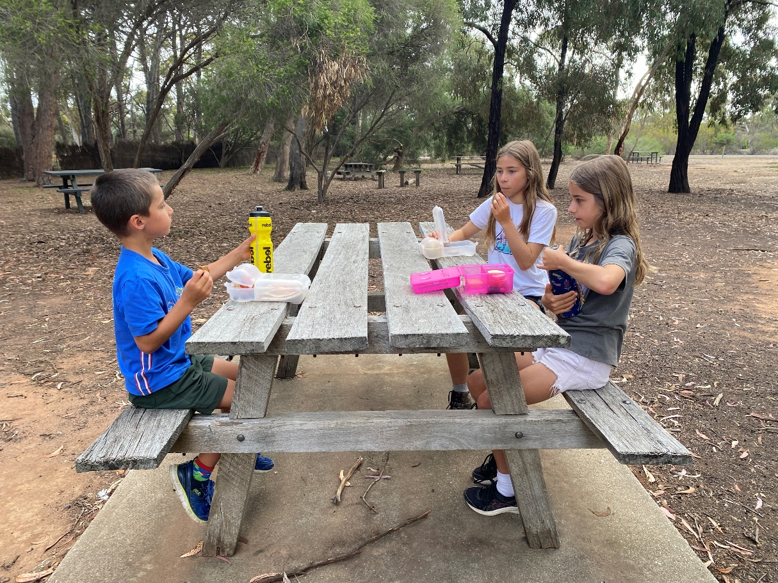

There are toilets next to the picnic area. If I need to go to the toilet, I need to tell my teacher first.
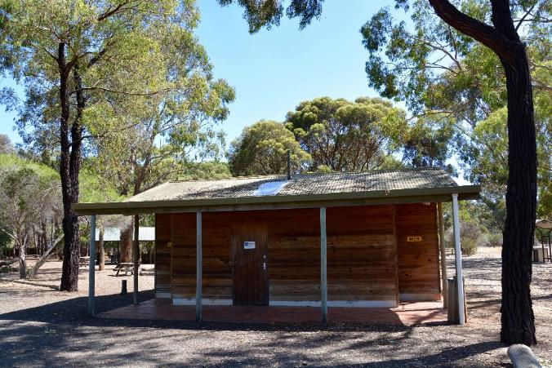 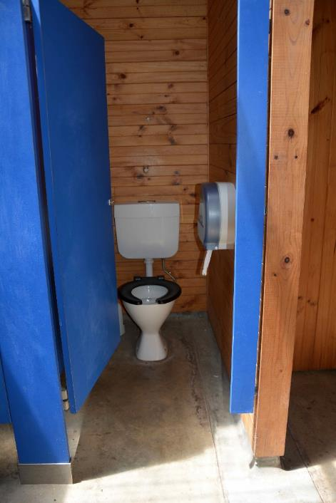

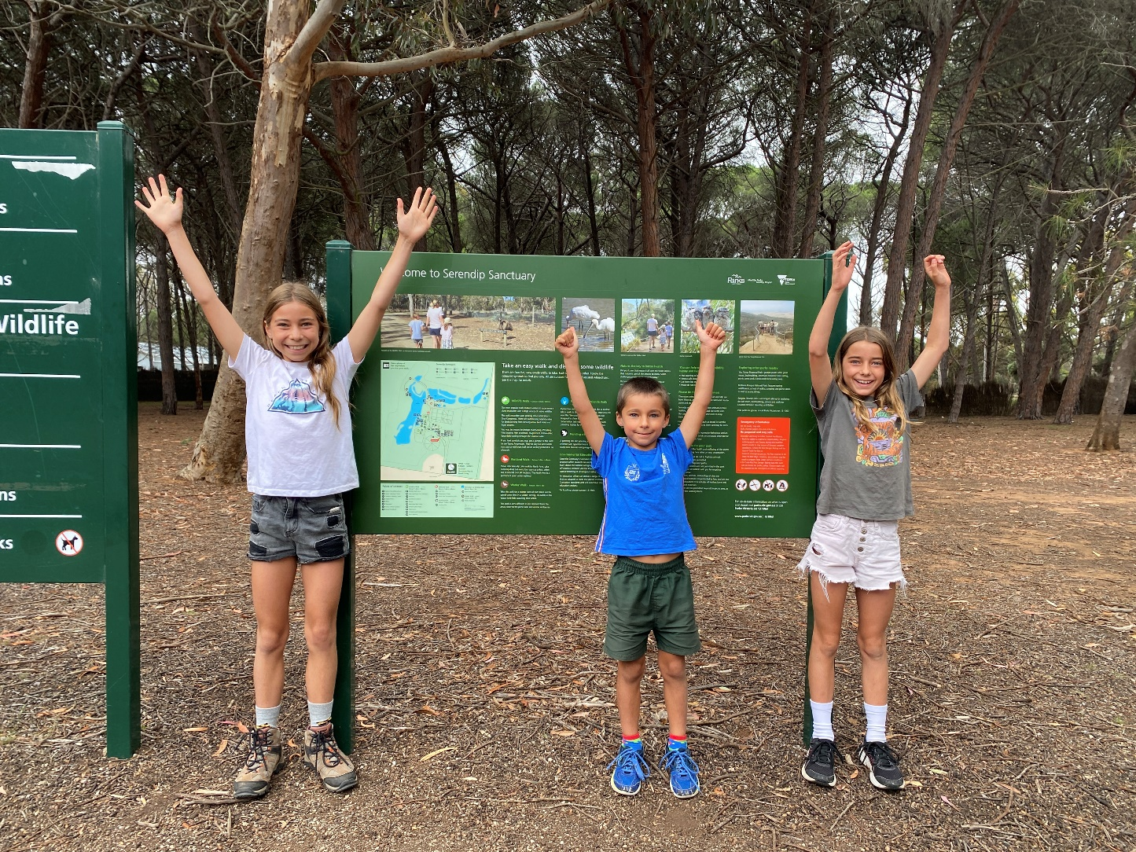
I had fun looking at minibeasts at Serendip Sanctuary.

Proudly produced by Parks Victoria in partnership with Amaze





Photo credits
Minibeast images by J. Gooderham and E. Tsyrlin
Cape Barren Goose image by Ruth Woodrow
Emu image by Joy Thorup Andersen
All other images by Vanessa Wiggenraad

