My Visit to Dandenong Ranges National Park

I am going on an excursion to the Dandenong Ranges National Park. I will visit Grants Picnic Ground.
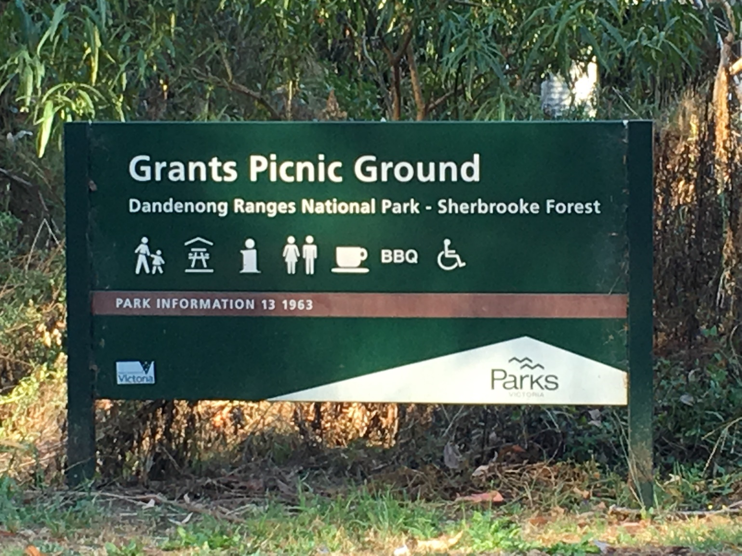
When I get to the park, I will stay with my teacher. There are many cars here, so I need to look for moving cars and be safe.
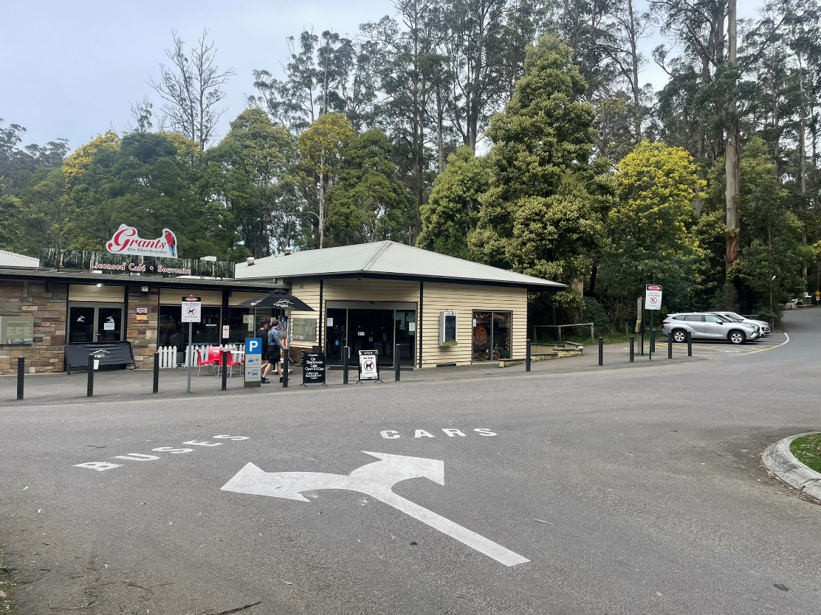
The picnic ground can be very busy and there may be lots of strangers there. I will stay with my group.
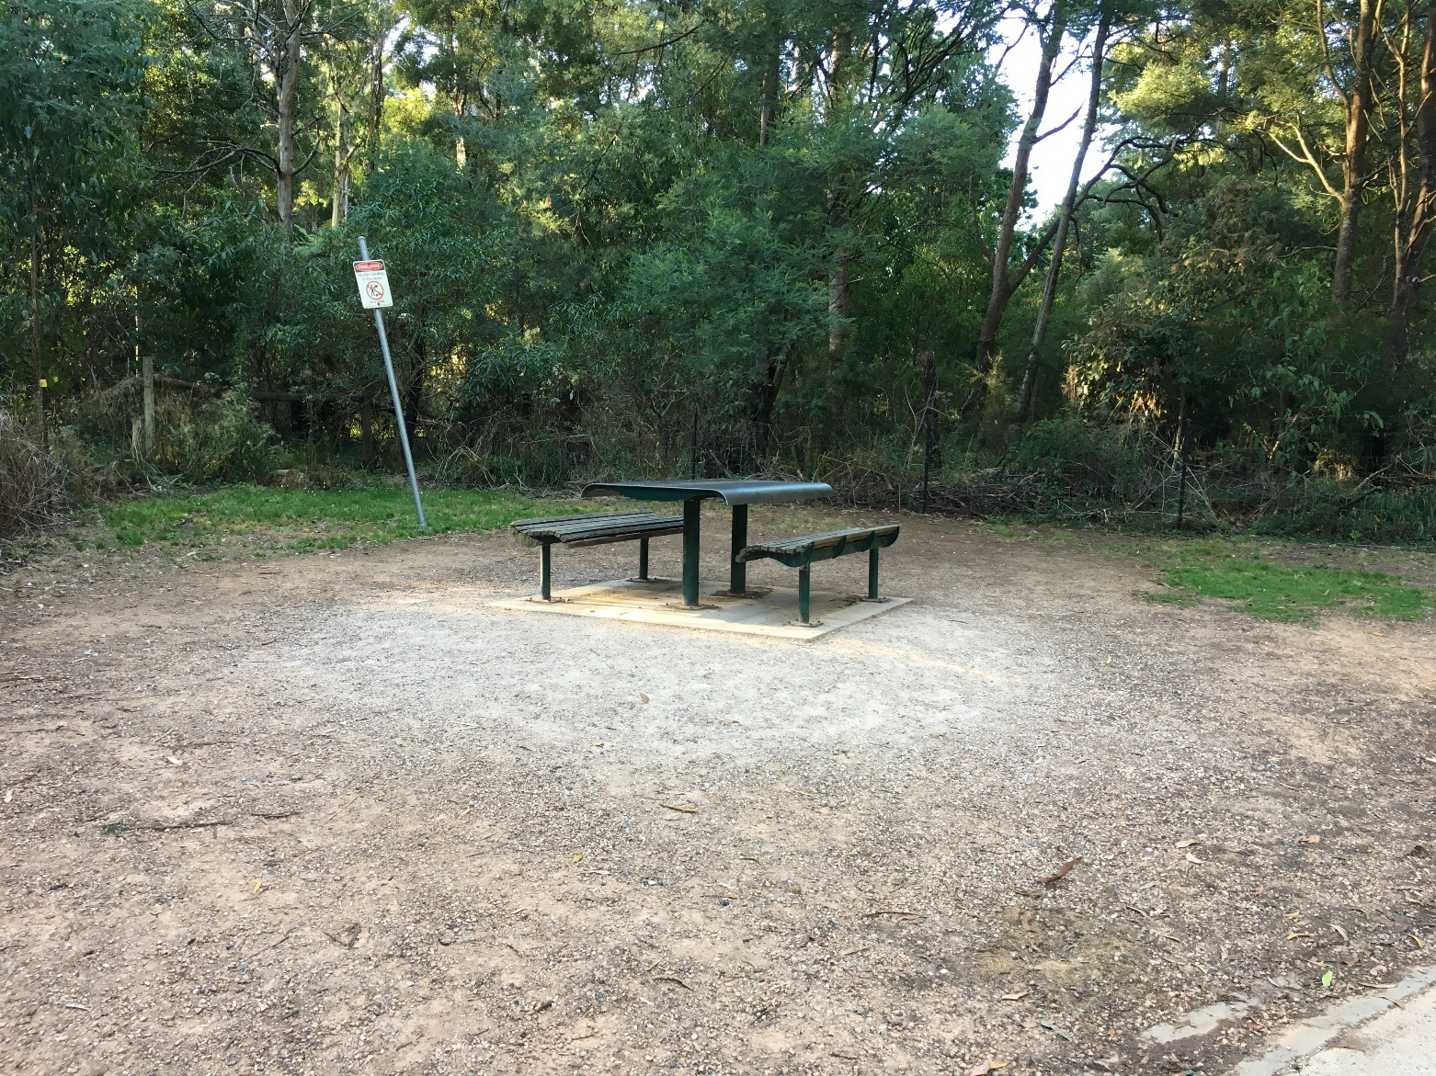
There is a shop and café at Grants Picnic Ground. I can only go in here if my teachers say it is OK.
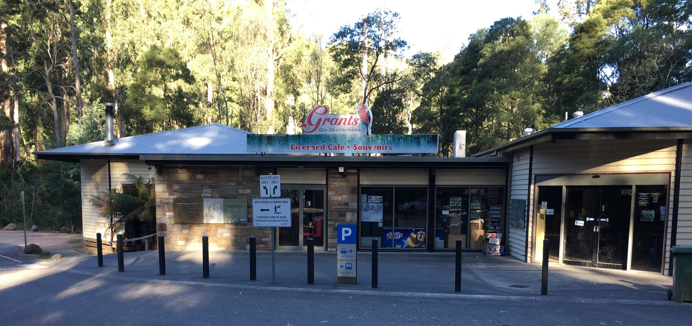

A Ranger will be leading an activity for my class today. Rangers wear a uniform, and I can ask them questions about the park.
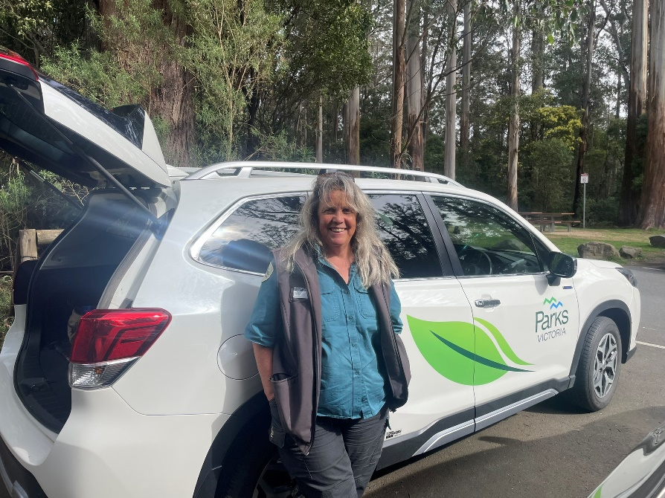

The Ranger will meet my class at the picnic shelter area.
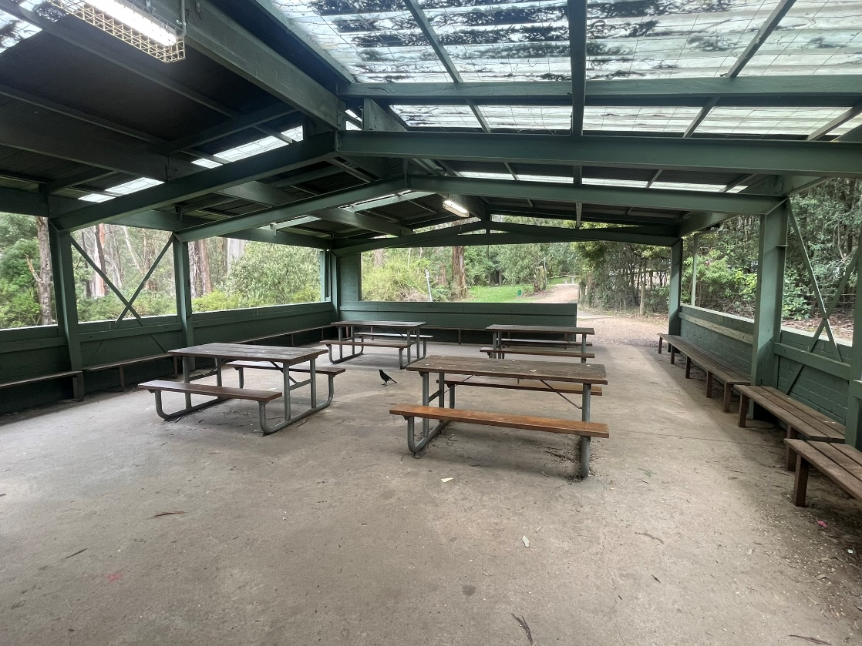

The Ranger will talk about some of the park rules. These rules keep both people and animals safe.

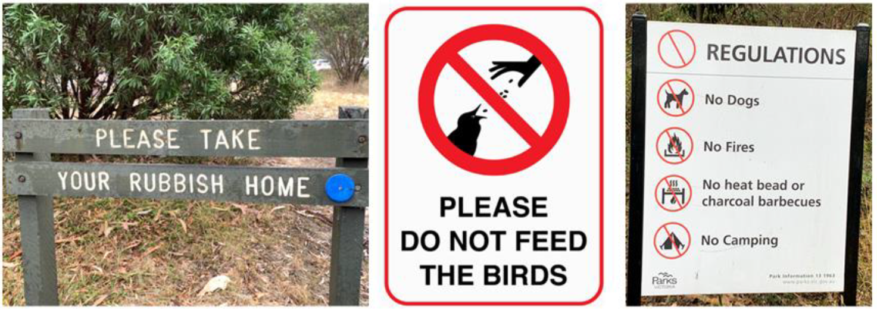

There are tables in the picnic shelter where I can sit and listen to the Ranger. I will also eat my food here. My food is not for the animals. The animals have their own food.
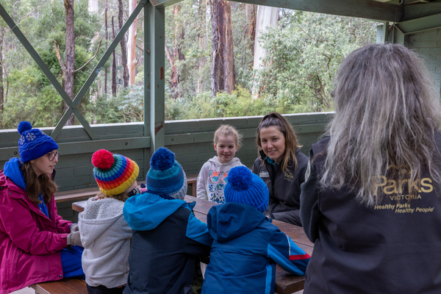
There are toilets and water taps near the picnic area. If I need to go to the toilet or refill my water bottle, I need to tell my teacher and I will go with a buddy.
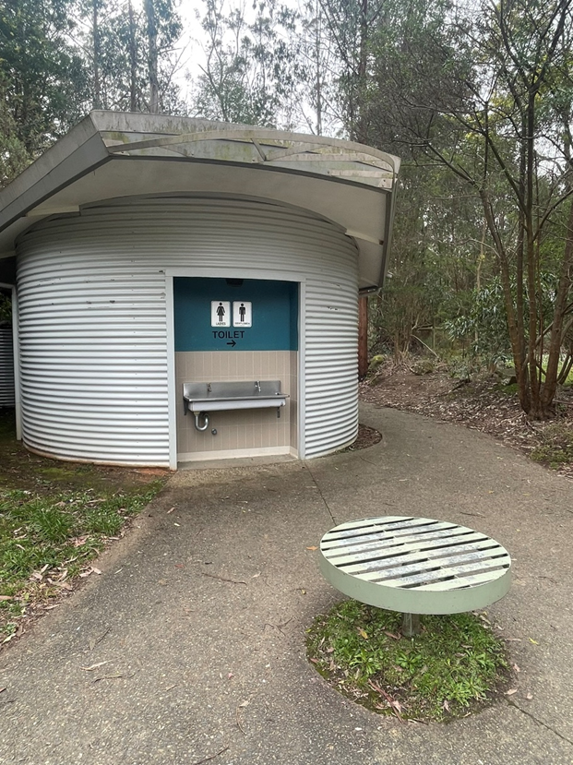
I can put my bag in the green locker in the picnic shelter so it will be safe while we go for a walk.
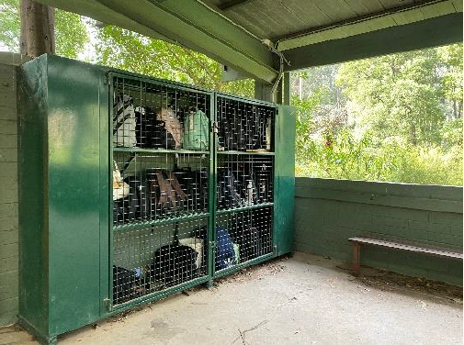

There are many animals in the forest. I will watch them quietly from a safe distance.
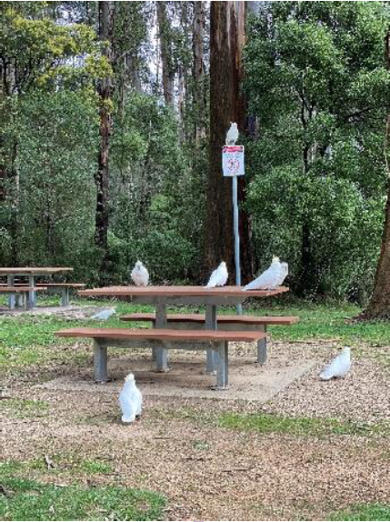
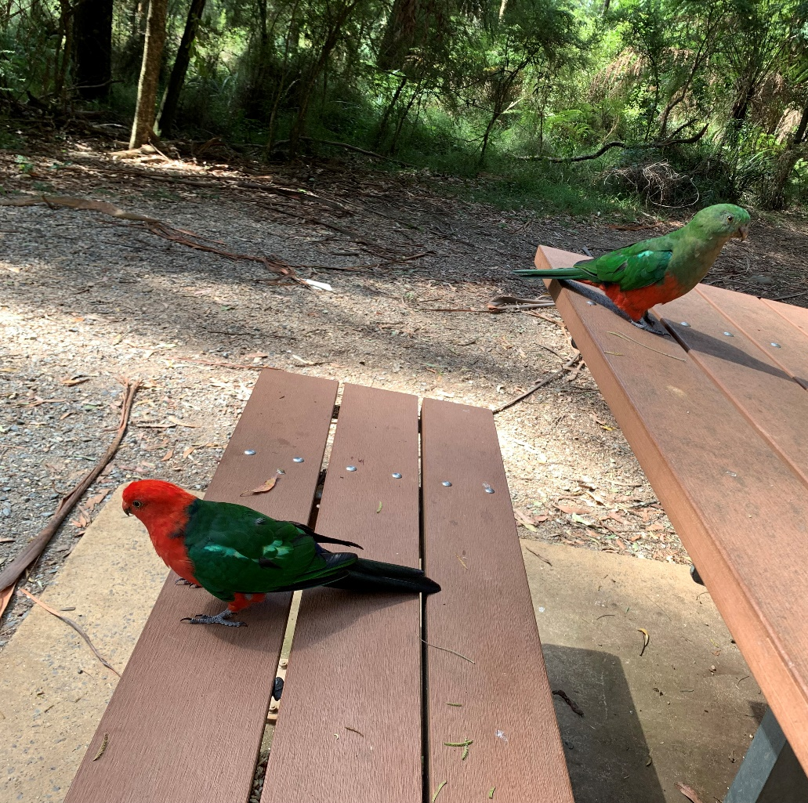
The Ranger will take me on a guided walk through the forest. I will stay with my teacher and the Ranger. This keeps me safe.
  - 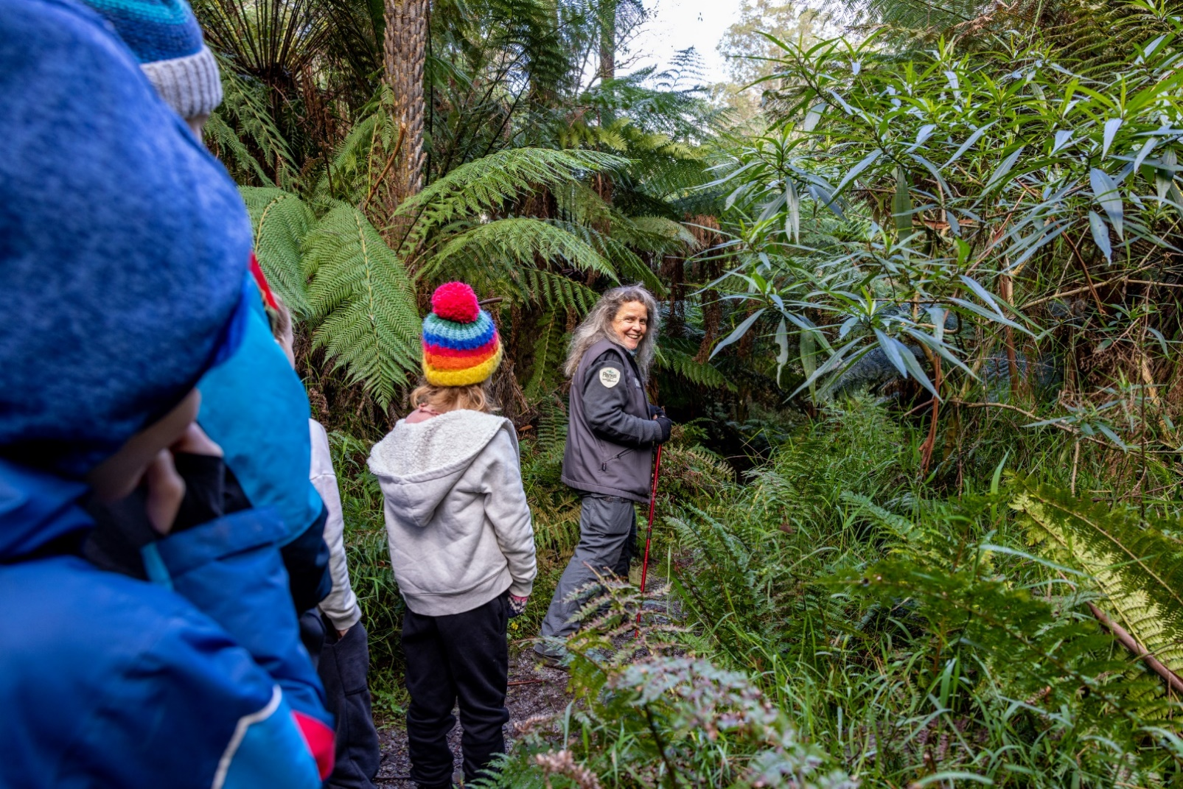
  - My class will be given pens, worksheets and clipboards to take on the walk. There will be stops along the way where I will listen to the Ranger and fill out the worksheets.
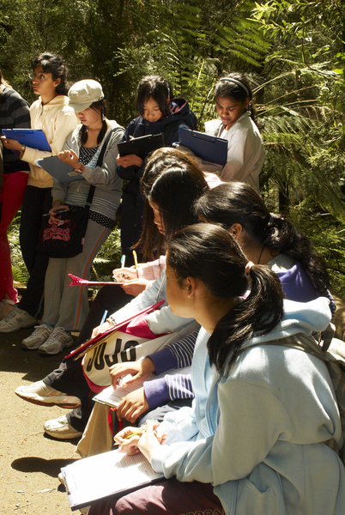
  - We might need to stand close to one another to hear the Ranger.
I can raise my hand if I can’t see or hear the ranger.
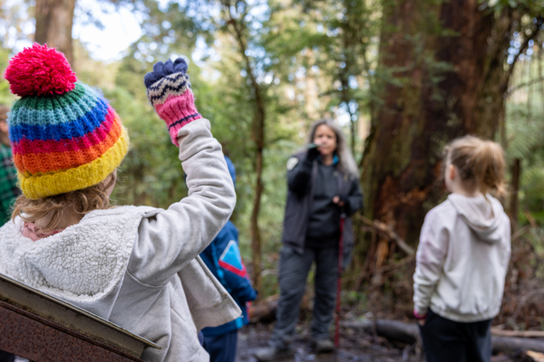
  - The track might be narrow or slippery at times. I will need to walk slowly and carefully.
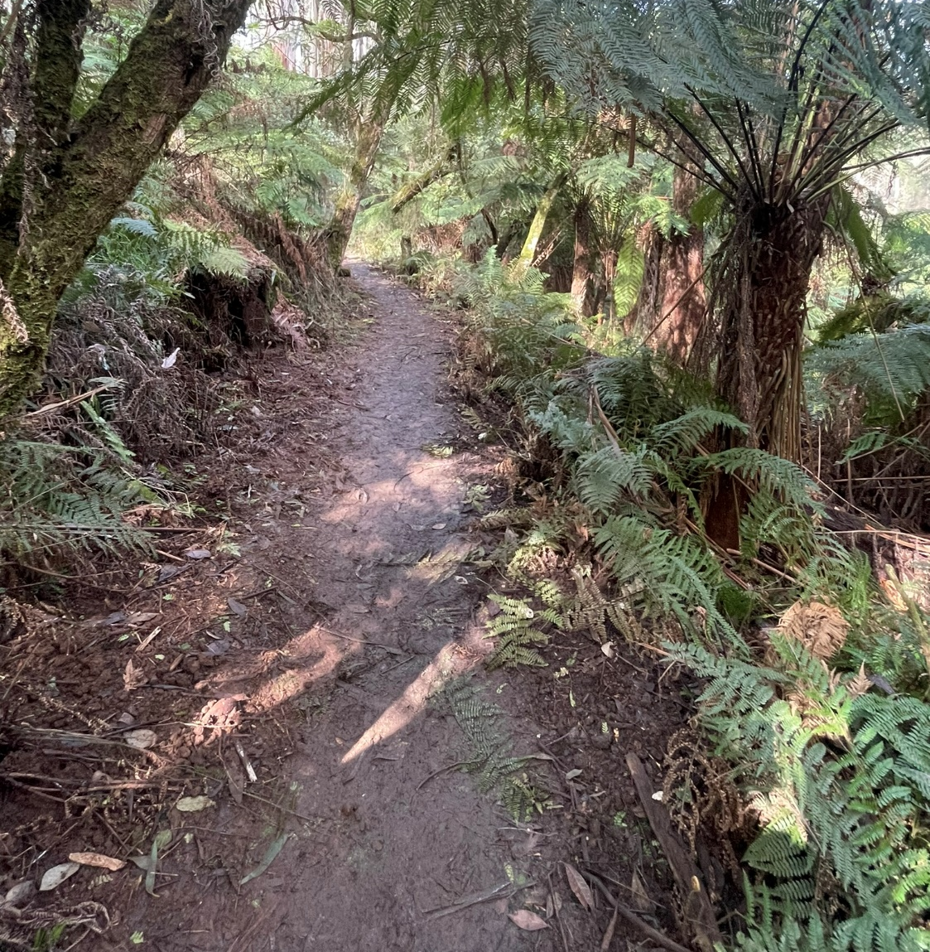

The tracks keep the plants safe from being stepped on. I will stay on the track to look at the plants.
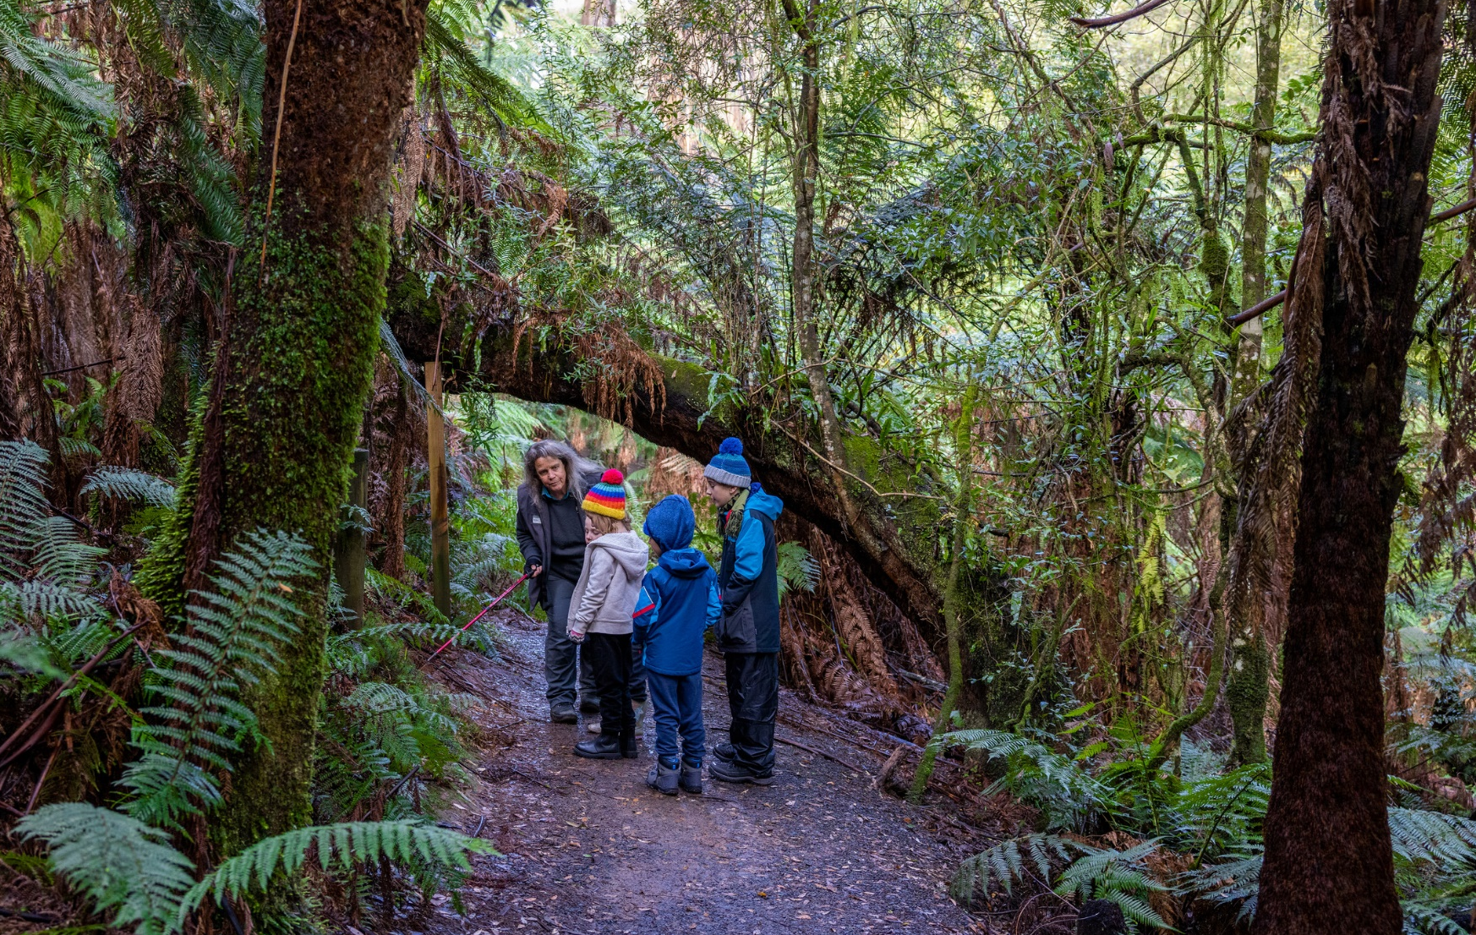

There are many plants in the forest. They provide food and shelter for animals. I will look at the plants and leave them where they are. The ranger will tell me if there is a plant I can touch.
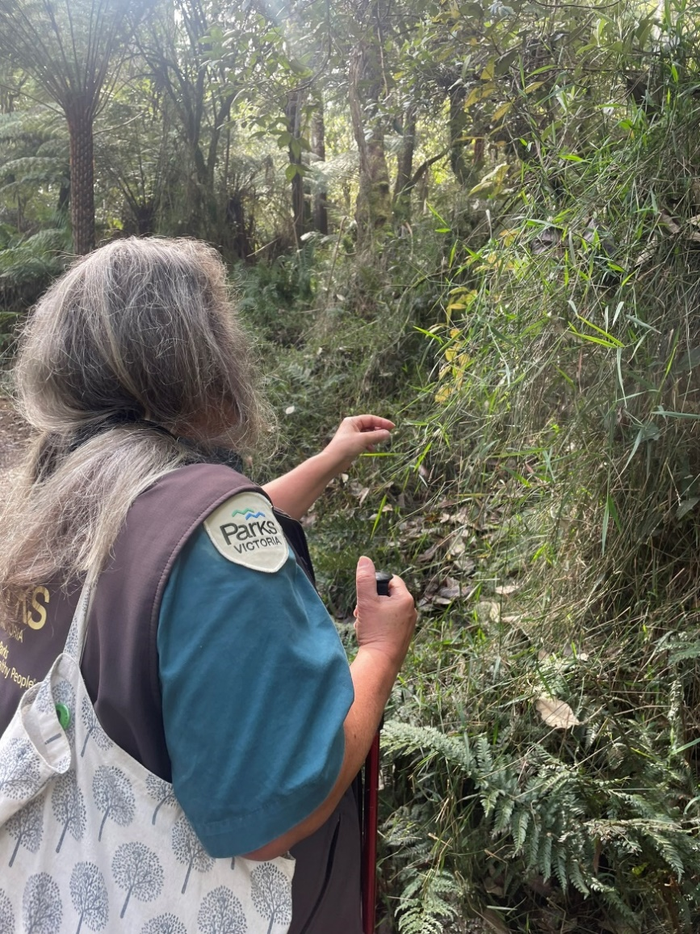

I might hear loud cockatoo and kookaburra calls. They can be very noisy. I might also see or hear other birds such as rosellas and lyrebirds.
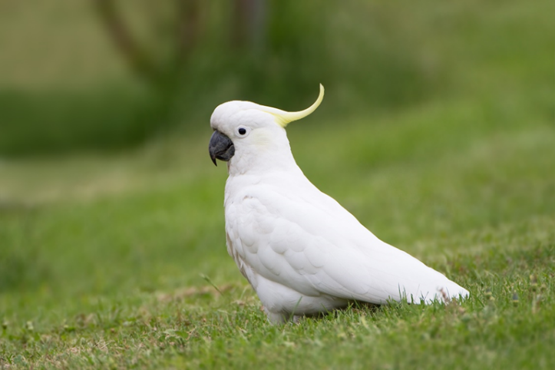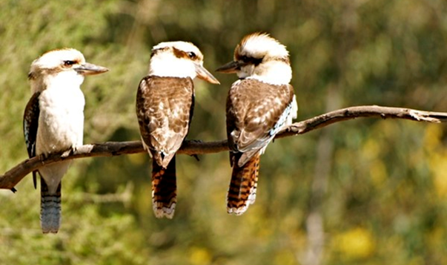
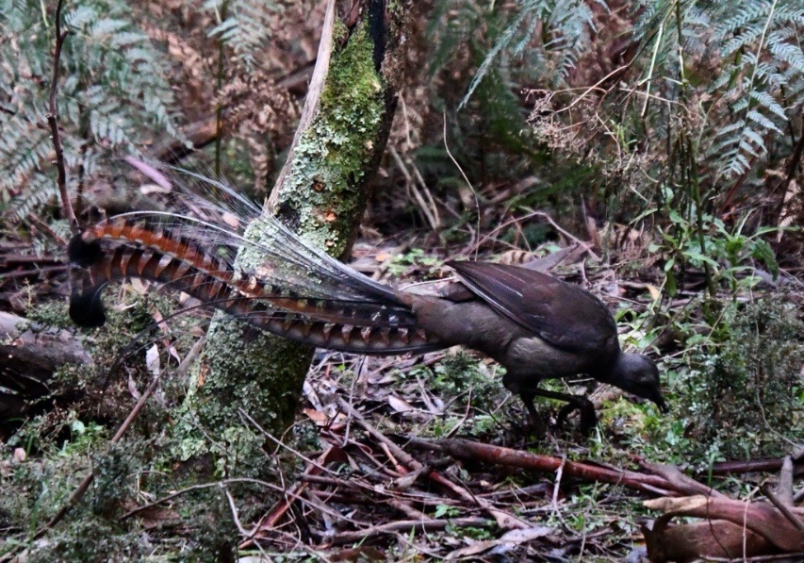
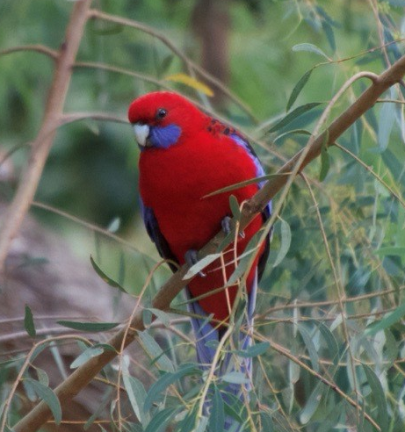

I will have fun exploring the forest and learning about animals and nature with the Ranger at Grants Picnic Ground.
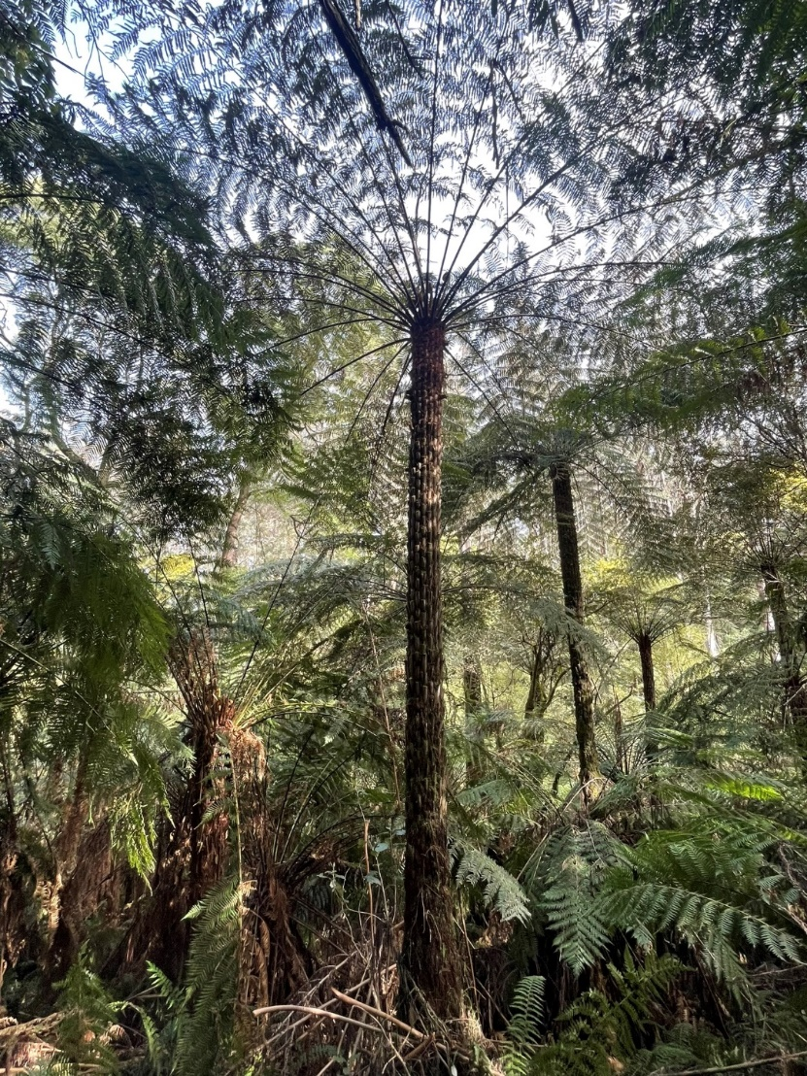
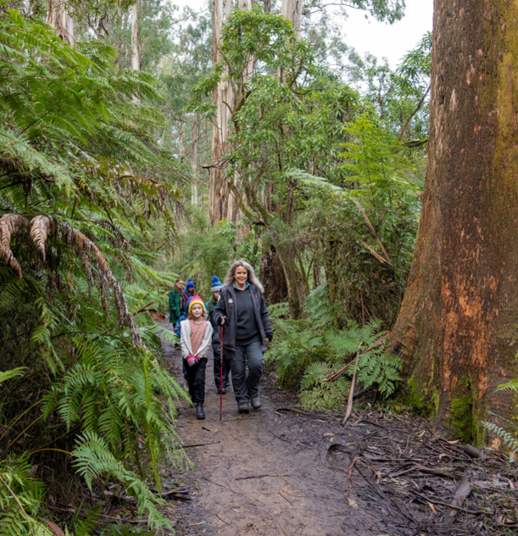
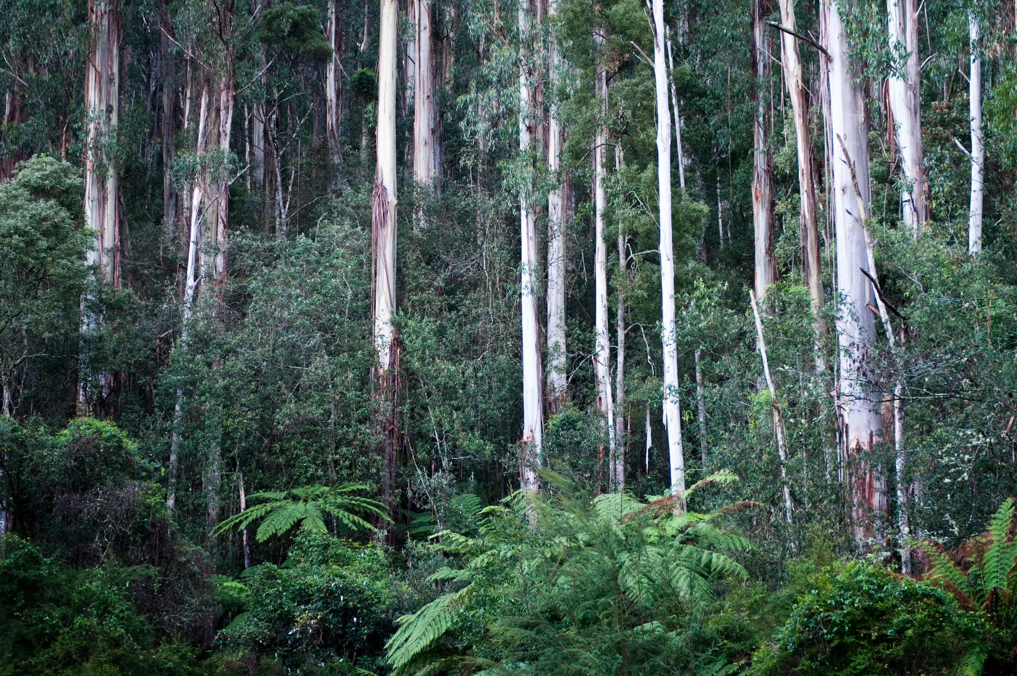
Proudly produced by Parks Victoria in partnership with Amaze





