My Visit to Dandenong Ranges National Park

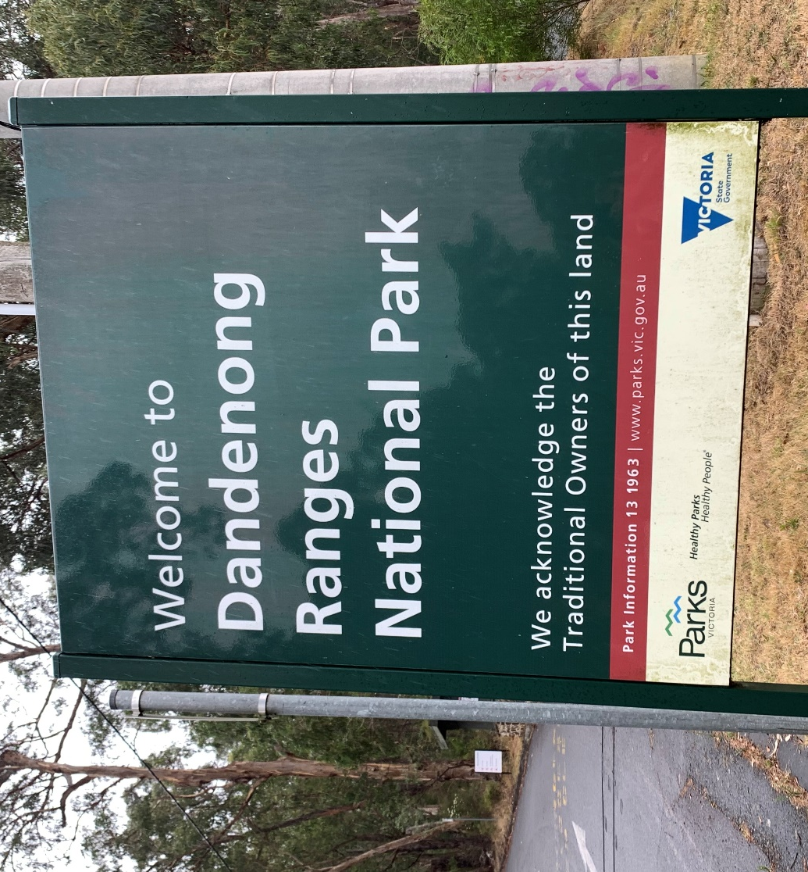

I am going on an excursion to the Dandenong Ranges National Park. I will visit the Education Centre in the Ferntree Gully Picnic Ground.

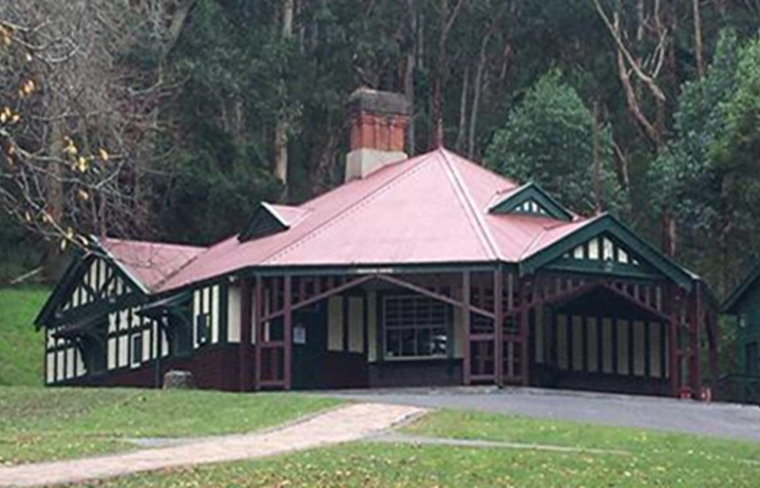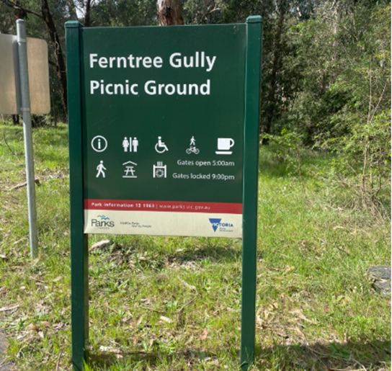

When I get to the park, I have to stay with my teacher. We will walk from the bus to the Education Centre.
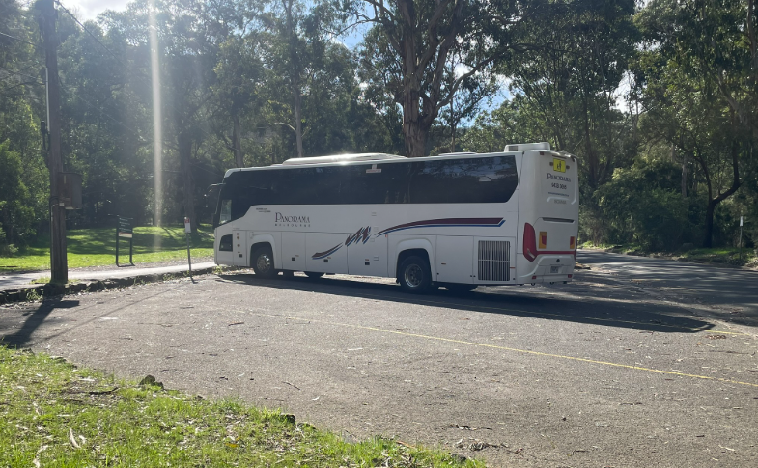

There are many cars here, so I need to look for moving cars and be safe.

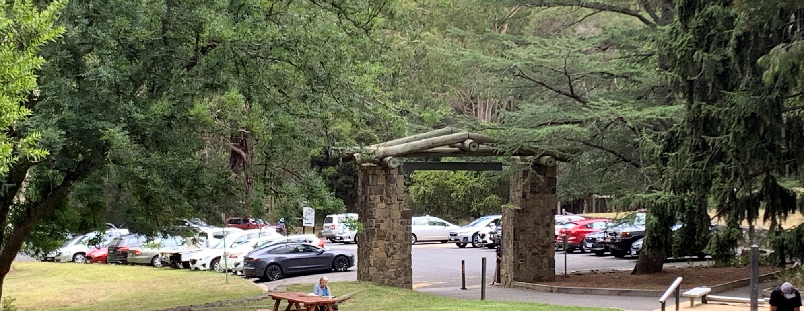

The picnic ground can be very busy and there may be lots of strangers there. I will stay with my group.
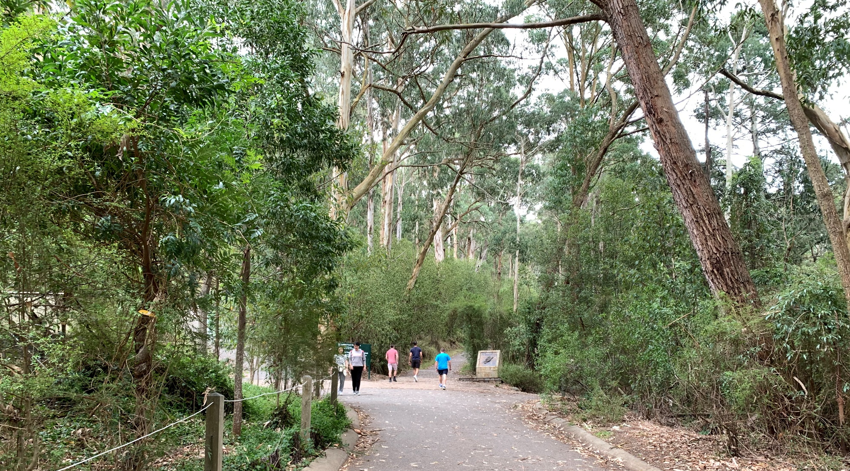
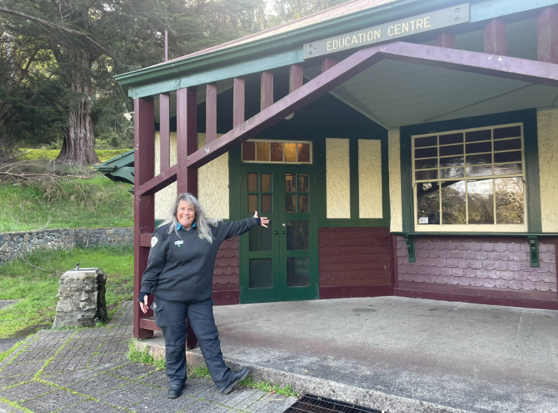
A Ranger will meet my class at the Education Centre. Rangers wear a uniform, and I can ask them questions about the park.

We can leave our bags outside the Education Centre.
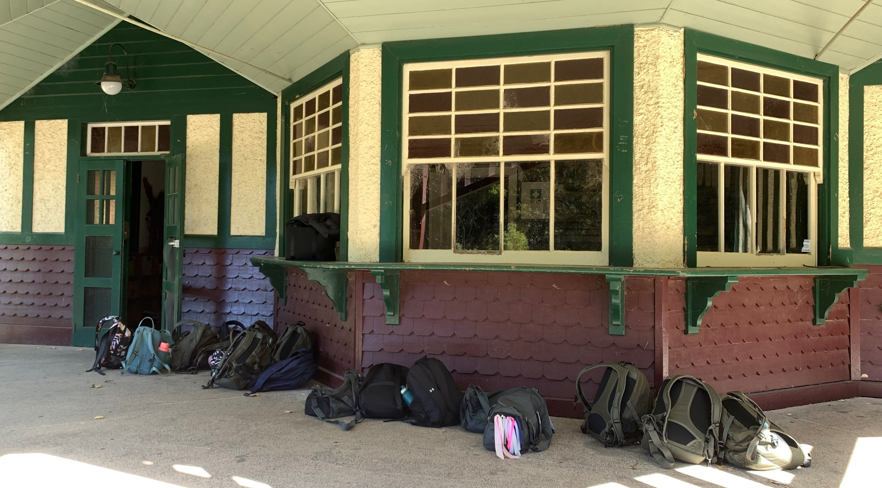

Inside the Education Centre is a classroom where we will learn.
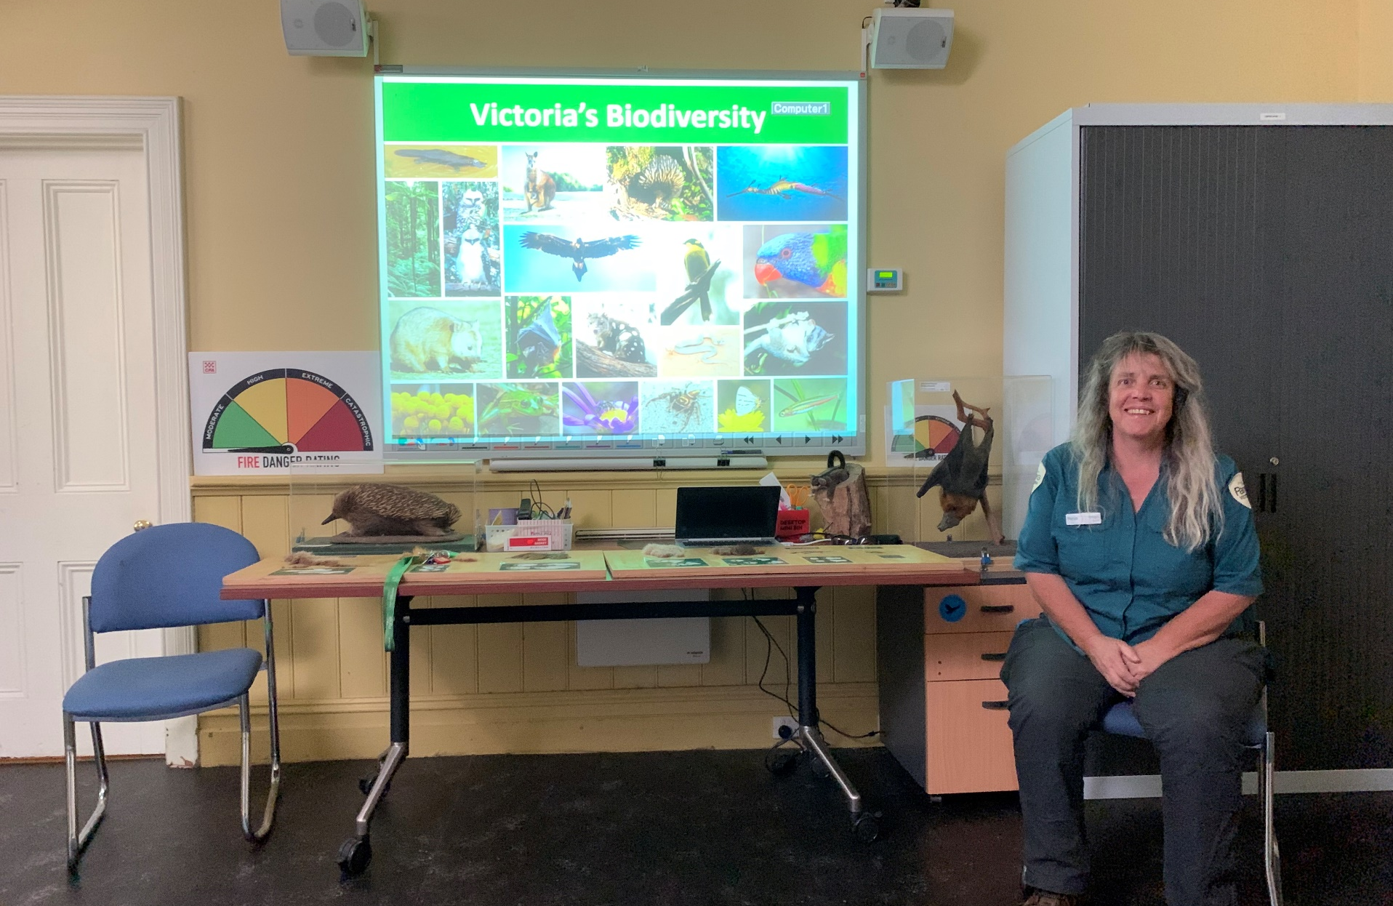
There are cushions that look like logs! I can sit on one of these in the classroom.
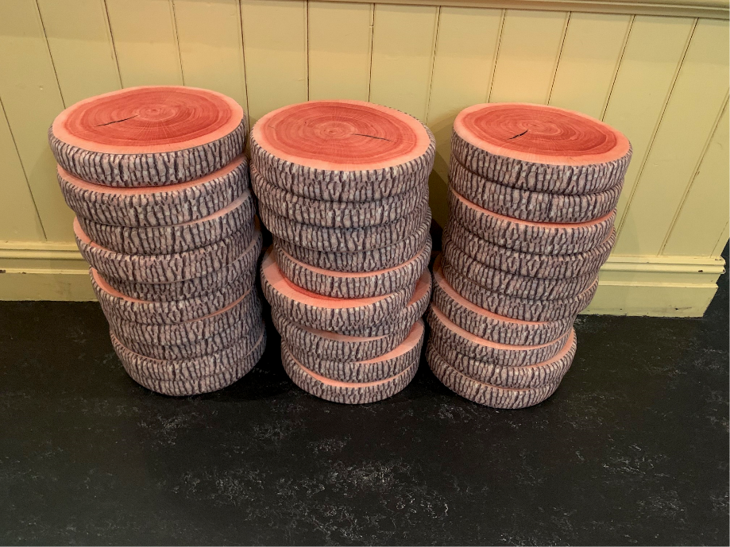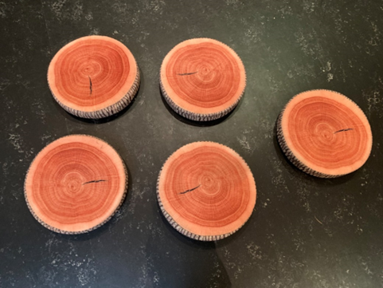

I can see a collection of taxidermy animal specimens that are kept in glass cabinets. These animals are no longer alive. The ranger will explain how the specimens have been made.
I can’t touch the animals, but I can pick up a soft toy animal to hold.
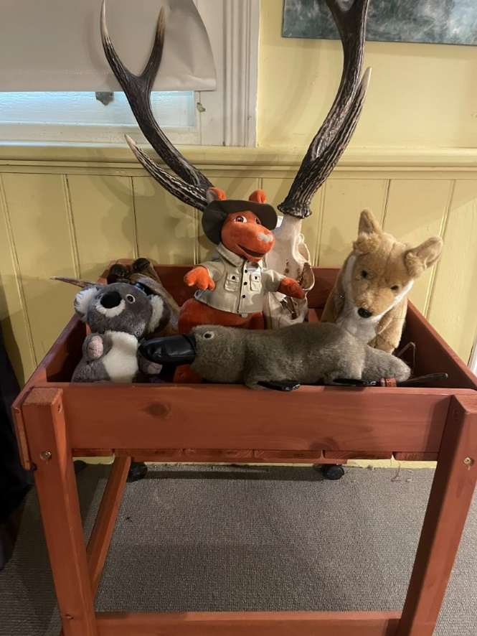
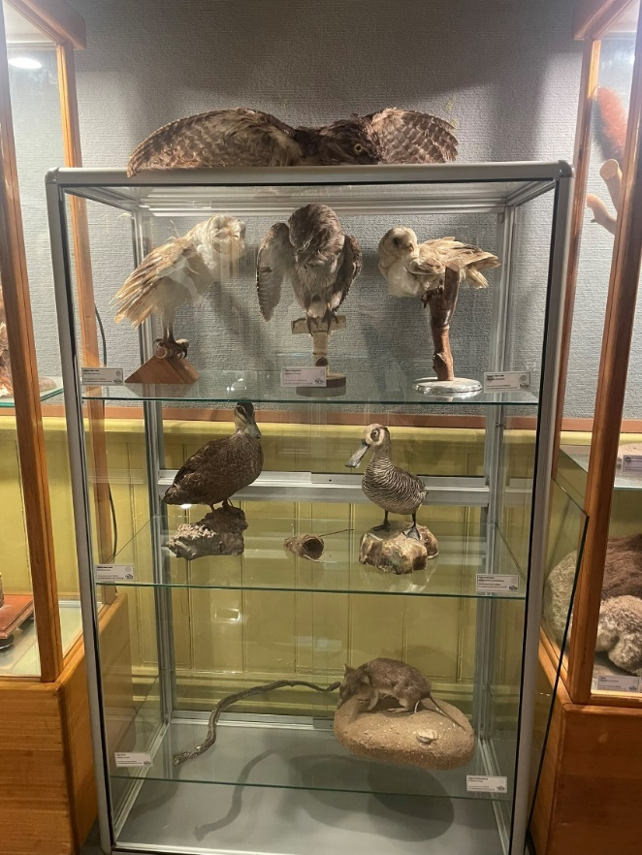

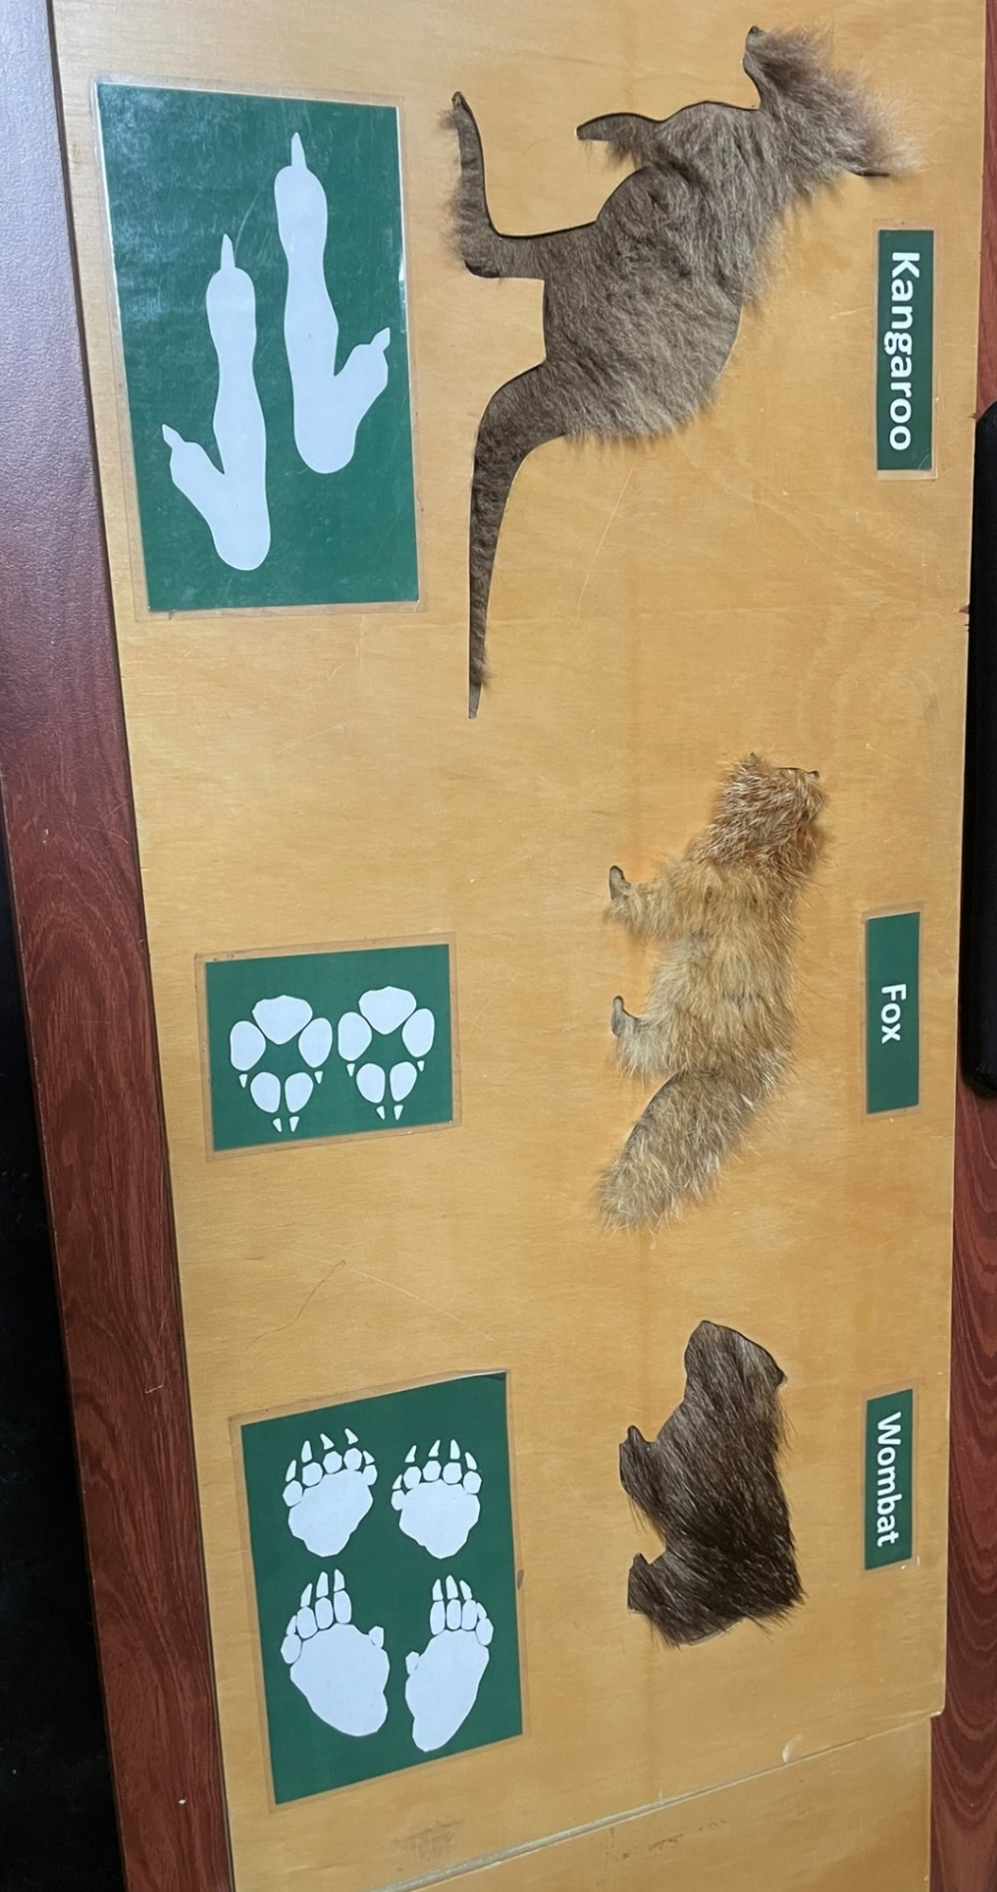
There are special boards that show the fur and paw prints of some animals. I can touch these boards to see what the fur feels like.

The ranger will talk about some of the park rules. These rules keep both people and animals safe.
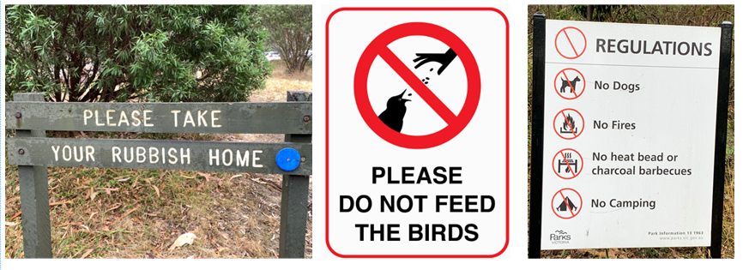

In break time and lunch time, we will eat our food outside the Education Centre.
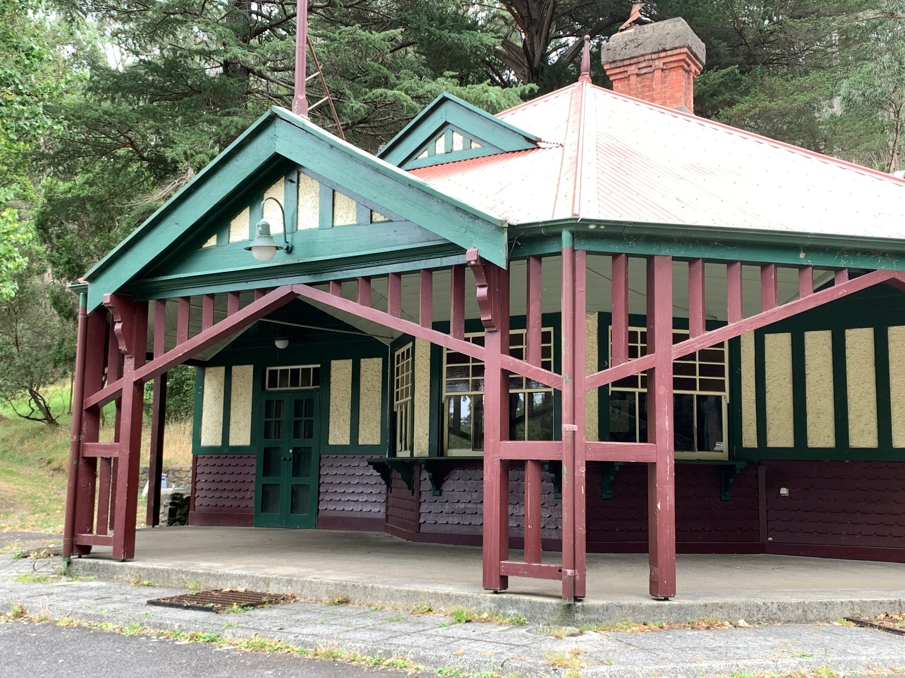
There are drinking fountains near the Education Centre. I can refill my drink bottle with water here.
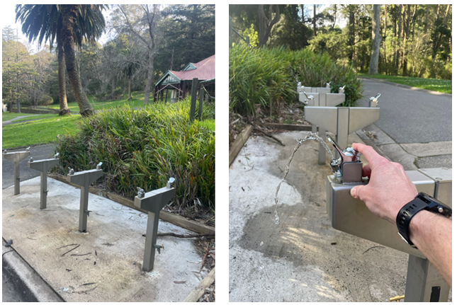
When I am outside during free time, I will make sure that I can always see the Education Centre so that I don’t get lost.
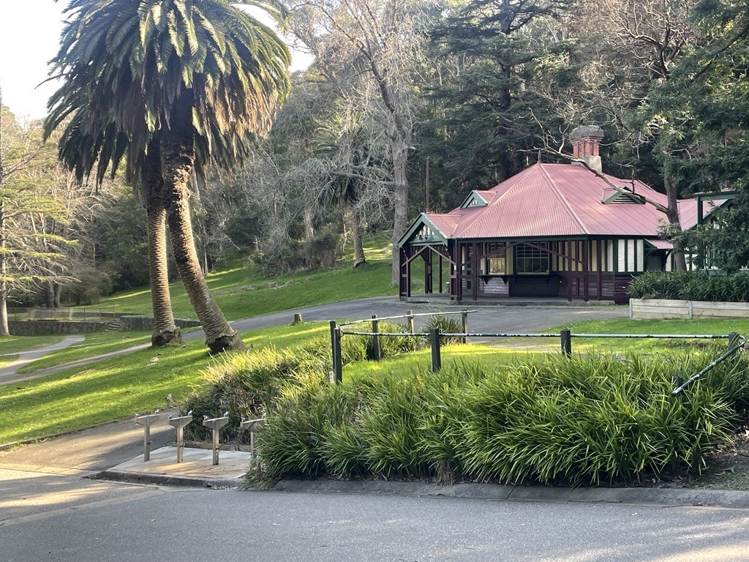
There are toilets close to the Education Centre. If I need to go to the toilet, I have to tell my teacher and I will take a buddy with me.
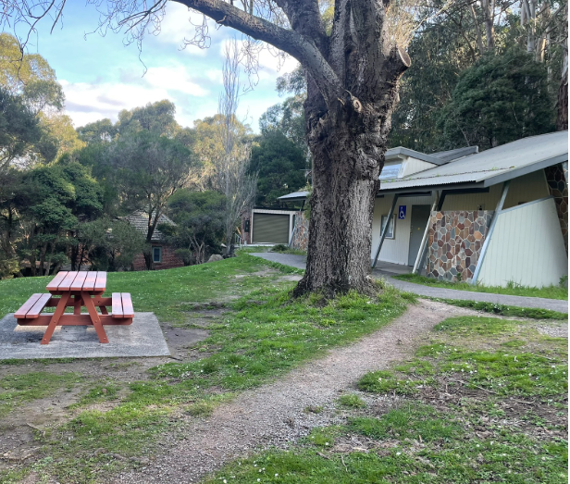
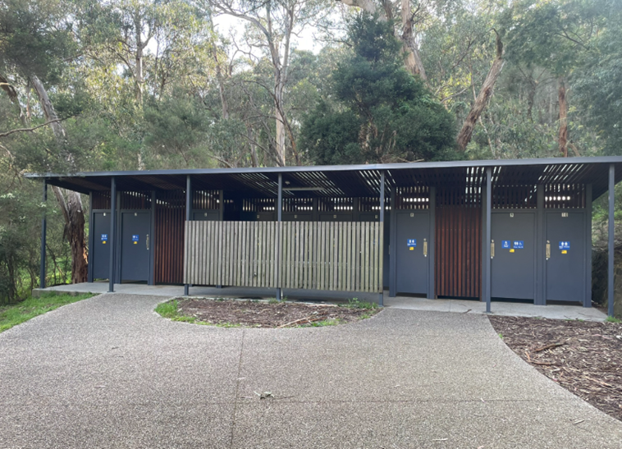

I may be lucky and see some animals. The animals have their own food. I will keep my food to myself. I will quietly watch the animals from a safe distance.
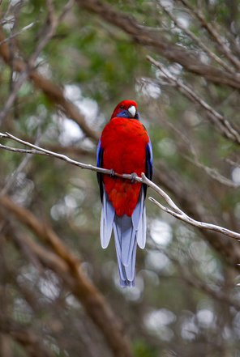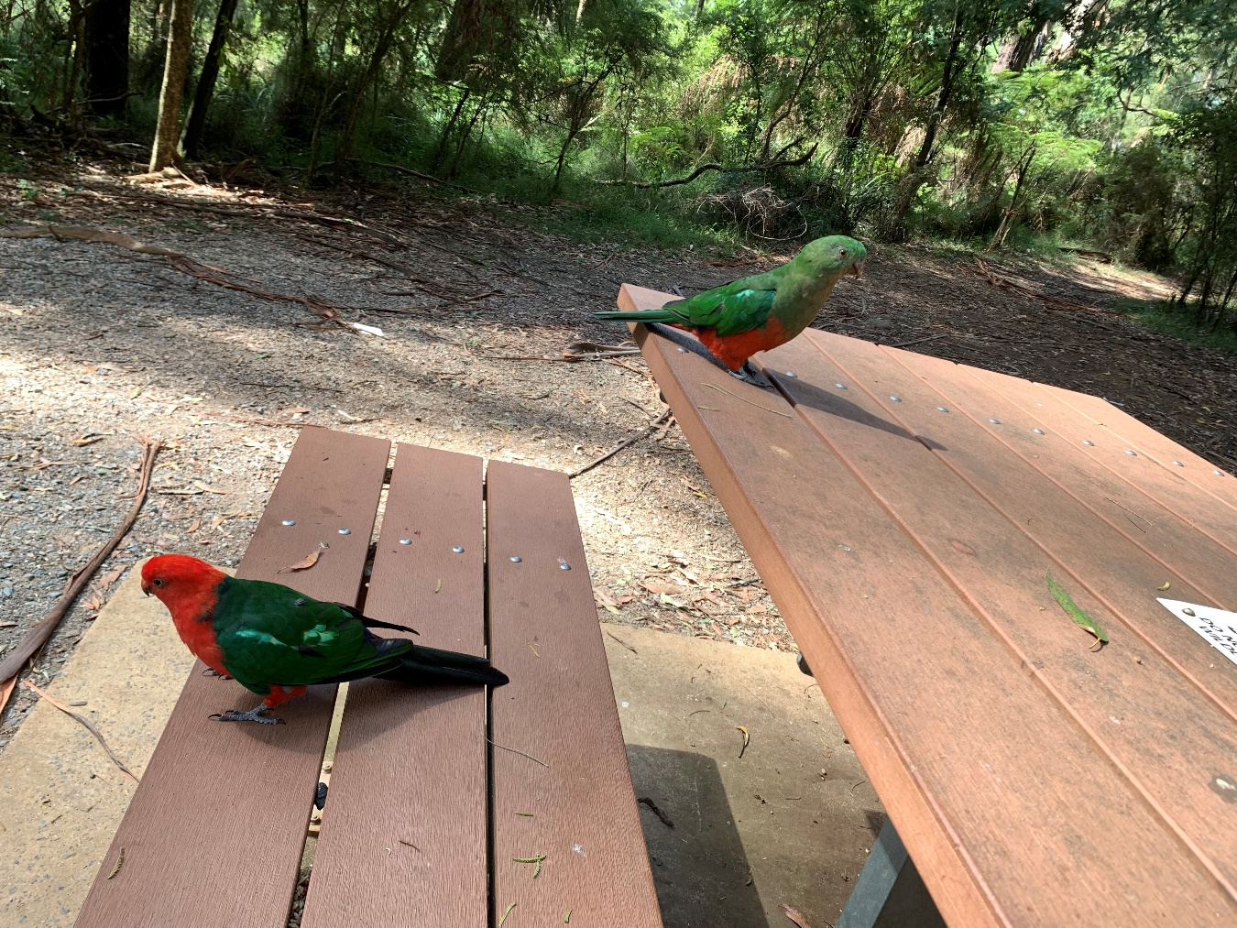
There is a special path to commemorate the 1997 bushfires in the Dandenongs. My teacher might give me a fun quiz where I have to find different things in the path.
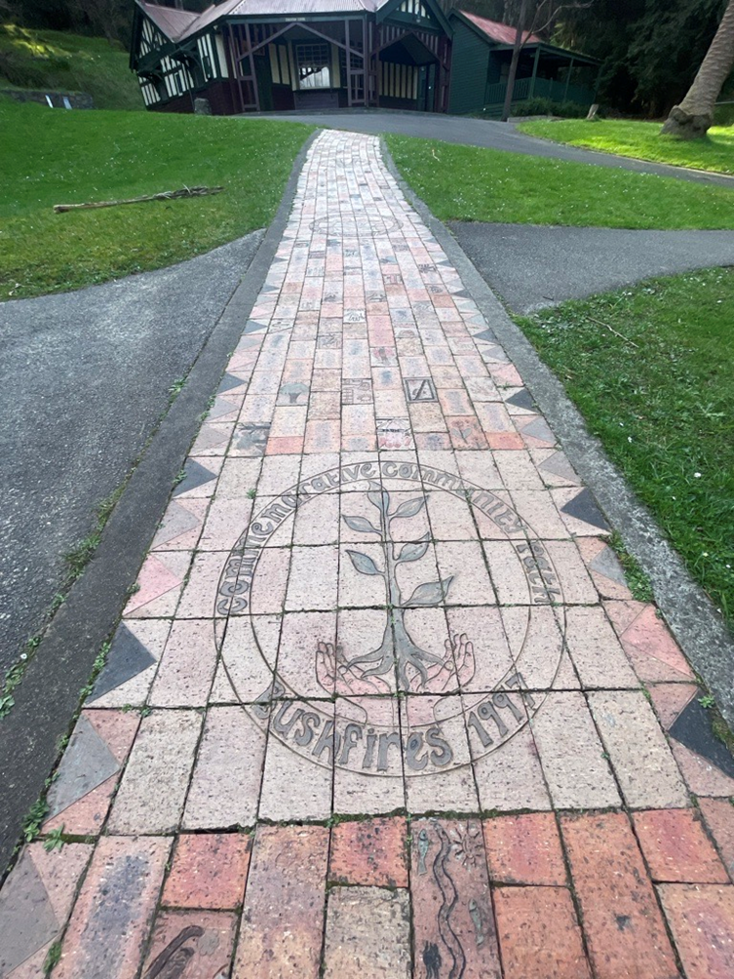
There are many plants in the forest. I will look at the plants and leave them where they are. The ranger or my teacher will tell me if there is a plant I can touch.
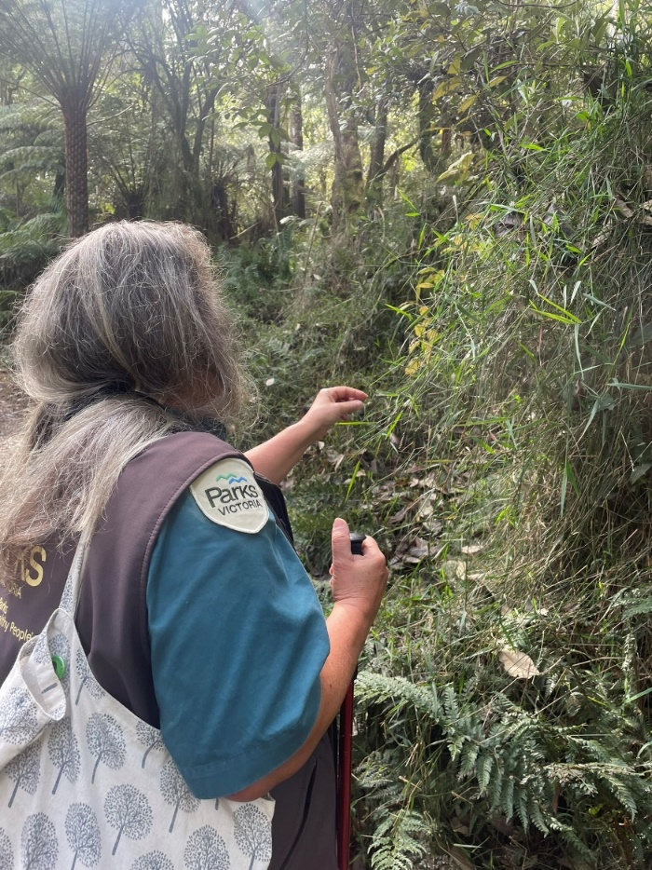

The paths keep the plants safe from being stepped on. I will stay on the path to look at the plants. The track might be narrow or slippery at times. I will walk slowly.
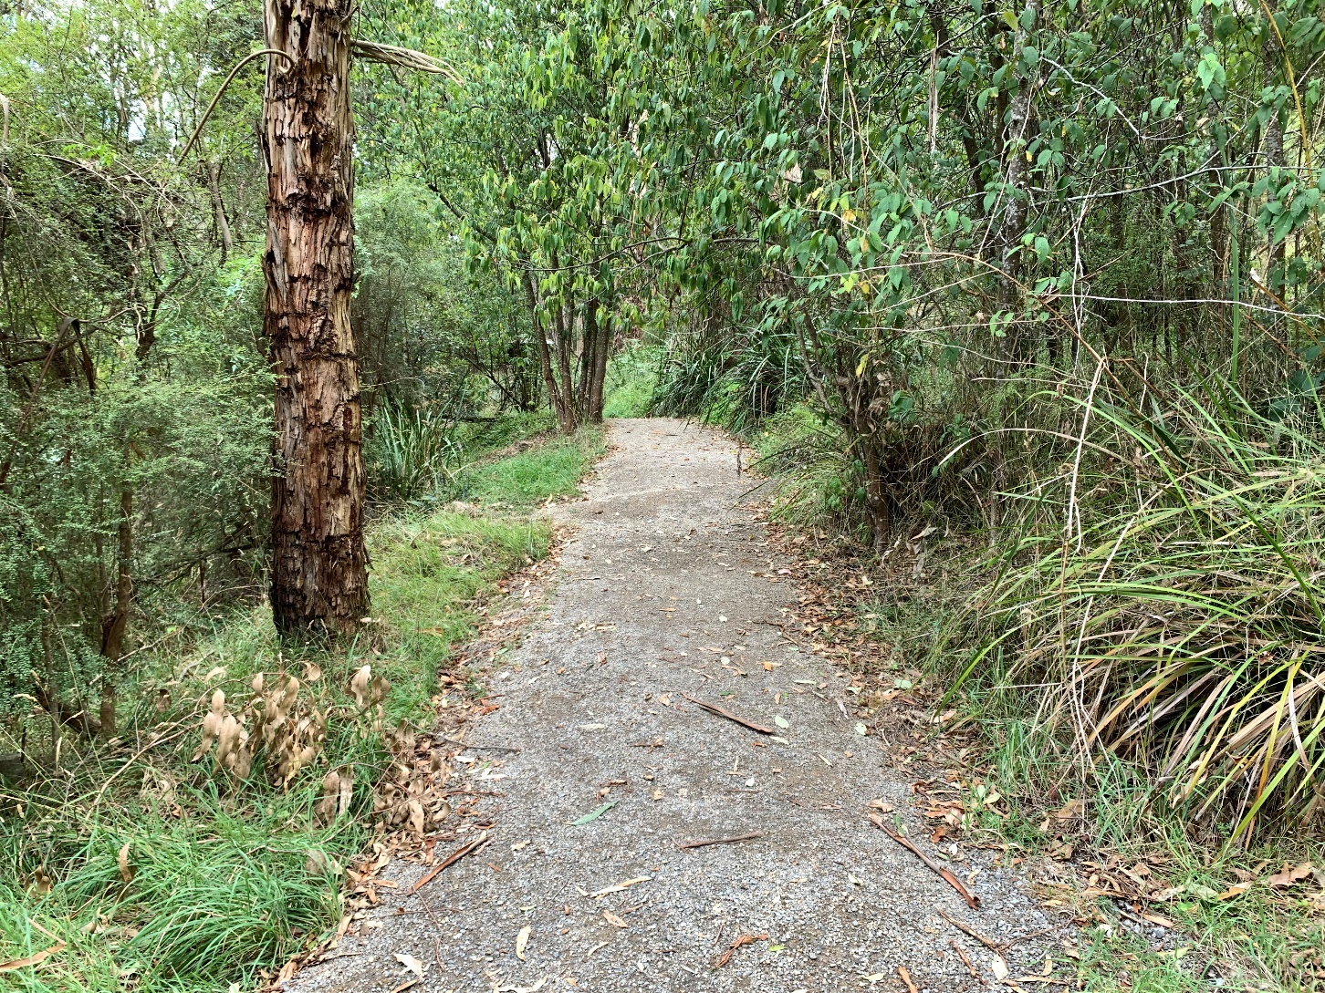
In the park you may hear loud cockatoo calls or Kookaburras laughing. They can be very noisy.

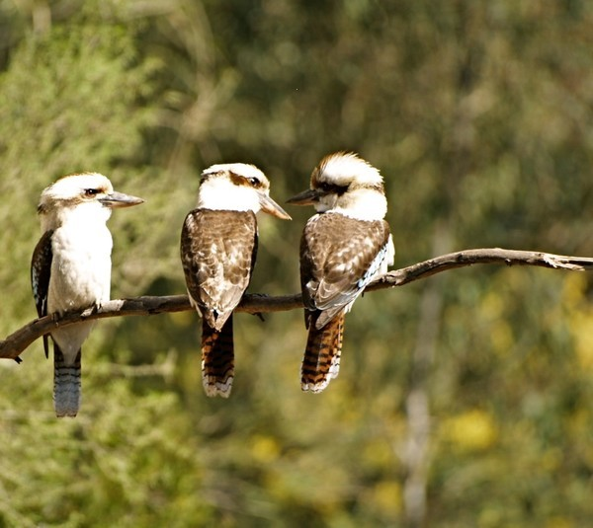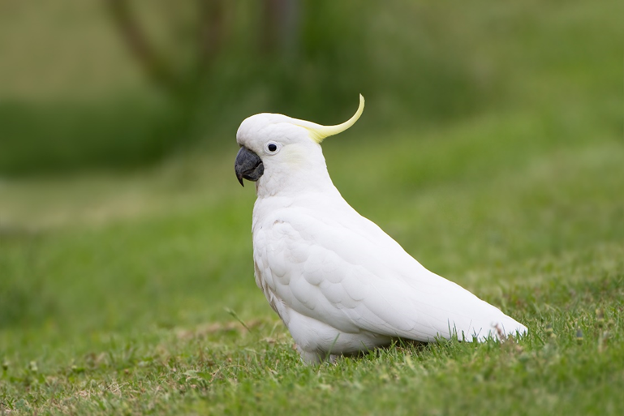

I might visit the park for an ANZAC Day Service. There is a special area called the Kokoda Terrace for this.
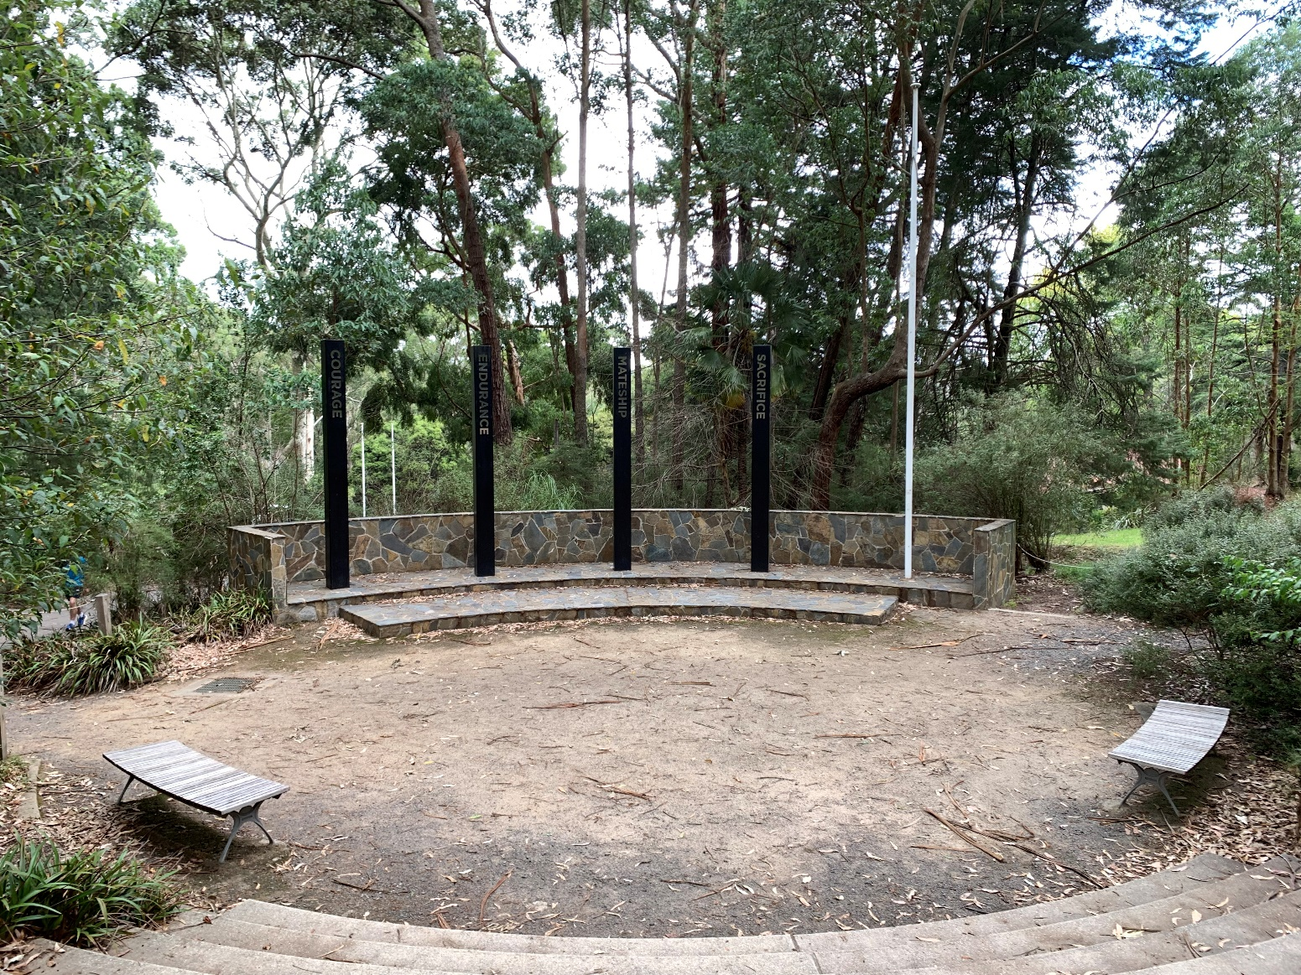
I will have fun learning about animals and nature at the Education Centre at Ferntree Gully Picnic Ground.
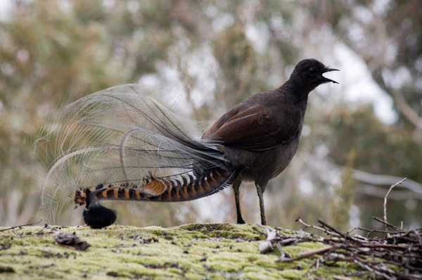
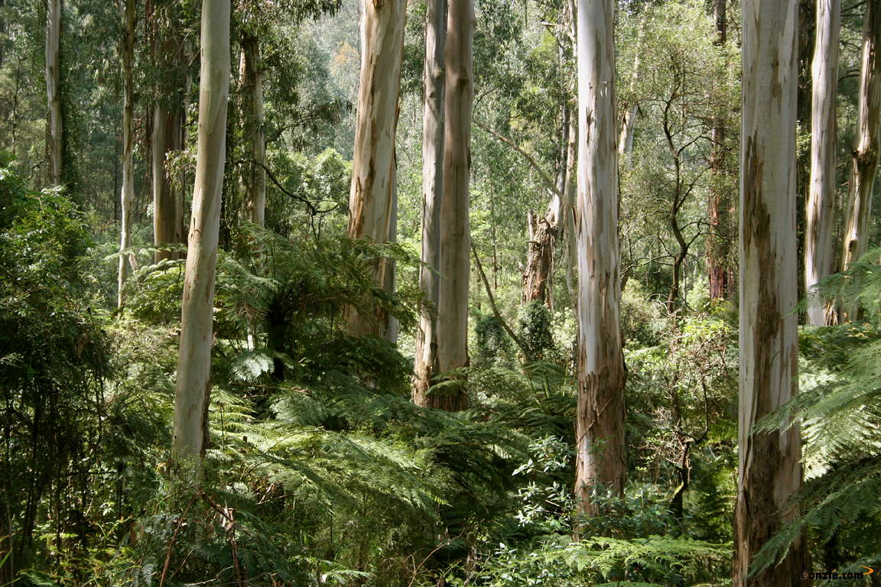
Proudly produced by Parks Victoria in partnership with Amaze





