My Visit to Barmah National Park

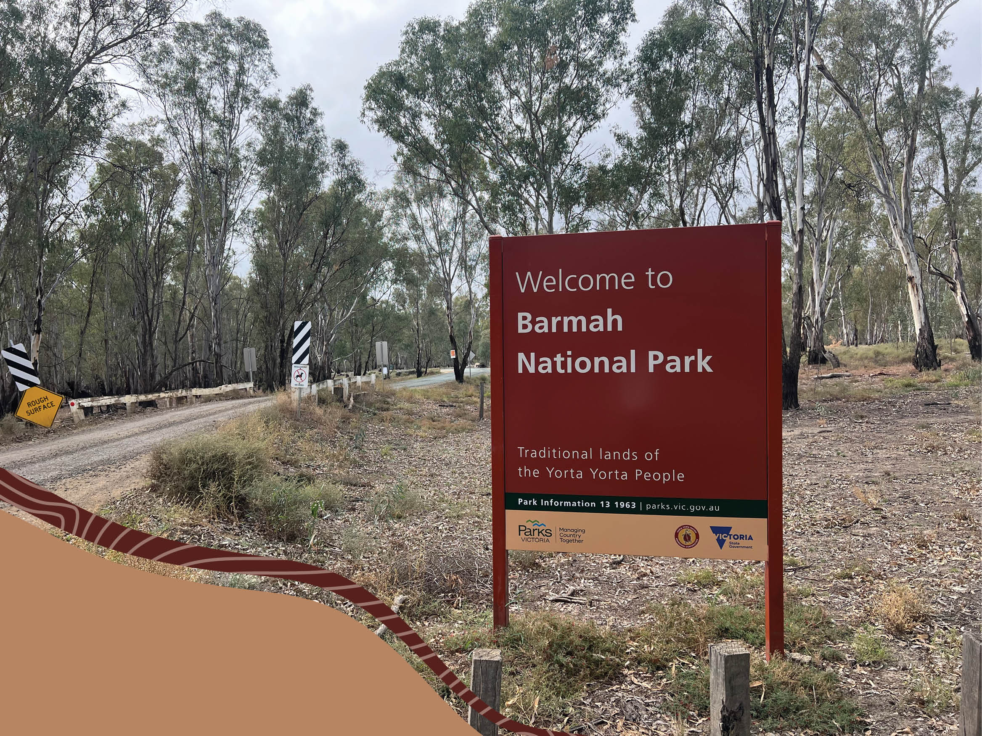
I am going on an excursion to Barmah National Park.
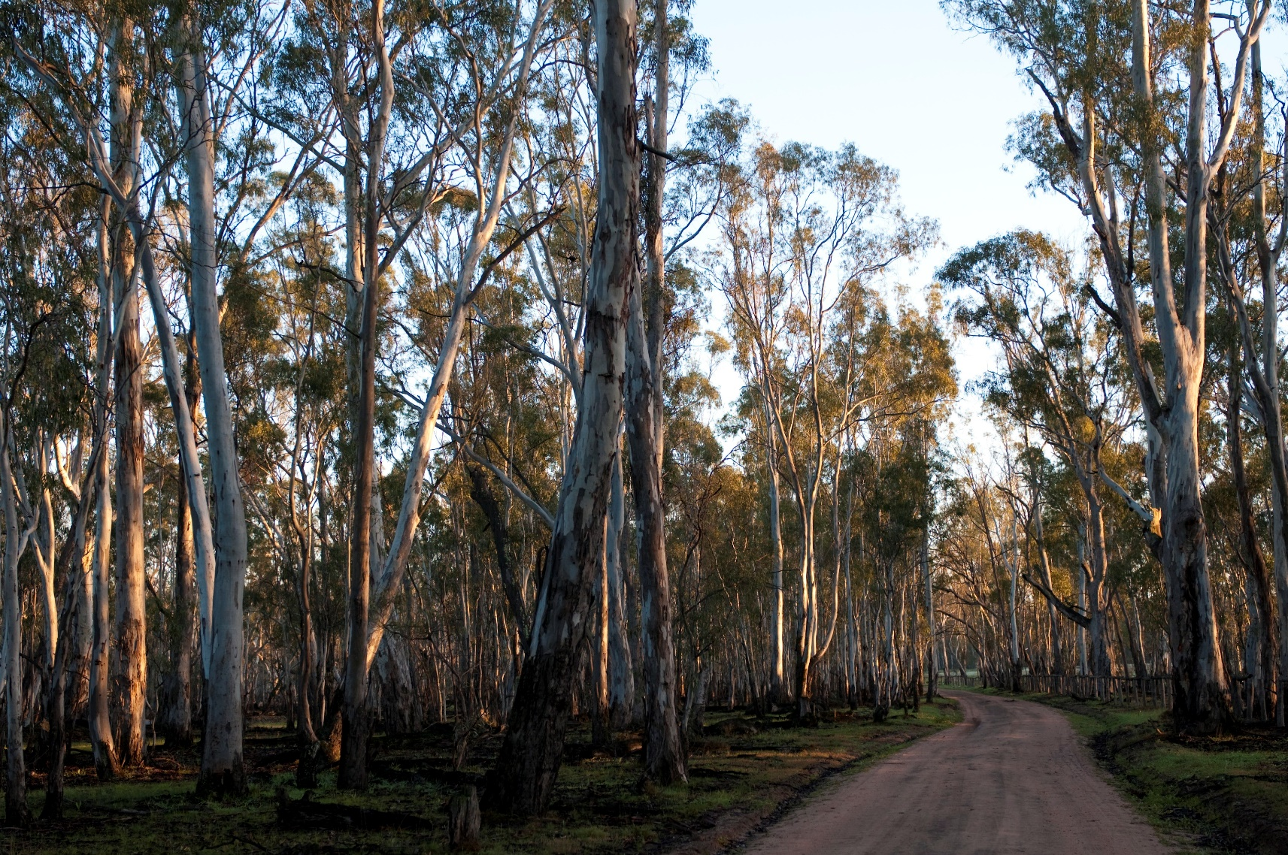

When I get to the park, I have to stay with my teacher.
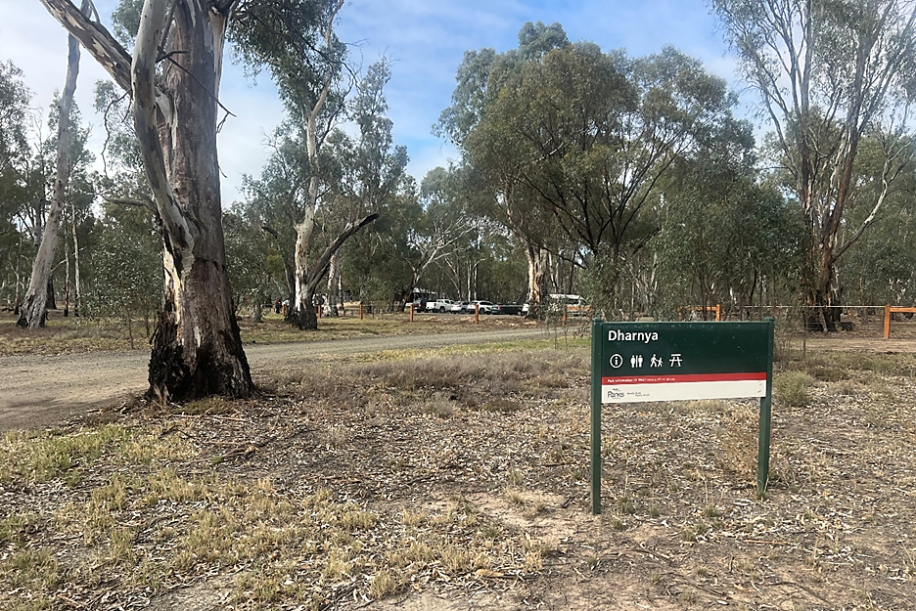

When we arrive, we will see other people and cars in the car park.
I need to stay with my group in the car park. I need to watch out for moving cars.
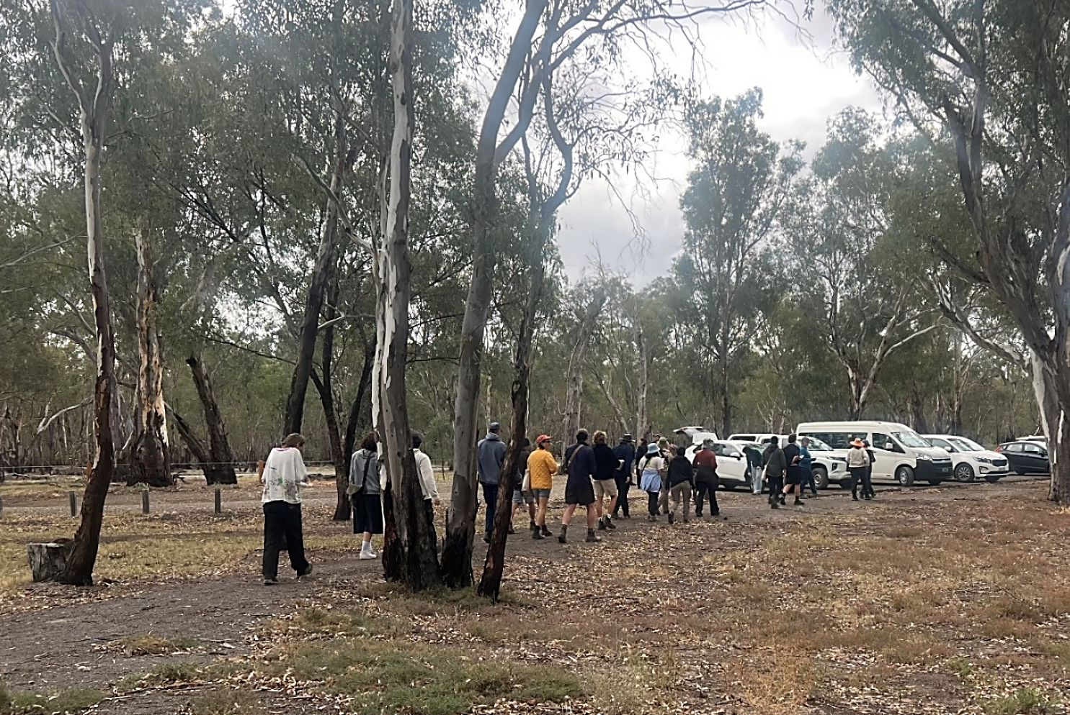

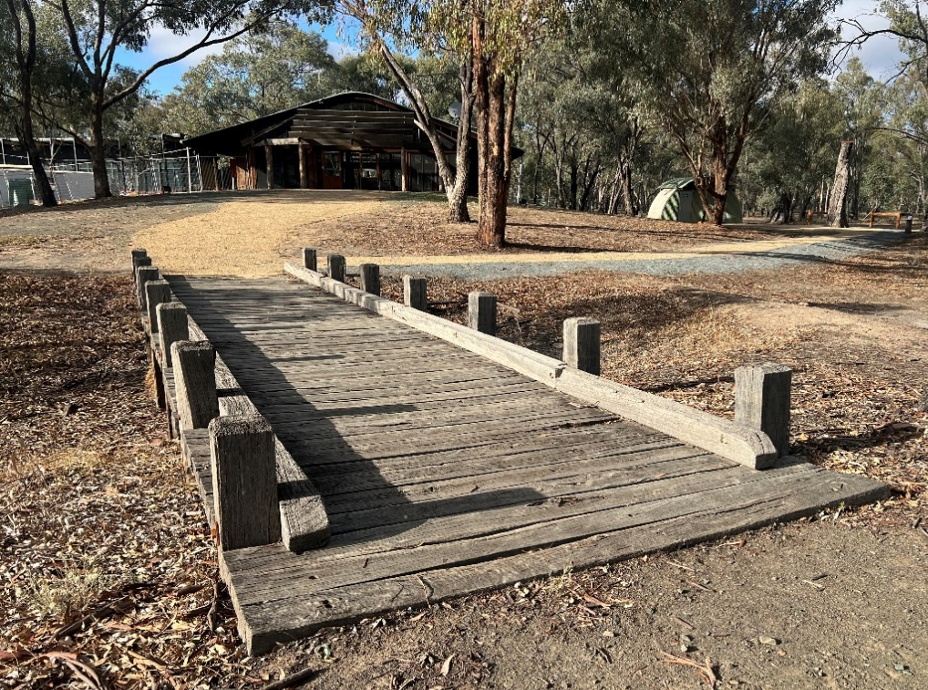
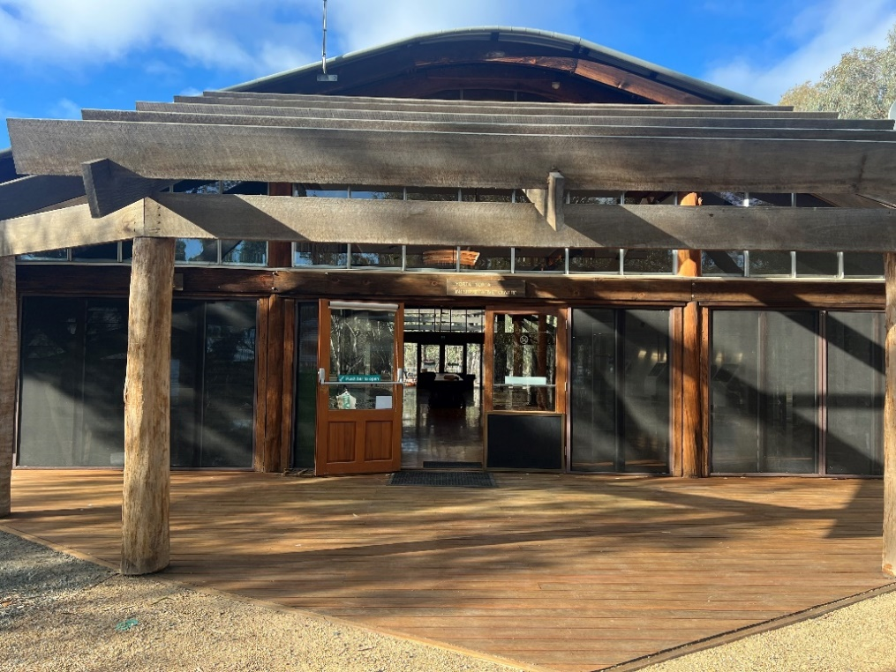
I might get to visit Dharyna Centre. This is a building where I will learn about Yorta Yorta People and Yorta Yorta culture.
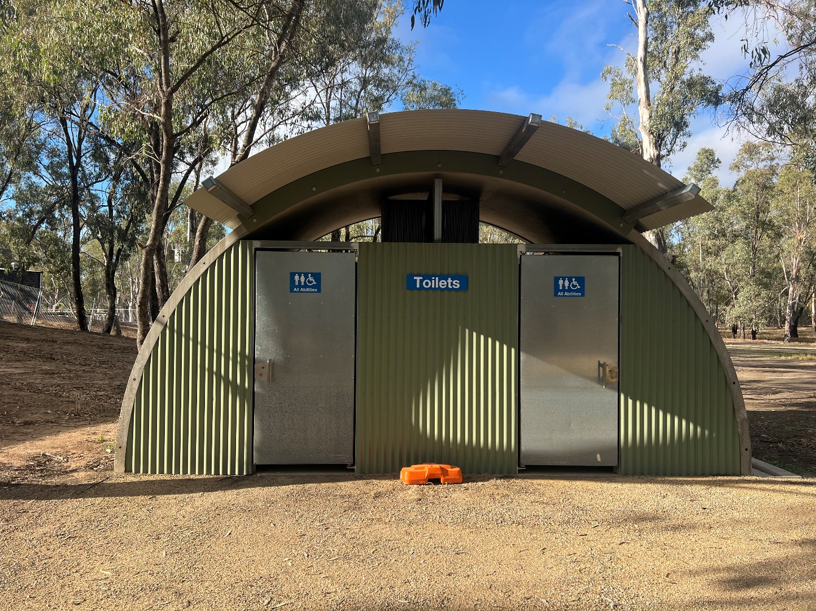
There are toilets next to the Dharnya Centre. Before we begin the tour if I need to go to the toilet, I have to tell my teacher.

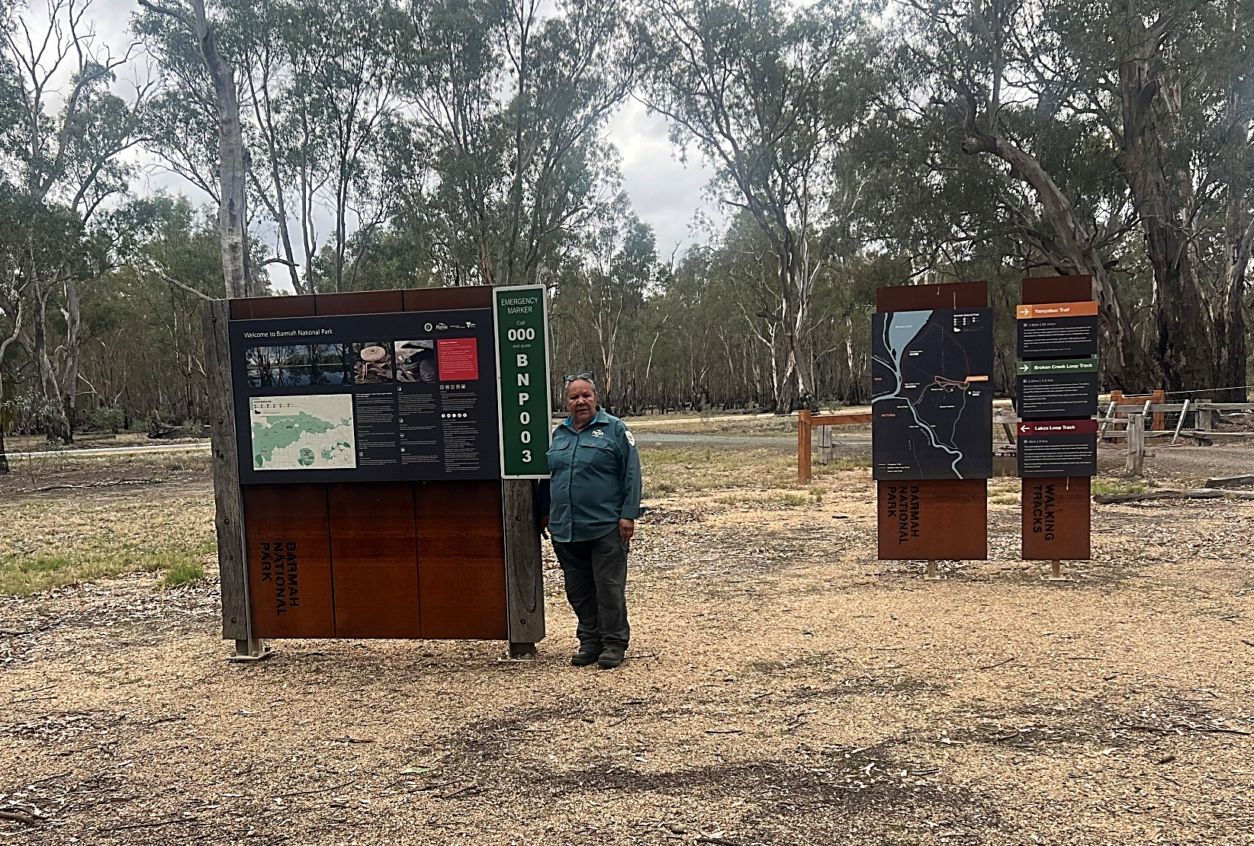
An Education Officer will meet my class at the Dharnya carpark. They wear a uniform and I can ask them questions about the park.

The Education Officer will talk about some of the park rules. These rules keep both people and animals safe.

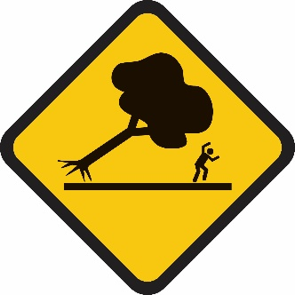 | 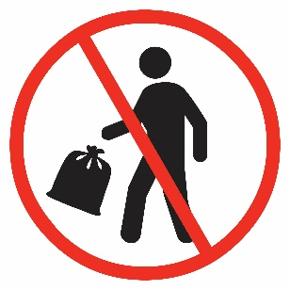 | 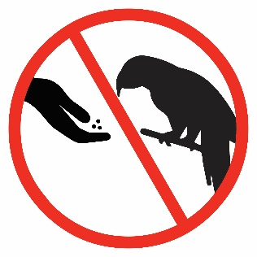

The Education Officer will take me on a walk along the Yamyabuc Trail. I will stay with my teacher and the Education Officer. This keeps me safe.
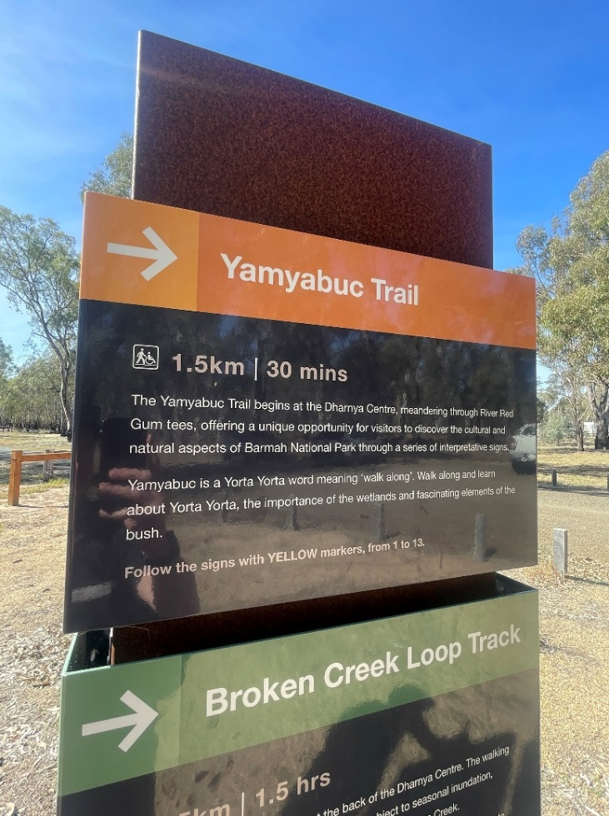
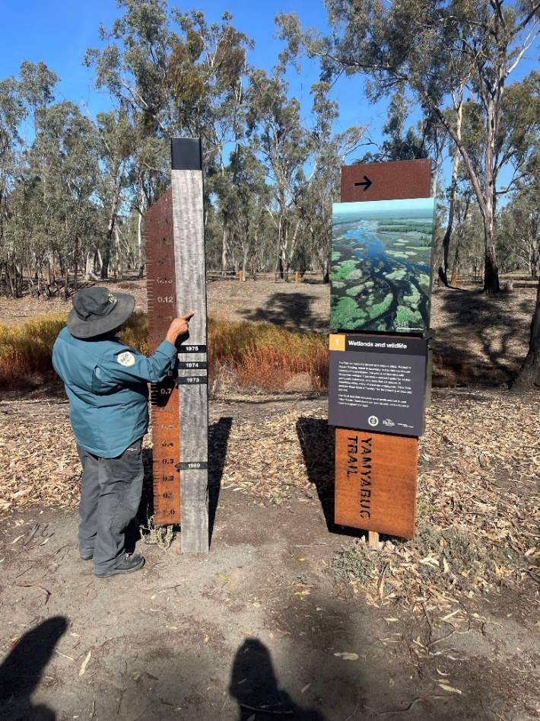

In the park, it is important to walk on the path. Lots of insects and small animals live on the ground. The path keeps everyone safe.
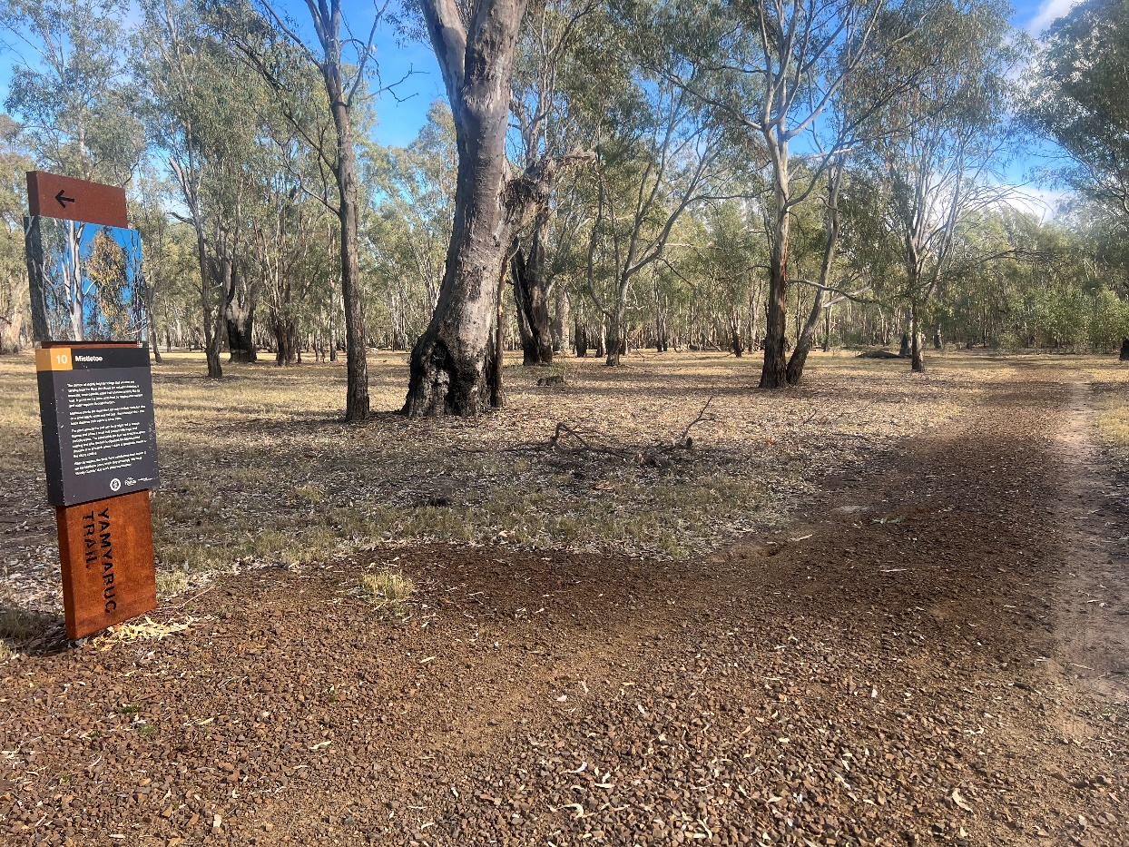
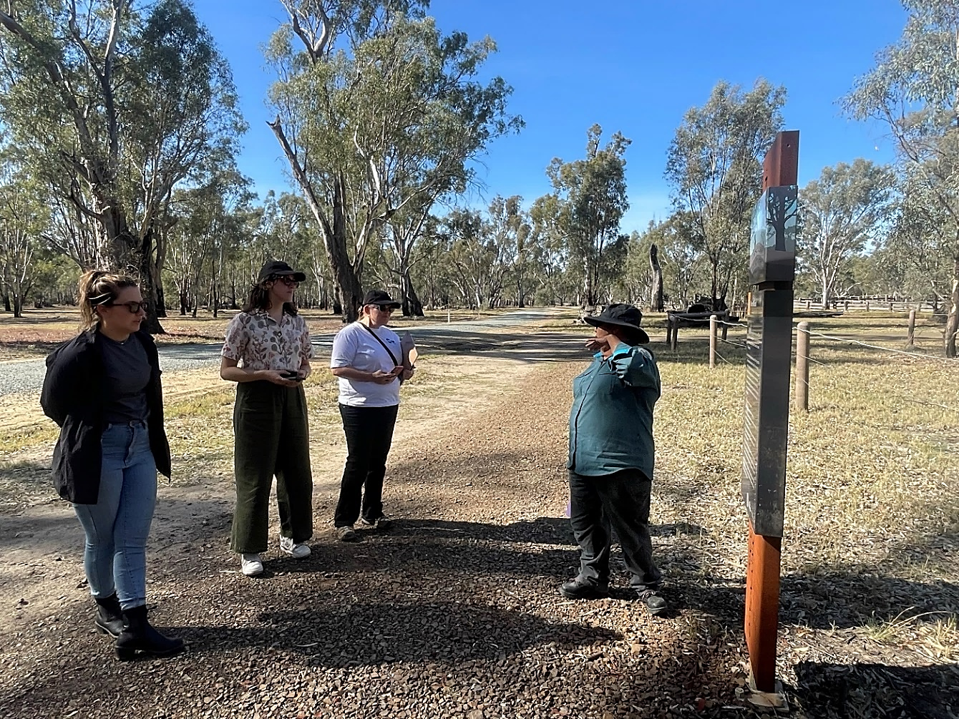
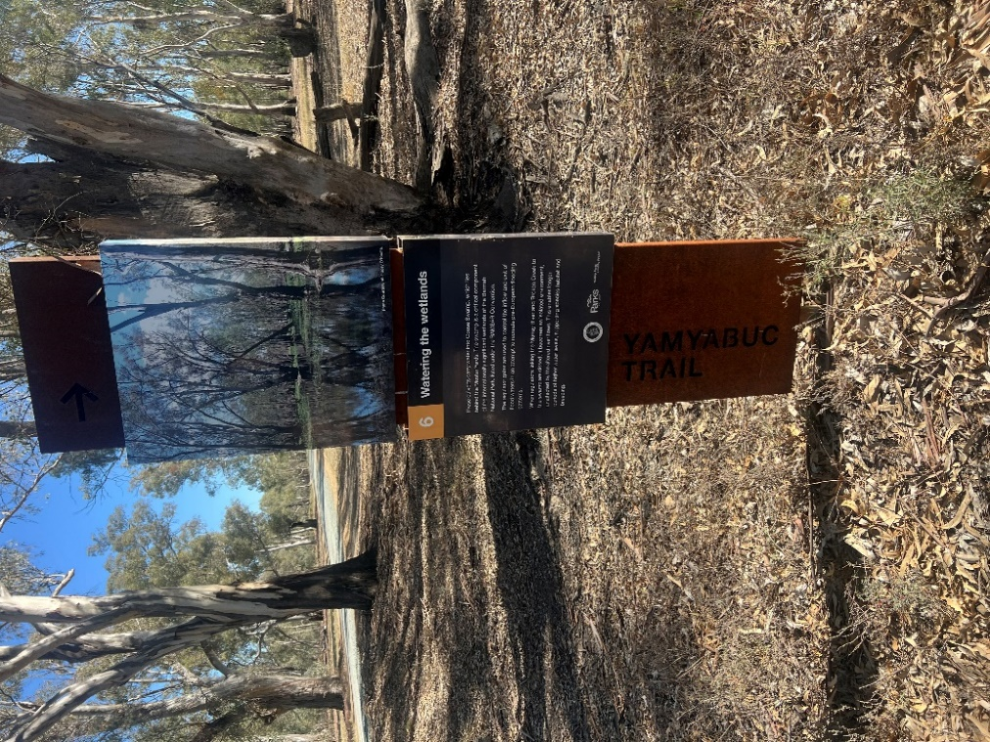
The tour follows the numbered signs throughout the park. The Yamyabuc Trail has yellow signs with numbers 1 to 13. The Education Officer will stop and talk about the park.
Sometimes there are animals at the park. If I see an animal, I quietly watch it from a safe distance. When there are lots of people, the animals hide in the bush. This makes them feel safe.
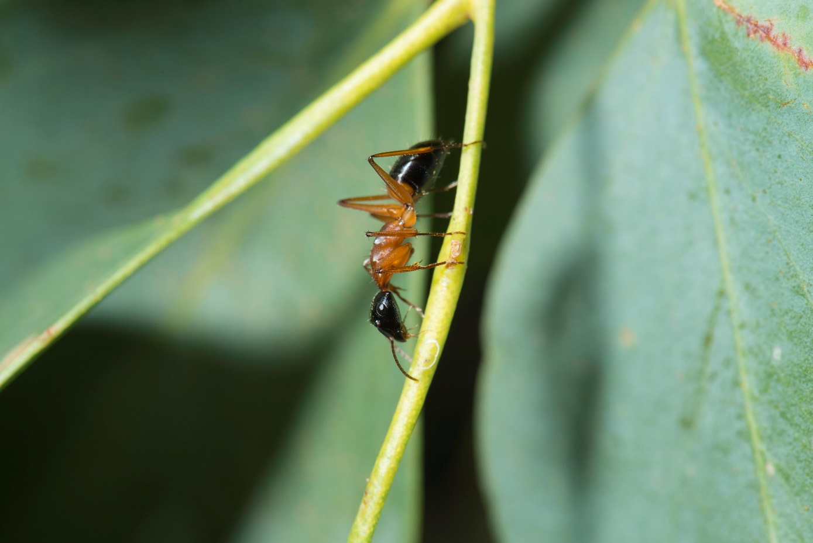 | 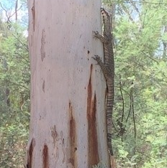 | 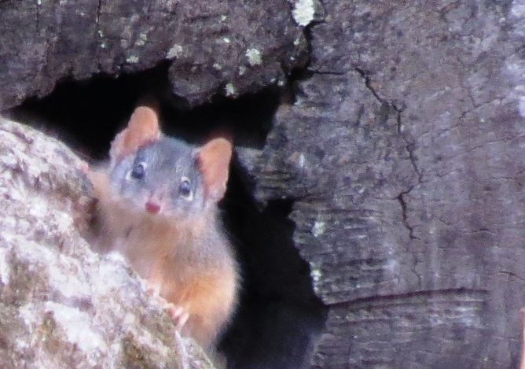
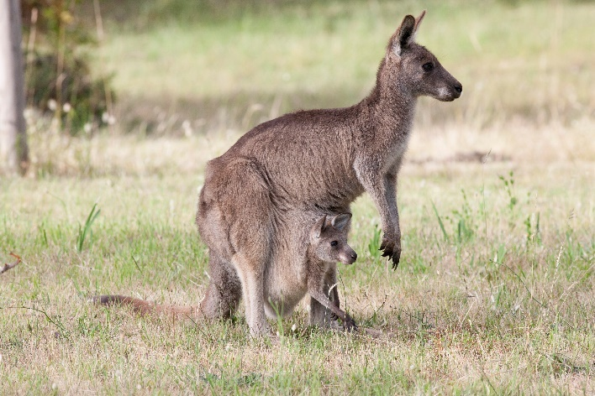 | 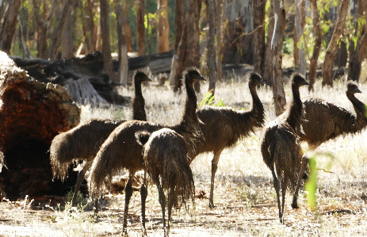 | 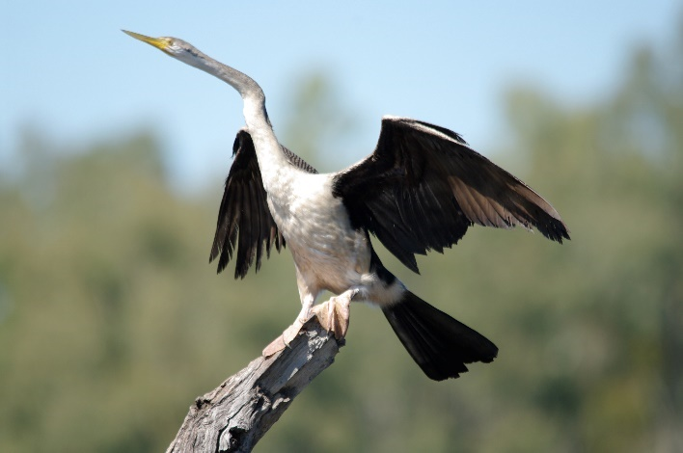
There are many plants in the park. I will look at the plants and leave them where they are. The Education Officer or my teacher will tell me if there is a plant I can touch.
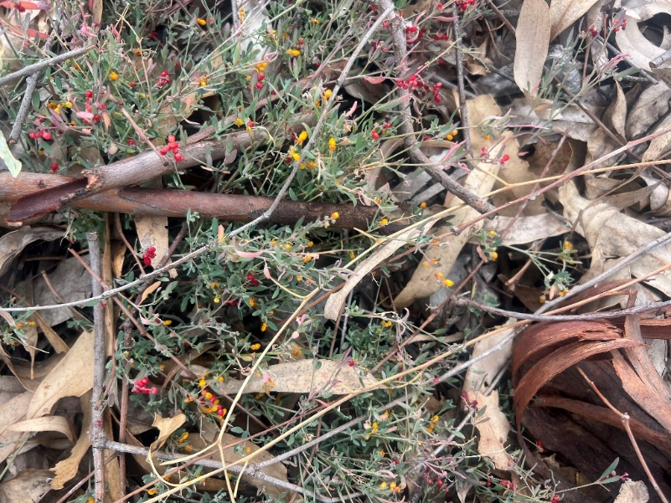 | 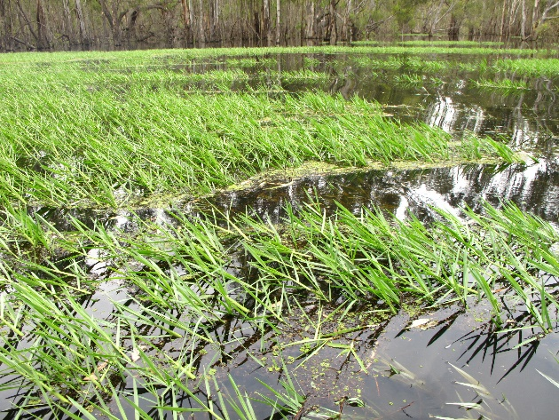  Libby Gunn | 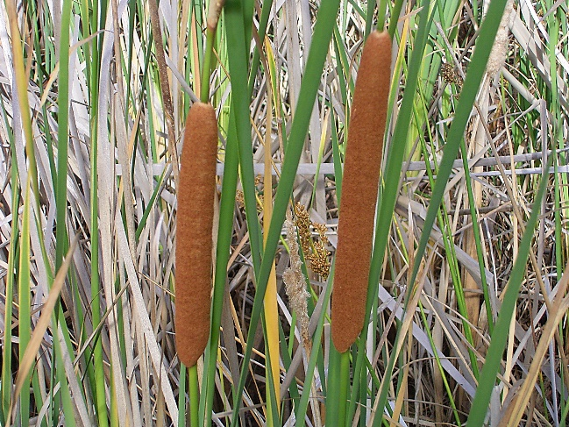
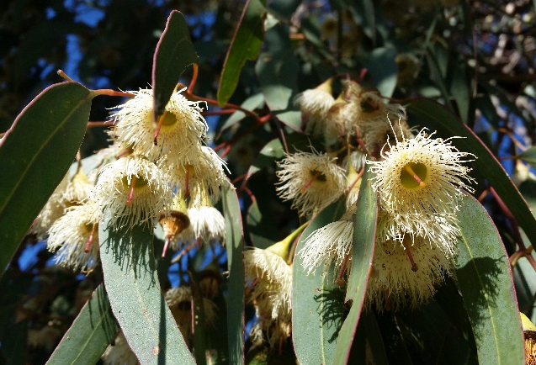  Deb Pople | 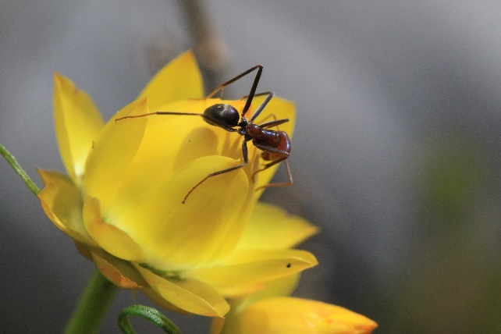  Deb Pople | 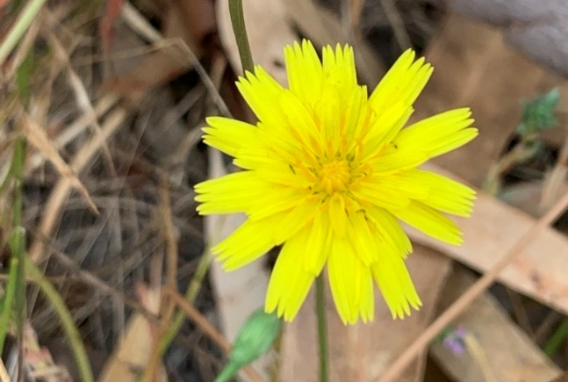
The park will look different at different times of the year. When the time is right, there are baby animals who grow up in the park.
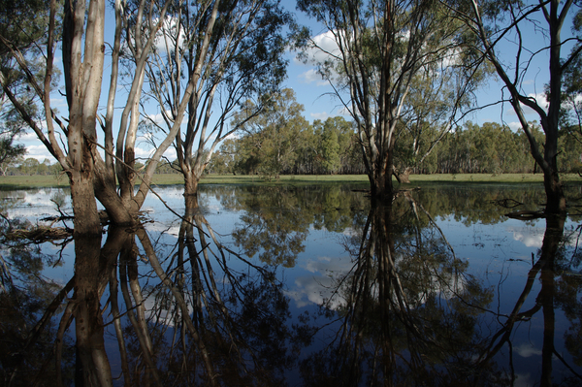 | 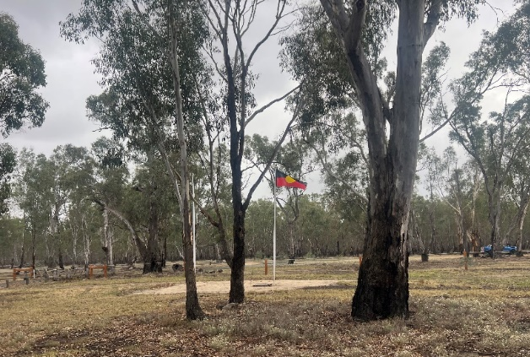
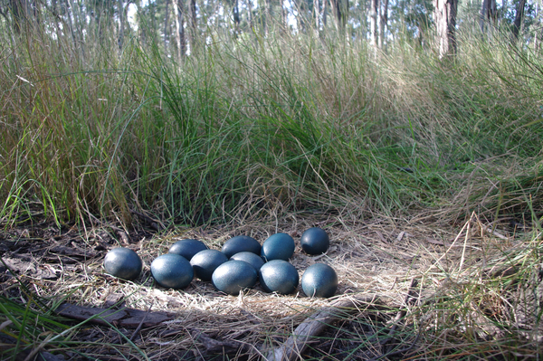 | 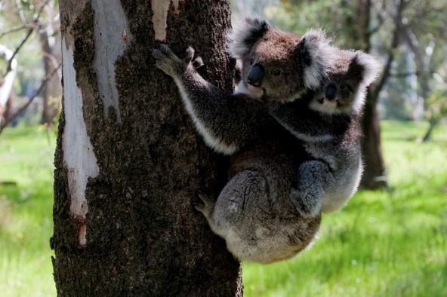

I might notice different smells in the air. When it has been raining, I might be able to smell wet soil. When it is dry, I might be able to smell gum leaves or fresh air.

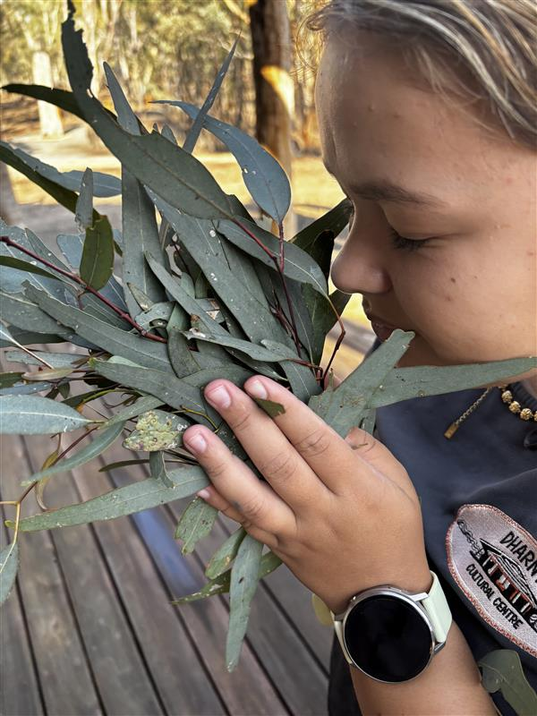
At lunchtime, I can sit at the picnic tables to eat. I will keep my food to myself. I will take my rubbish home with me. The animals have their own food in the bush.
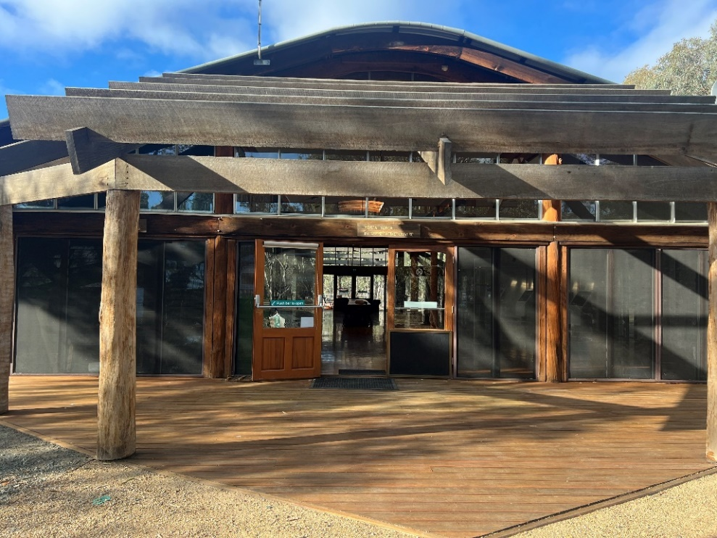
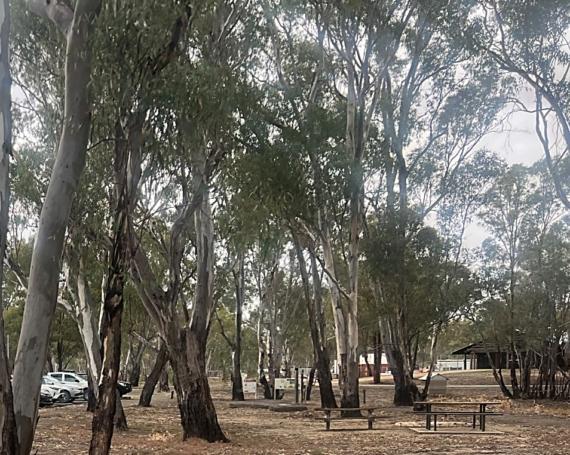

In the park you may hear loud cockatoo calls or kookaburras laughing. They can be very noisy.

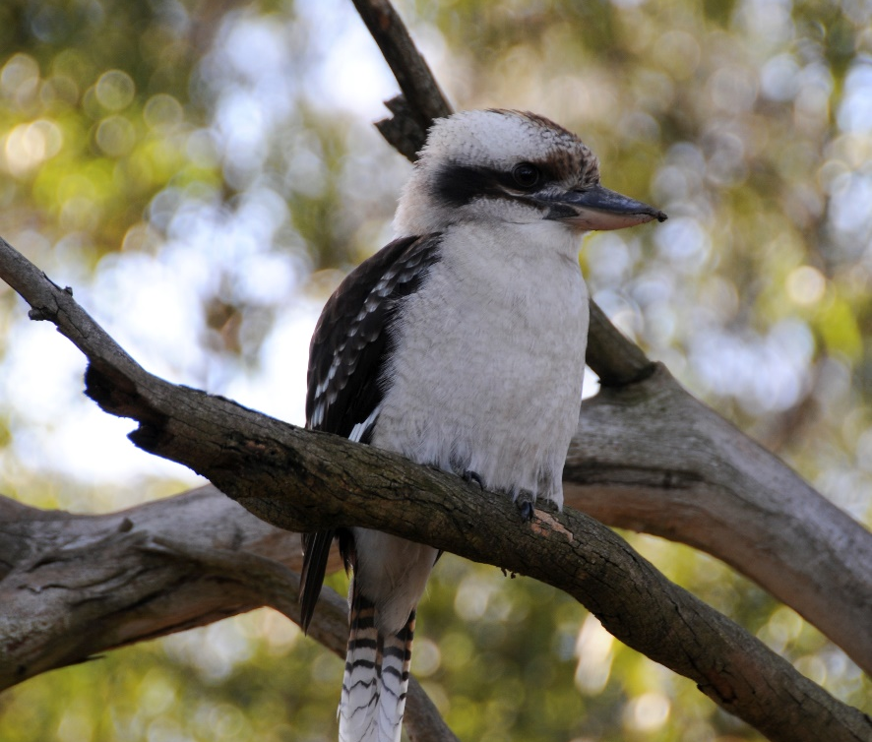
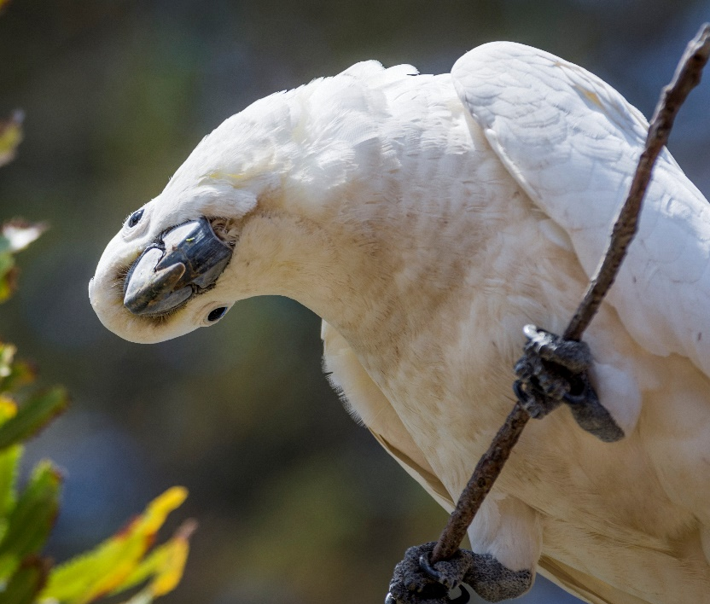

I will have fun exploring the park and learning about Yorta Yorta Country with an Education Officer at Barmah National Park.
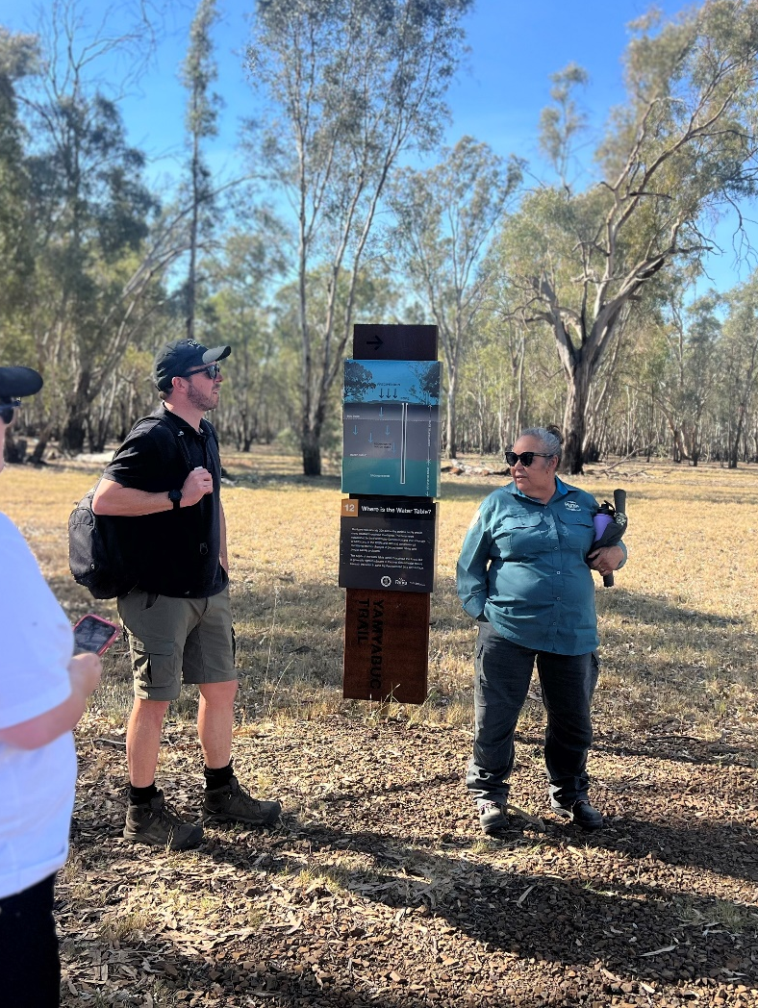
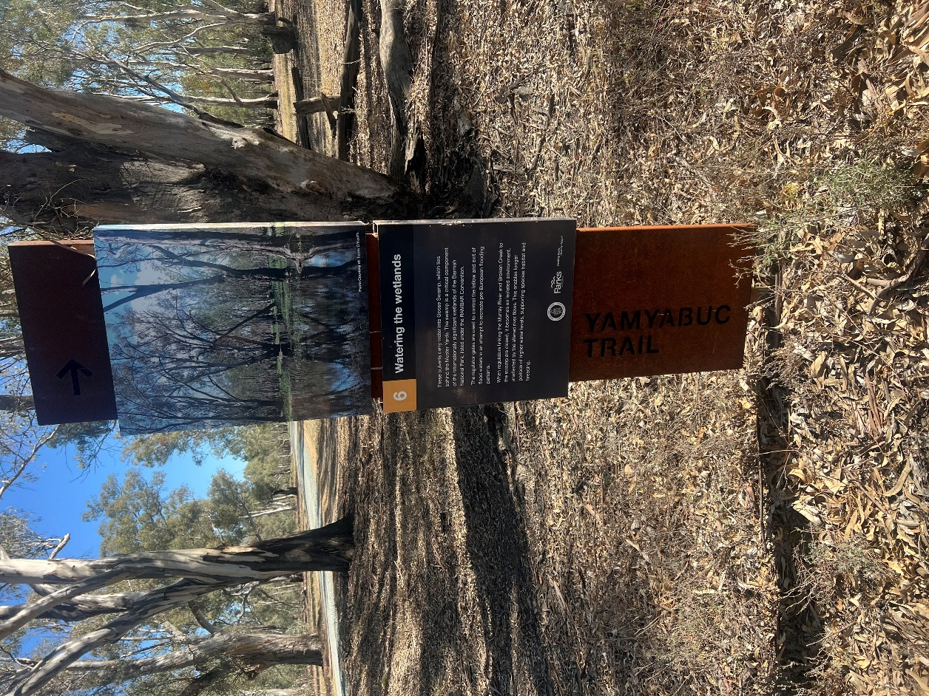
Proudly authored by Yorta Yorta Education Officers, Parks Victoria and Amaze.
Illustrator: Reanna Bono, Wemba Wemba and Wiradjuri

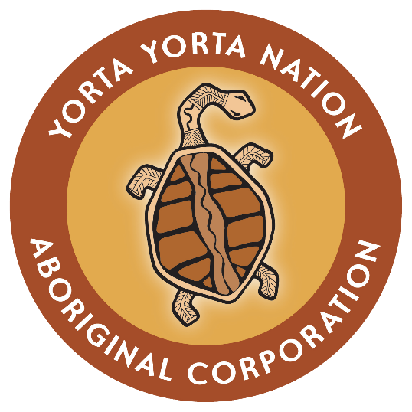 | 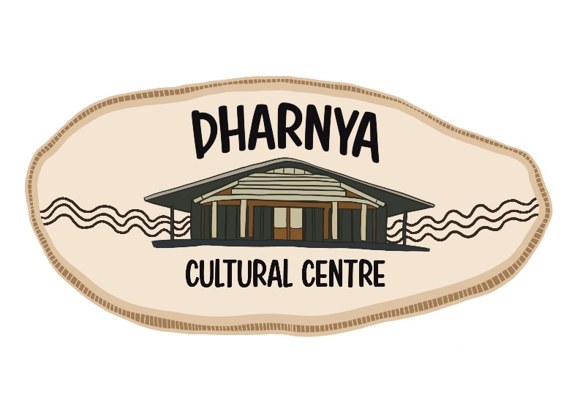
 |   

